ANCIENT COINS

GREEK

1 Phoenicia, Byblos, 4th Century BC, silver 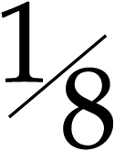-Shekel (10), galley left, hippocamp below, rev lion attacking stag, various inscriptions (cf S 6010). Fine. (10) £80-100

2 Thessaly, Thessalian Confederacy, c.196-146 BC, Double Victoriatus 5.9g, head of Zeus right, rev legend around Athena advancing right, ΦΙΛΟΚΡΑΤΥΟΣ and ΦΕΡΕΚΡΑΤΕΣ (BMC 32). Toned, light tooling to reverse, very fine. £60-80

3* Greek Silver (3) including Didrachm, Neapolis c.400BC with field symbol elephant (SNG ANS 394), Stater, Selge c.370 BC, wrestlers and Drachm, Dyrrachium c.200 BC, cow suckling calf. Very good to fine. (3) £60-80

4* Greek Silver (18),Drachms (12) including Sycion, Rhodes, Phillip II of Macedonia, Alexander the Great, Argos and Hemidrachms and smaller (6) including Thebes, Rhodes, Phokaia. Mixed grades. £400-500

5 Greek bronze coins (14), of Spain, Carteia, Ae 19mm, Germanicus and Drusus (Vives 128-14), Carthago Nova, Ae 21mm, Persephone (V 8-12), Ae 21mm, Augustus (V 131-2), and Castulo (8), Ae 34mm and smaller, head, rev sphinx (3) (V 68-11 ff), CN VOC ST F (3) (V 71-2), another V 70-11), another M BAL F (V 71-9); other Spanish bronzes (3). Good to fine, some scarce. (14) £60-80

INDO-GREEK

6 Apollodotus II (c.11-80 BC), silver Drachms (3), Taxila (Mitch 2054-2061); Western Ksatrapas, silver Drachms (13), other Indian silver coins (11). Fine to very fine. (28) £50-80

7* Menander I, Drachm, diademed bust right, rev Athena right, monogram (Bop series 13 cf 91). Very fine. £30-40

8* Menander I, Drachm, helmeted bust right, rev Athena left, monogram (Bop series 16 cf 142). Good very fine. £35-45

9 Menander I, Drachms (5), diademed head right (2), helmeted head right (2) and heroic bust left. Fine or better. (5) £60-80

ROMAN

10* Roman Republic, Denarii (9), including Julius Caesar, Brutus and Ahala, Musa, and others (6), Quinarius with types of Cn Cornelius Lentulus though inscription off flan. First pierced, others fair to about very fine. (10) £220-280
11 Roman Republic, Denarii (2), M Porcius Laeca, c.125 BC, rev quadriga right (Syd 513) and M Fannius, c.123 BC, rev quadriga right (Syd 419). Fine to very fine. (2) £40-60

12* Roman Republic, Denarius Serratus, C Mamil Limetanus C F, Rome 82 BC draped bust of Mercury right, caduceus and control letter A behind, rev Ulysses standing right holding staff and extending hand to dog, Argus, C MAMIL and LIMEĀN on either side (Cr 362, 1). Edge prepared apparently for mounting, about extremely fine. £100-150

13 Q Caecillius Metellus Pius Scipio (Imperator 47-46 BC), Denarius 3.8g, head of Jupiter right, rev SCIPIO IMP, elephant right (Syd 1046). Banker's mark, fine. £60-80

14 Augustus (27 BC-AD 14), Denarius 3.8g, laureate head right, rev Caius and Lucius Caesars, shields and spears (see RIC 207). Some weakness, about very fine. £80-100

15* Claudius (AD 41-54), Denarius 2.94g, Lugdunum AD 44-45, laureate head right, rev IMPER RECEPT depiction of praetorian camp (RIC 52). Pierced, fine. £120-150

16 Claudius, As, Rome AD 50-54, bare head of Nero Claudius Drusus left, rev S C Minerva standing right holding shield and hurling spear (RIC 100). Sharp portrait with pleasing patina, very fine. £80-100

17 Claudius, in the name of Divus Augustus, Dupondius, Rome, radiate head left, DIVVS AVGVSTVS S C, rev DIVA AVGVSTA, Livia seated left holding corn ears and long torch (RIC 101). Striking split at 11 / 6 o’clock, pleasing fine, very rare. £60-80

18* Nero (AD 54-68), Aureus 7.02g, Rome AD 64-65, laureate head right, rev CONCORDIA AVGVSTA, Concordia seated left, holding patera and cornucopiae (RIC 47). Some staining, trace of mount, fine. £400-500

19* Vitellius (AD 69), Denarius, laureate head right, rev CONCORDIA PR, Concordia seated left (RIC 73). Flan cracked at 8 o’clock from striking, very fine. £150-200

20 Vespasian (AD 69-79), Denarii (2) and others of Trajan (4). Fine or better. (6) £60-80

21 Vespasian, As, Rome AD 76, laureate head right, rev SC Spes standing left holding flower (RIC 583a). Attractive very fine. £60-80
22* Trajan (AD 98-117), Aureus 7.24g, Rome AD 112-14, laureate bust right, draped and cuirassed, rev CONSERVATORI PATRIS PATRIAE, Jupiter standing left holding thunderbolt, and holding drapery over Trajan to protect him (RIC 249). Polished, fine, scarce. £400-500

23* Antoninus Pius (AD 138-161), Aureus 7.32g, Rome AD146-161, laureate draped bust right, rev COS IIII Felicitas standing left holding Capricorn and long caduceus (RIC 131). Pierced, good fine. £200-250

24* Antoninus Pius, Denarius, bust right, rev funeral pyre of four storeys, quadriga on top (RIC 436). Very fine, traces of lacquer on obverse. £20-30
Provenance: “Found by Gilbert in the papershop”

25 Marcus Aurelius (AD 161-180), Denarius, rev Mars, and others of Faustina II (3), rev Fecunditas (2), Venus. About very fine. (4) £60-80

26* Faustina Junior, memorial Sestertius from the reign of Marcus Aurelius, AD 161–180, DIVA FAVSTINA PIA bust right, rev AETERNITAS S C, Aeternitas holding globe surmounted by phoenix and leaning on column (RIC 1693). Very fine. £120-150

27 Septimius Severus (AD 193-211), Denarii (2), and others of Julia Domna (1), and Caracalla (6). Some fine. (9) £60-80

28* Julia Domna, wife of Septimius Severus, Aureus 7.31g, Rome AD 193-196, draped bust right, rev VENER VICTR Venus right (RIC 536). Ex mount, gilt, fine. £400-500

29 Julia Domna, Denarii (2), rev Pietas standing before lighted altar, raising both arms (RIC 574). Fine to very fine. (2) £20-30

30* Gordian III (AD 238-244), Tetradrachm, Antioch, Seleucus and Pieria, bust radiate left draped and cuirassed holding shield over left shoulder, sceptre over right shoulder, rev displayed eagle, ram left below (Prieur -). Extremely fine. £40-60

31 Antoniniani (5), Gordian III (AD 238-244), Philip II (AD 247-249, as Caesar), rev PRINCIPI IVVENT (RIC 218d), Trajan Decius (AD 249-251). Fine to very fine. (5) £50-70

32 Postumus (Gaul, AD 259-268), Antoniniani (5). Very fine. (5) £50-70

33 Claudius II (AD 268-270), bronze Radiates (45), various types. Good to fine. (45) £40-60

34 Aurelian (AD 270-275), Antoniniani (12). Many very fine. (12) £60-80
35 Maximianus (AD 286-305), large Folles (3), Thessalonika, Serdica and Antioch mints, bust, rev Genius standing. Fine to very fine. (3) £30-40

36* Constantius II (AD 337-361), Siliqua 3.1g, Constantinople, bust right, pearl diademed, draped and cuirassed, rev VOTIS XXX MVLTIS XXXX, within wreath, C A in ex. (RIC 102). Appealing, well centred good very fine. £150-200

37 Roman Denarii (4), Julius Caesar, head of Venus, rev Aeneas carrying Anchises and Palladium (RRC 458/1), fair; Octavian head right, rev Mercury seated on rock and holding lyre (RIC 257), bankers mark on obverse, about fine; Tiberius, laureate head right, rev PONTIF MAXIM, very good; Otho, head right, rev Securitas once fragmented, poor. (4) £200-250

38 Roman Imperial Denarii (3), Vespasian, rev Jupiter standing (Sear RCV 776), very fine, Hadrian, rev Concordia seated (RIC 82), fine, and Antoninus Pius, rev Aequitas (cf RCV 1235), extremely fine. (3) £60-80

39 3rd - 4th Century Roman Bronze coins (5), Antoniniani of Gallienus, Tetricus and Aurelian, Folis of Constantius I, Centenionalis of Constantius Gallus. Fine. (5) £40-60

40 Roman Barbarous Radiates (60). Fine and better. (60) £80-100

41* Roman Ae (45), mainly Constantine and family, including Antoniniani (9), Follis (1). Mixed grades. (45) £120-150

42* Roman Ae (8), Antoniniani (4), Claudius Gothicus, Aurelian (2), Tacitus, Folles (4), Diocletian, Maximianus, Licinius, Constantine. Fine to very fine. (8) £150-200

43 Late Roman Radiates of Diocletian (11). One pierced, generally fine. (11) £30-40

44 Medallic cast copies (10) of Roman Sestertii. Fine. (10) £60-80

45 Roman Folles (9), time of Constantine the Great, London Mint (4), Commemorative Urbs Roma, Barbarous (4). Very fine. (9) £60-80

BYZANTINE

46 Anonymous Folles (5), facing bust of Christ (4), standing figure (S 1793ff). Fine to very fine (5) £30-50

47* Michael IV (1034-1041), Histamenon Nomisma 4.39g, Constantinople, bust of Christ facing, rev emperor facing holding labarum and globus cruciger (S 1824). Plugged, very fine. £100-120

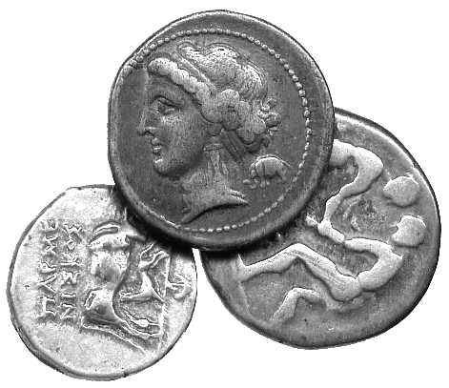  3  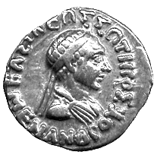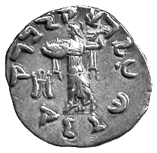  7 | 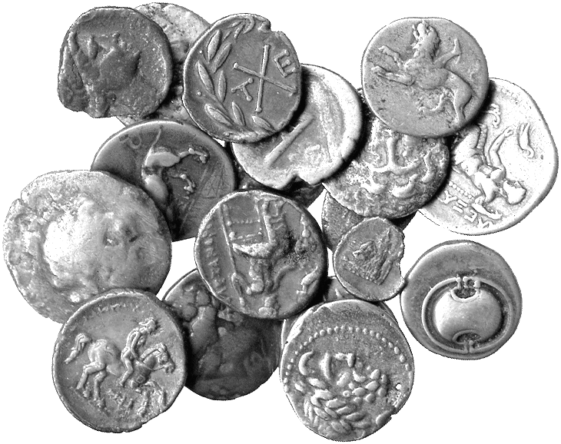  4 | 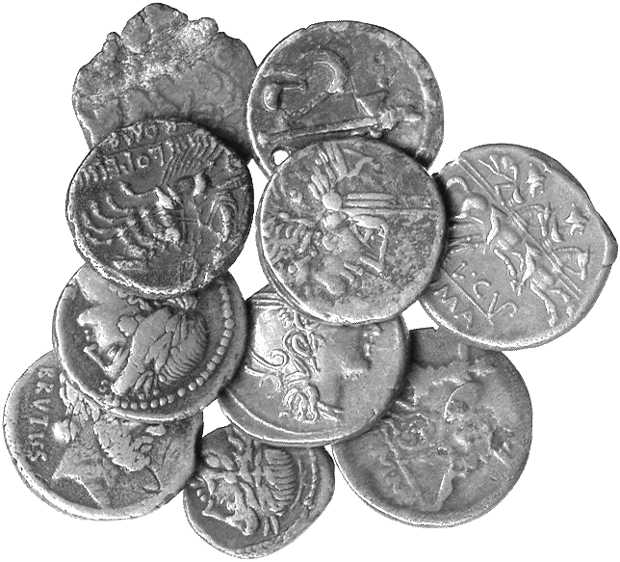  10

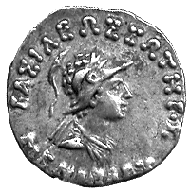8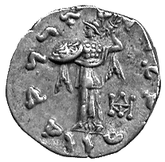 | 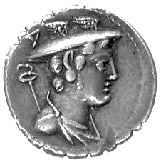12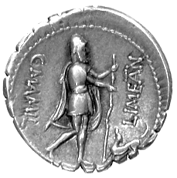 | 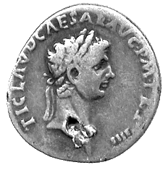15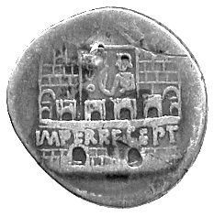 | 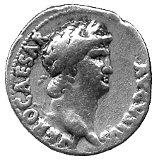18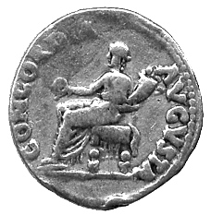

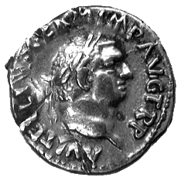19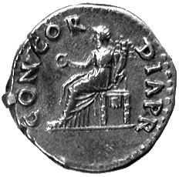 | 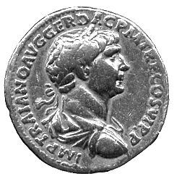22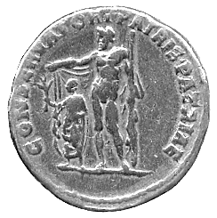 | 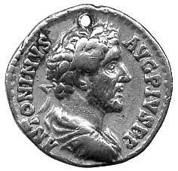23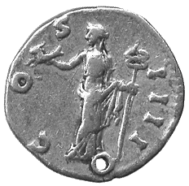 | 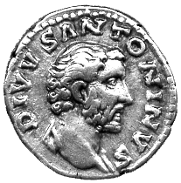24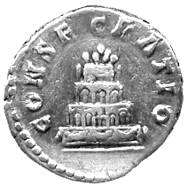

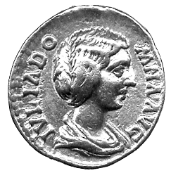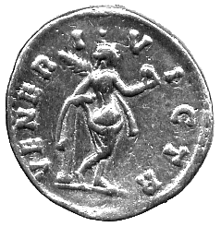  28 | 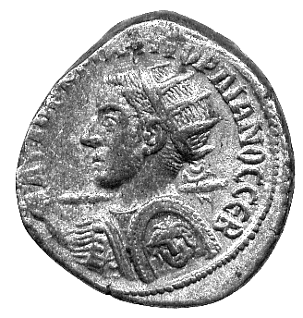30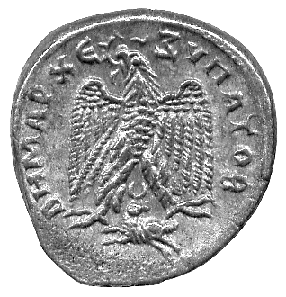 | 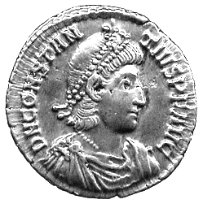36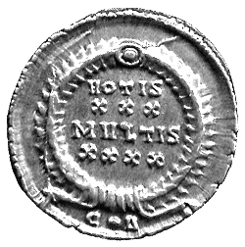 | 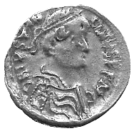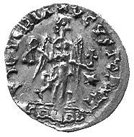  52

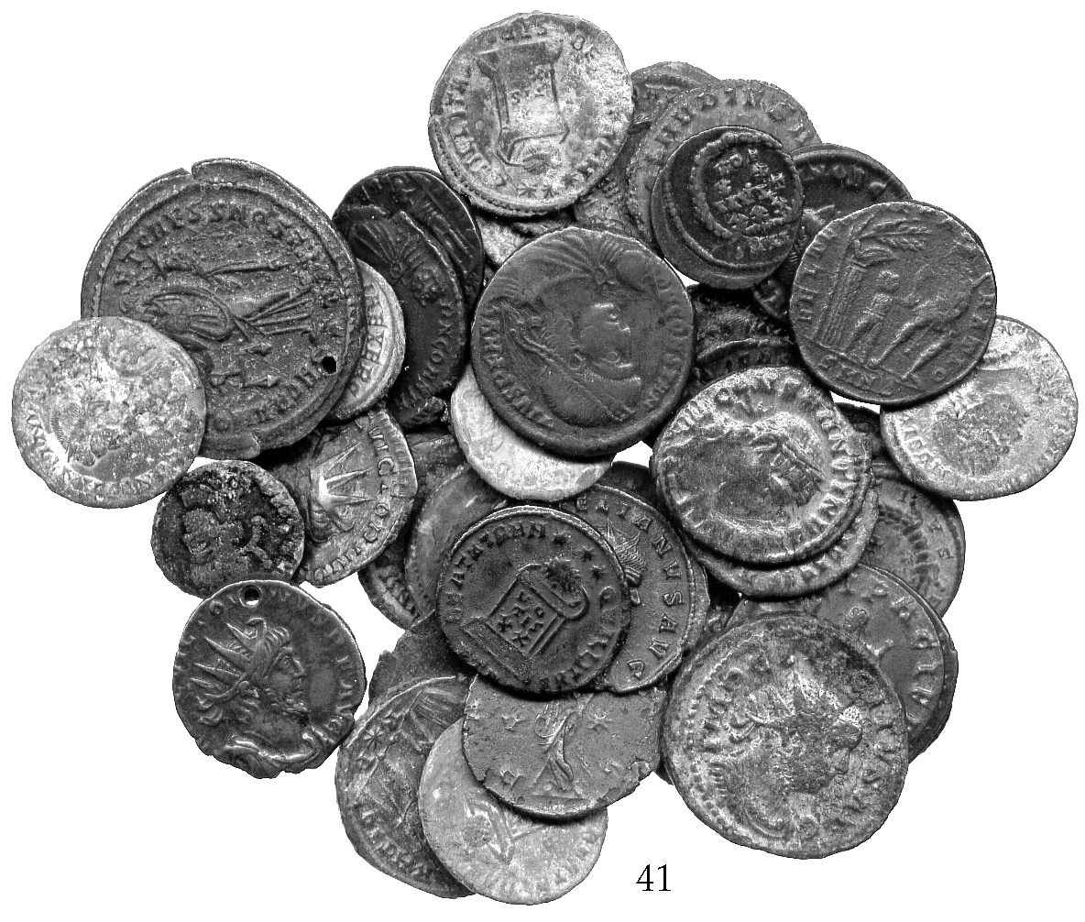 | 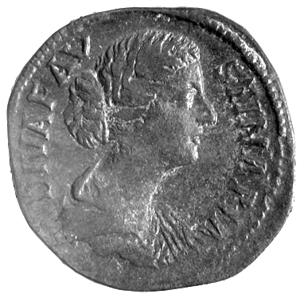26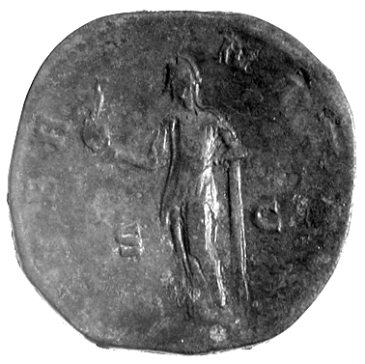  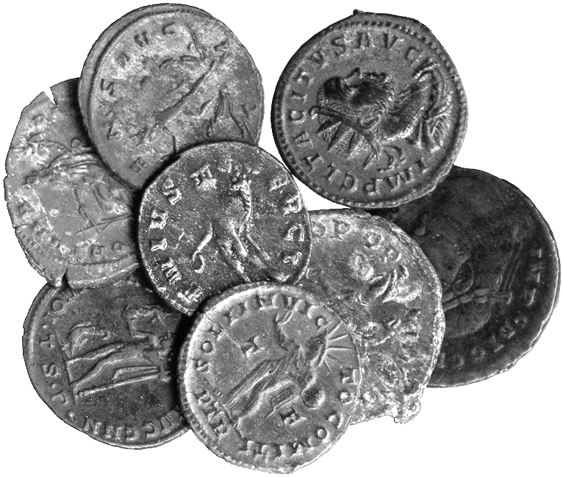  42

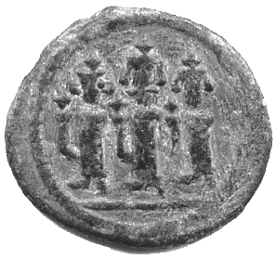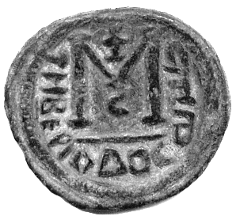  54 | 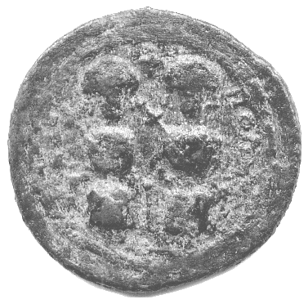55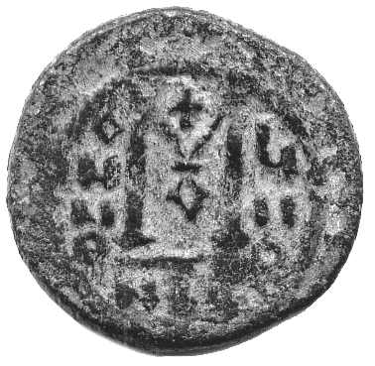 | 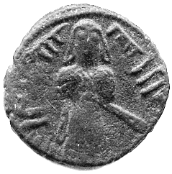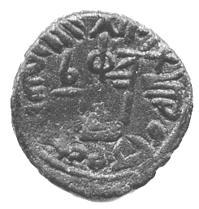  56

48* Empire of Nicea, John III (1222-1254), Hyperpyron 3.82g, Magnesia, Christ enthroned, rev John standing, being crowned by the Virgin (DOC IV pl.xxix/4d). Very fine. £100-120

49 Andronicus II and Michael IX (1295-1320), Hyperpyron, Virgin within walls of Constantinople, sigla *K-*N, rev Christ crowning emperors (DO V, 320; S 2396). Very fine. £40-60

50 Andronicus II and Andronicus III (1325-1334), Hyperpyron, Virgin within walls of city of Constantinople, sigla K-X (DO V, 502; S 2461 var). Very fine. £50-70

51 John VIII Palaeologus (1423-1448), Stavrata (4), Constantinople, bust of Christ facing, rev bust of emperor within two bands of legend (S 2564). Very fine. (4) £150-200

DARK AGE EUROPE

52* Merovingian gold Tremissis 1.49g, in the name of Justinian I, bust right, rev Victory (MEC 357 var). Rare, very fine. £220-280

ARAB BYZANTINE

53* Hims (Emesa) 4-7h, Imperial bust facing, rev follis type (SICA 540 ff). Fine. £8-12

54* Tabariyya (Tiberias) 6-9h, Follis 4.51g, three standing imperial figures, rev follis type (SICA 590-91). About very fine. £40-60

55* Baysan (Scythopolis) 6h, Follis 10.83g, depictions of Justin II and Sophia seated facing, rev follis type (SICA 594). Fair. £50-70

56* Halab (in Jund Qinnasrin) 8h, Ae Fals 2.84g, standing Caliph with long robes, hand on pommel of sword, rev transformed cross on steps, legend (SICA 612). Very fine. £20-30

57* Dimishk (in Jund Dimashq) 4h, Ae Fals 3.43g, bare headed Caliph standing facing, rev transformed cross on steps (SICA 706). Fine. £30-40

58* Dimishk (in Jund Dimashq) 4h, Ae Fals 3.43g, bare headed Caliph standing facing, rev transformed cross on steps (SICA 709). Fair. £15-25

59* Amman (in Jund Disashq) 10h, Ae Fals 2.74g, Caliph standing facing, rev transformed cross on steps (SICA 717-19). Fine. £15-25

60* Amman (in Jund Disashq) 10h, Ae Fals 2.74g, Caliph standing facing, rev transformed cross on steps (SICA 717-19). Fine. £10-15

61* Iliya (in Jund Filastin) 6-12h, Follis 2.53g, standing Caliph facing, with herringbone robe, rev follis type (SICA 730-31). About very fine, scarce. £20-30
SASANIAN

62 Silver Drachms (11). Fine to good very fine, one pierced. (11) £40-60

BRITISH COINS

Celtic
63* Iceni, Ecen (1st Century BC), silver unit, two opposed crescents, rev horse, ECE below (VA 730; Mack 424; S 443A). Obverse fair, reverse very fine. £20-30
bought C J Martin April 1980

64 Ancient British, Potin coins (2) and fragments (5), crude head, rev bull (S 63). Fine. (7) £30-40

Viking
65* Cnut, patriarchal cross, rev CVNNETI around small cross, 1.35g (N 501 var; S 993). Good very fine, lightly cleaned. £150-200

Anglo-Saxon
66* Mercia, Burgred (852-874), Penny, type D, bust right, rev moneyer’s name Osmund between two lines, 1.22g (N 426; S 941). Very fine, lightly cleaned, small edge crack at 6 o’clock. £150-200

Henry I (1100-1135)
67* Penny, Type XV, London, moneyer EDGAR (S 1276). Fine, large flan, some ghosting. £130-160

Henry II (1154-1180)

68* Penny, short cross, class 1b, London, Fil Aimer (N 963; S 1344). Very fine or nearly so. £80-100

Edward I (1272-1307)
69 Penny, London, fine, lightly cleaned, small edge chip 5 o’clock; Antoninianus of Philip I, rev Felicitas standing, very fine. (2) £25-35

Edward III (1327-1377)
70* Quarter-Noble, fourth coinage, Pre-Treaty period, French titles, Series G, pellet below shield, annulet stops (S 1498). Very fine or better. £300-350

Henry VI (1422-1460)
71* Penny, probably rosette-mascle issue, mullets by crown (S 1868); Edward IV, Penny, Durham, DV by neck (S 2133). Fine but irregular and short of flan as usual, second clipped. (2) £40-60

Edward IV, first reign (1461-1470)
72* Groat, light coinage, Norwich mint, mm sun (S 2011). Plugged, about very fine, rare. £60-80
ex J J North collection

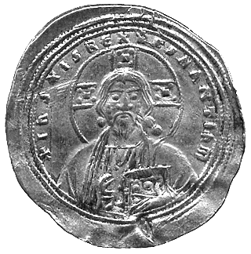47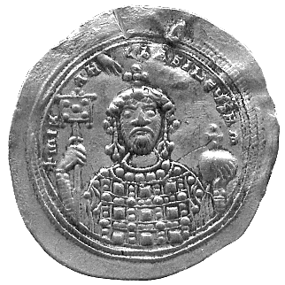 | 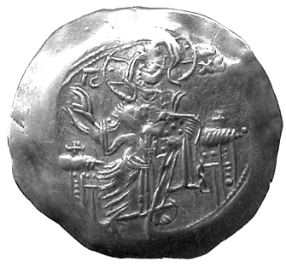48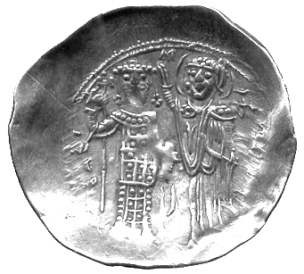 | 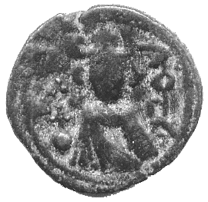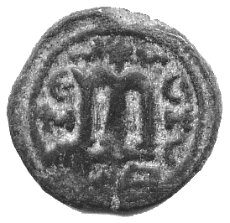  53

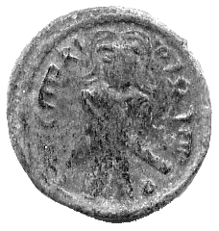57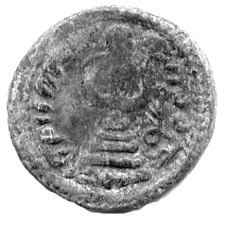 | 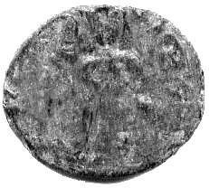58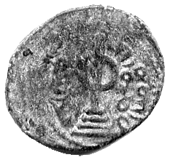 | 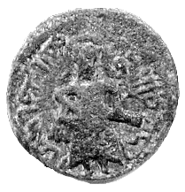59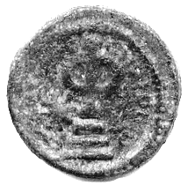 | 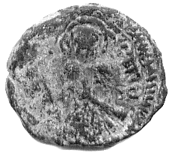60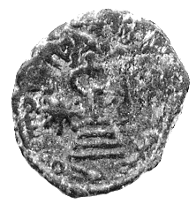

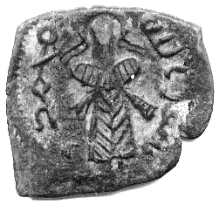61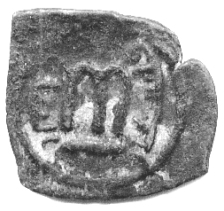 | 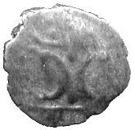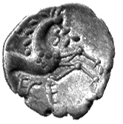  63 | 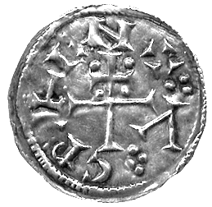65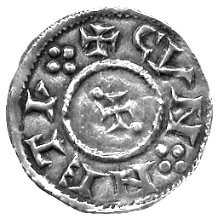 | 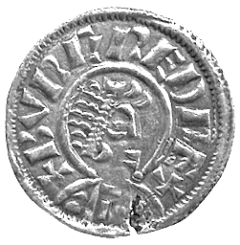66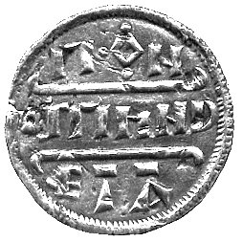

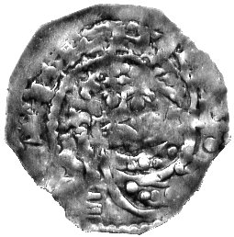67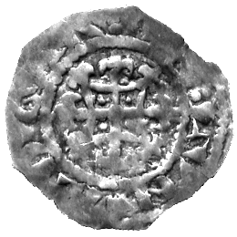 | 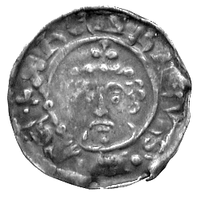68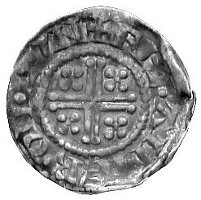 | 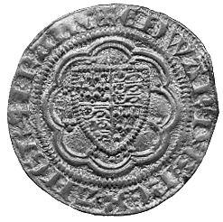70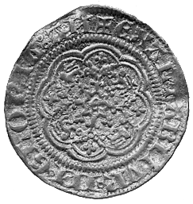 | 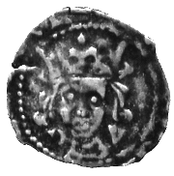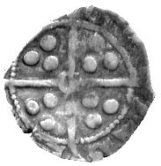  71

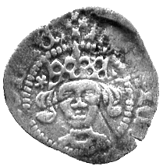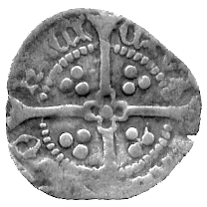  71 | 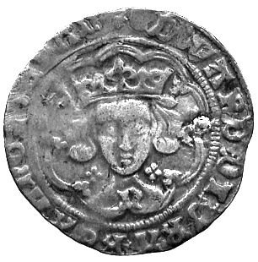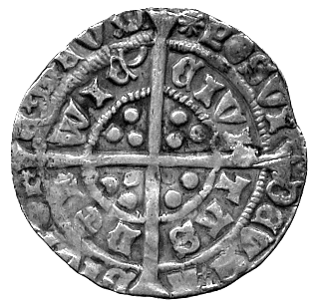  72 | 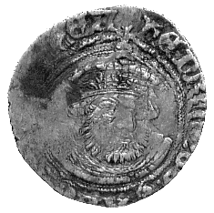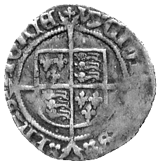  73 | 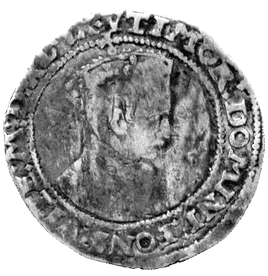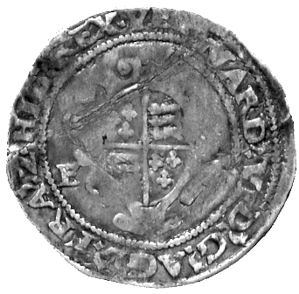  74

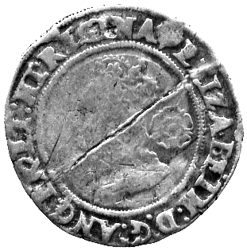75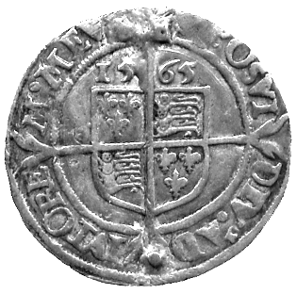 | 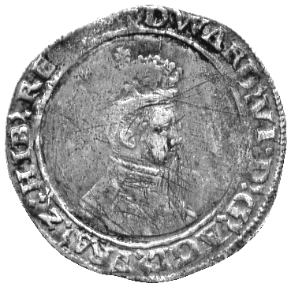75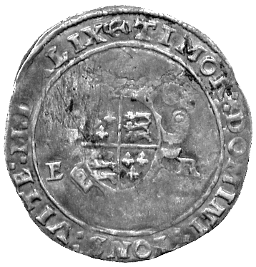 | 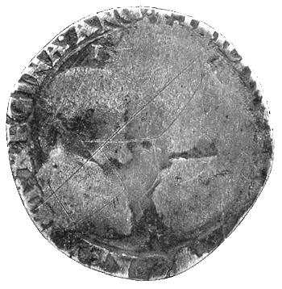76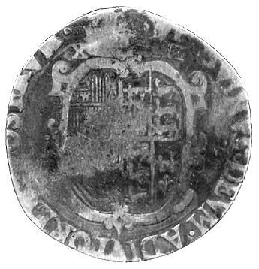

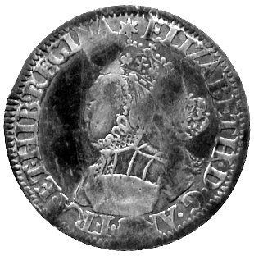77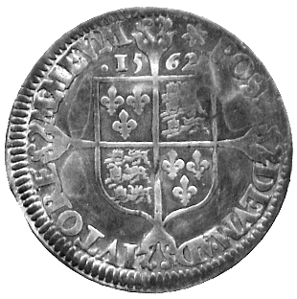 | 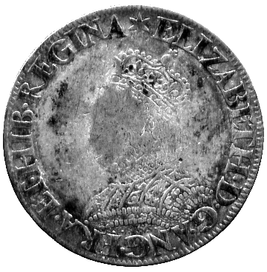77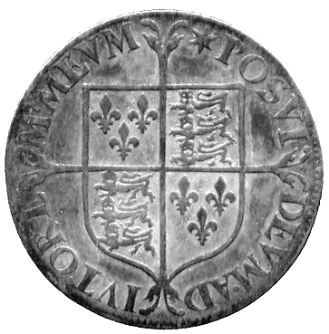 | 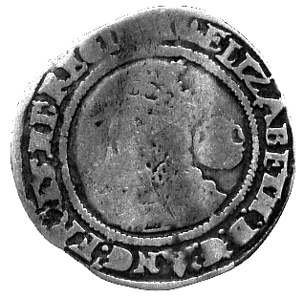78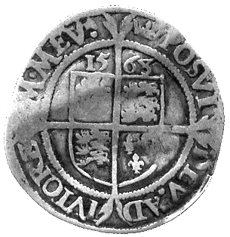

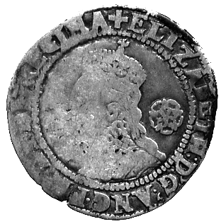79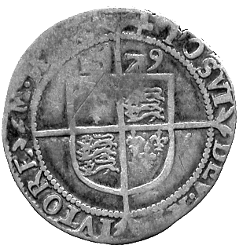 | 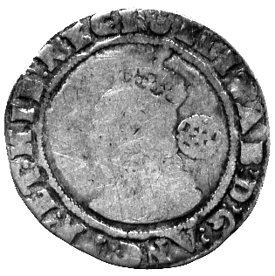80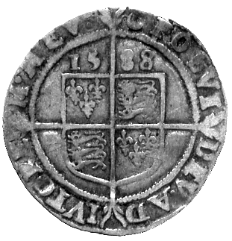 | 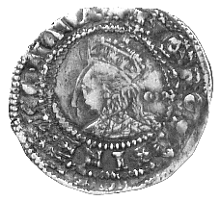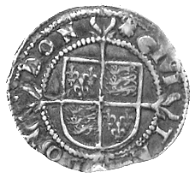  81 | 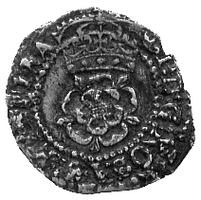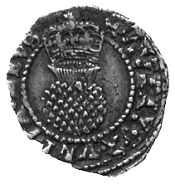  82

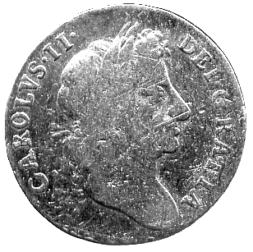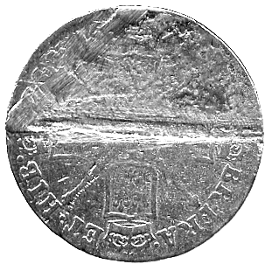  87 | 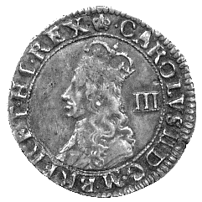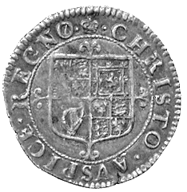  88 | 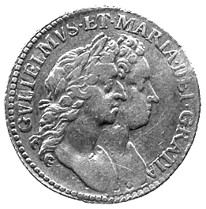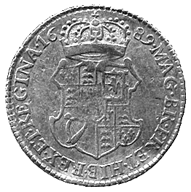  90 | 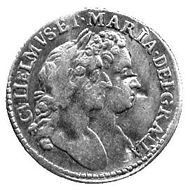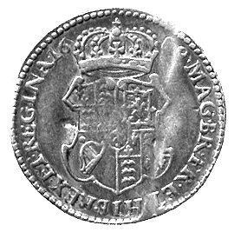  91

Henry VIII (1509-1547)
73* Halfgroat, Bristol, mm WS monogram (S 2377). Fine. £30-40

Edward VI (1547-1553)
74* Shilling, dated MDXLIX, first bust, Southwark, mm y (S 2465A). Fine, a couple of crease marks, rare. £100-150

75* Second period, Tower Shilling, second bust, mm grapple, dated MDXLIX (S 2466), fine, but surface scratches; Elizabeth I, Sixpence 1565, mm rose over pheon/rose (S 2561), fine, but obverse crack in flan, scarce. £80-100

Philip and Mary (1554-1558)
76* Shilling, facing busts, rev shield (S 2498ff). Good. £30-40

Elizabeth I (1558-1603)
77* Milled Shilling, small size (S 2592), Sixpence 1562, plain dress (S 2594). Fine, weak face, the sixpence with weak areas. (2) £100-130

78* Sixpence 1563, mm coronet (S 2562). Crimpled flan, fine, reverse better. £25-35

79* Sixpence 1579, mm cross 7 (S 2572). Fine, profile flat. £30-40

80* Sixpence 1588, mm crescent (S 2578A). Poor/ fine, worn obverse but full round with clear date and marks, nearly always a poor issue, rare. £60-80
struck in the year of the Armada

81* Halfgroat 1584-1586, pellets behind head, mm scallop (S 2579). Some double-striking, fine. £30-40

James I (1603-1625)
82* Halfgroat 1607-1609, mm coronet (S 2660). About very fine. £25-35

Charles I (1625-1649)
83* Parliament Halfcrown, 3a³, mm (P) (S 2840). Nearly very fine but edge splits and cracks at 8 to 10 o’clock. £100-120

84 Shilling (2), 1632, mm harp (S 2785). First good fine, second some corrosion, about fine. (2) £70-90

85* Shilling 1645-1646, mm sun (S 2843). Crude, deep scratches on reverse, fine. £20-30

86* Halfgroat 1625-1626, mm cross calvary (S 2806). Fine. £20-30

Charles II (1660-1685)
87* Guinea, date illegible due to severe scrape on reverse, second laureate bust, 8.06g. Fair, reverse poor. £150-200
88* Hammered Threepence 1660-1662, mm crown (S 3325). Toned, about very fine. £40-50

James II (1685-1688)
89* Guinea, 1685, mounted, with scrolled wire and ring through loop, 9.27g. Fine, the reverse better. £200-250

Willam and Mary (1689-1694)
90* Half-Guinea 1689 (S 3429). Slightly buckled, fine. £250-300

91* Half-Guinea 1689, top of 9 punch broken (S 3429). Slightly buckled, flats on reverse, fine. £200-250

Anne (1702-1714)
92 Guineas (2), 1707, 1714, the first with solder damage from mounting at top of bust, the other pierced above bust, 16.48g. First fair, the second good fine. (2) £120-140

93* Guinea, 1714, mounted, with looped wire scroll, 8.56g. Fine. £80-100

George I (1714-1727)
94 Guineas (2), 1719, 1726, one mounted, with loop and ring, the other mount removed at top, 16.64g.. Fair and about fine. (2) £100-120

95* Guinea 1720, fourth laureate head (S 3631). Good very fine. £1400-1800

96 Guineas (2), 1733, 1748, both with suspension mounts, 16.6g. First fair, the other better. (2) £100-120

97* Half-Guinea 1727, second laureate head (S 3636). Good very fine. £600-800

98 Halfpennies (10), various dates. Fair to fine. (10) £60-80

George II (1727-1760)
99* Two-Guineas, 1735, mounted, with twisted wire loop, 16.76g. Fair, gilt. £100-120

100* Two-Guineas, 1739, mounted, with ring, 16.52g. Good fine, reverse better, gilt. £100-120

101* Two-Guineas, 1739, pierced, 16.10g. Both fair and gilt. £100-120

102* Halfcrown 1746, regnal year Decimo Nono (S 3695A). Good very fine, reverse better. £120-150

George III (1760-1820)
103 Guinea, 1773, loop mount, 8.58g. Fine, reverse better, gilt. £60-80

104 Spade Guineas (3), 1791, 1793, 1794, all with mounts, the first two elaborate, the last a loop, 25.19g. Fair, the last better but gilt. (3) £140-180

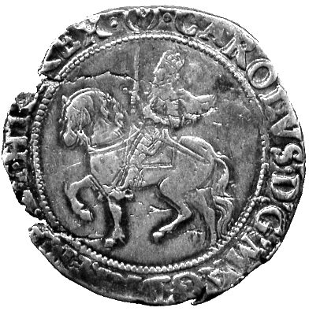83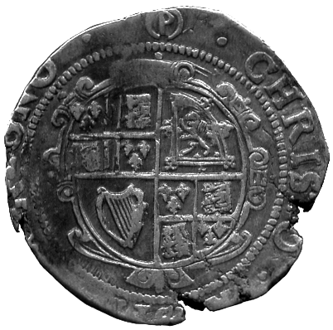 | 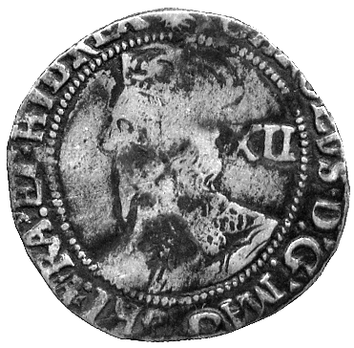85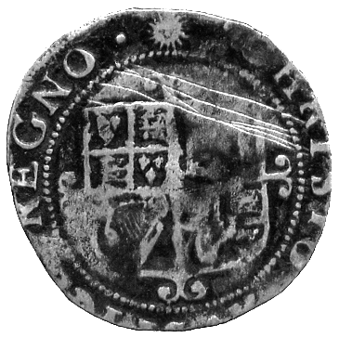 | 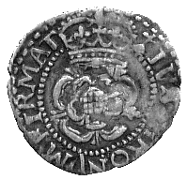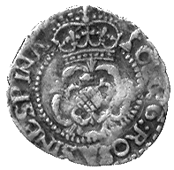  86

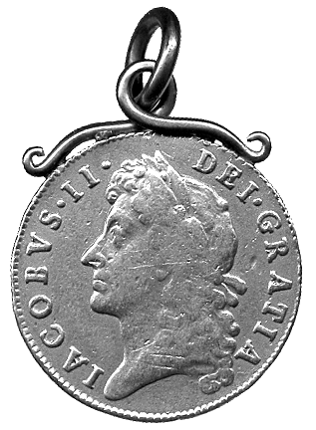89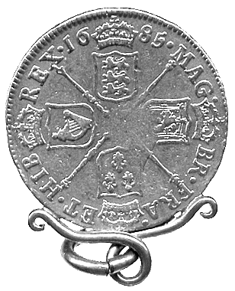 | 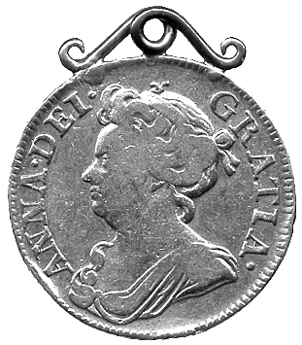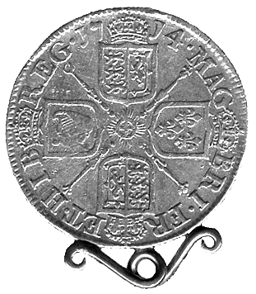  93 | 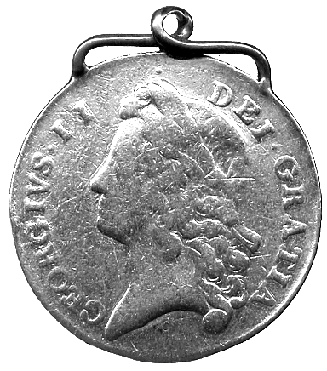99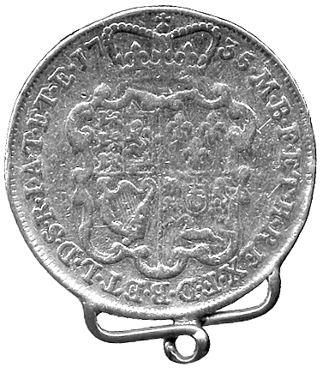

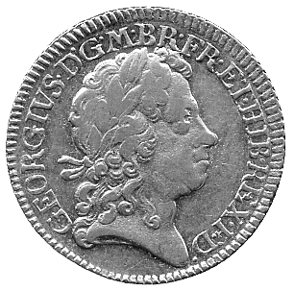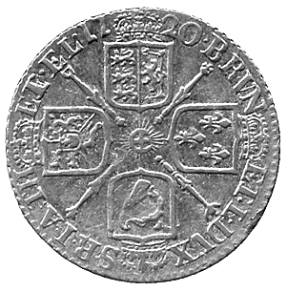  95 | 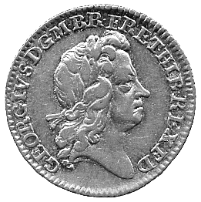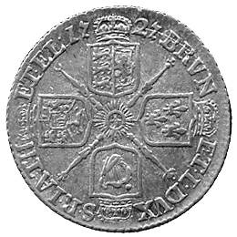  97 | 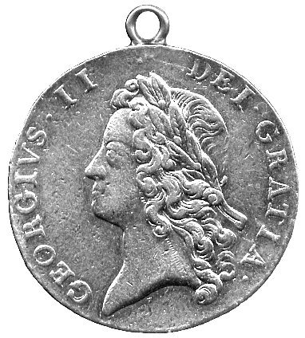100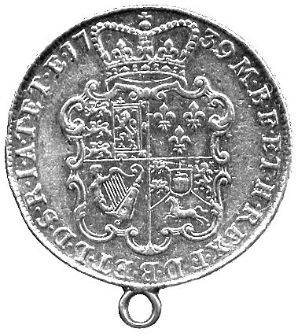

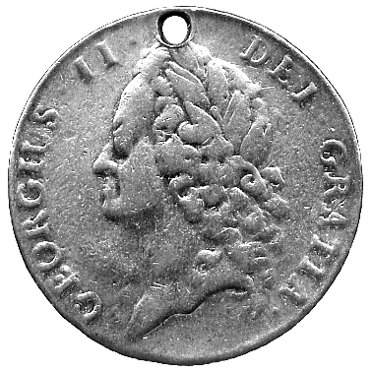101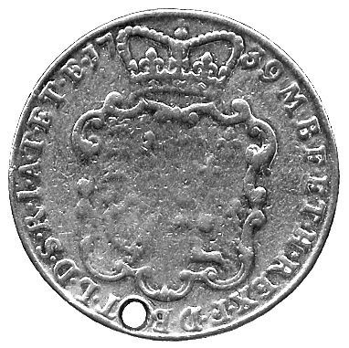 | 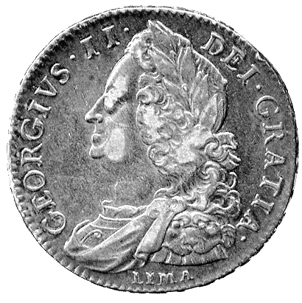102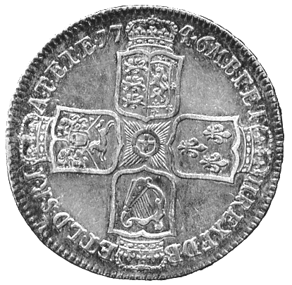 | 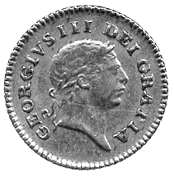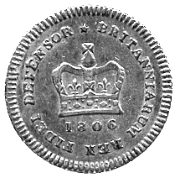  111

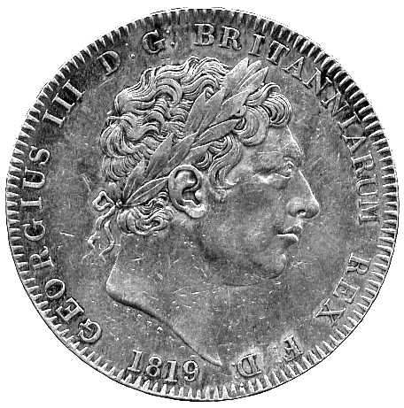114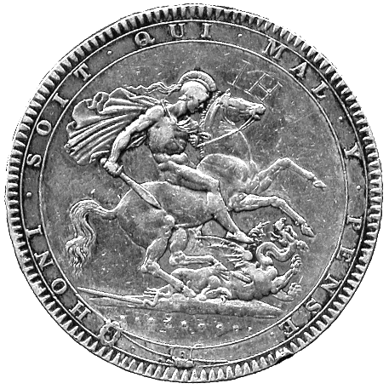 | 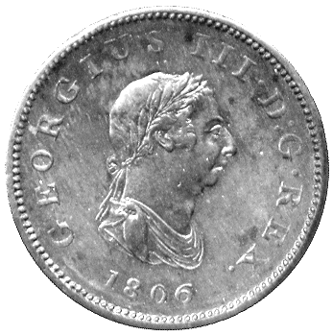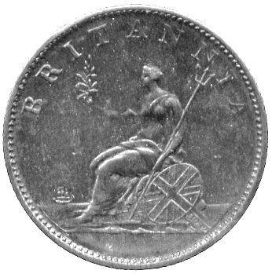  117 | 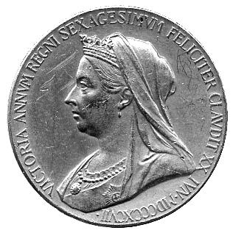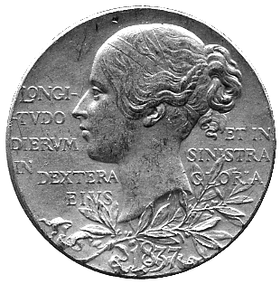  120

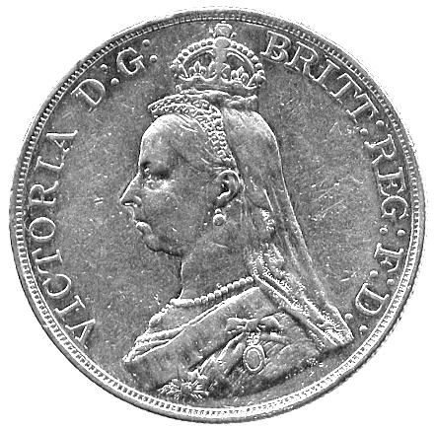121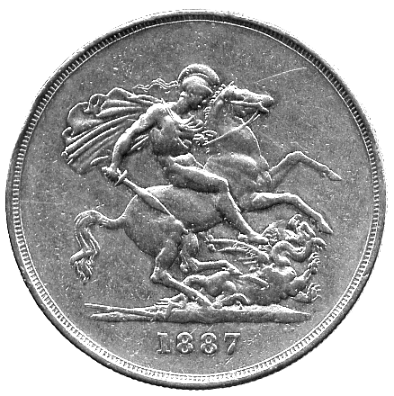 | 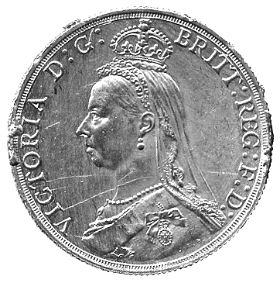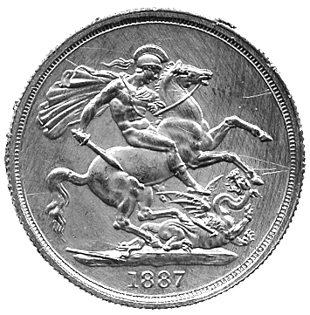  122 | 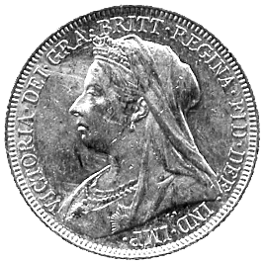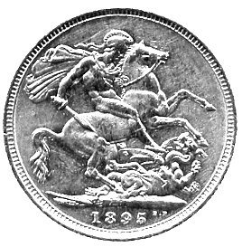  123

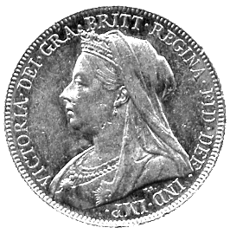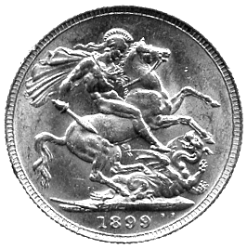  124 | 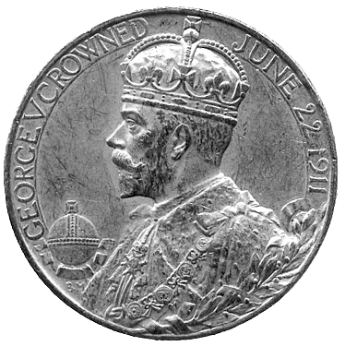128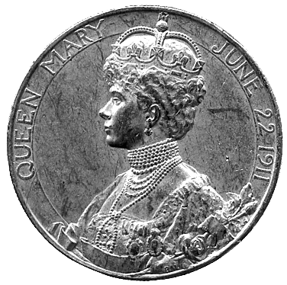 | 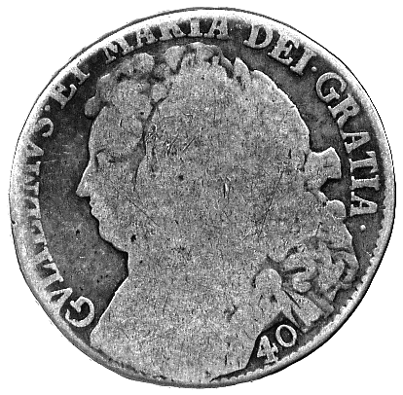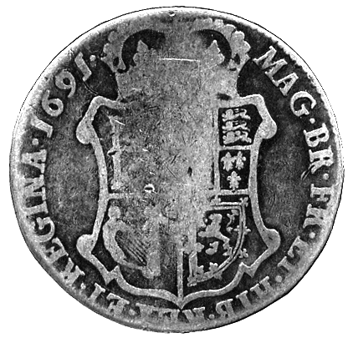  140

105 Spade Guineas (3), 1792 and two with dates illegible, all with loop mounts, 24.80g. The first about very fine, others fair. (3) £140-180

106 Spade Guineas (3), 1787, 1794 and one with date illegible, first and last pierced, second with mount removed, 24.36g. Fair to fine. (3) £140-180

107 Spade Guineas (3), 1787, 1793, 1794, the first damaged on edge, last two mounted, with decorative scrolls, 26.34g. Fine or better but gilt. (3) £140-180

108 Spade Guineas (3), 1777, 1791, 1793, first and last mounted, second pierced, with rings, 26.75g. Fine. (3) £140-180

109 Spade Guineas, 1791, 1792, 1793, all with traces of mounting, 25.00g. About very fine, the last polished. (3) £140-180

110 Spade Half-Guineas (3), 1791, 1794, 1796, first and last with suspension loops, the second bent twice for luck and Garter Half-Guineas 1804 (2), both mounted with loops, 20.93g. Fair to fine or better. (5) £130-150

111* Third-Guinea, 1806 (S 3740). Lightly scratched on obverse, very fine. £60-80

112 Sovereigns (4), 1817 (2), 1820 (2) and a George IV sovereign, 1830, 38.81g. First four pierced, last with traces of mount and piercings in edge, fine or better. (5) £350-400

113 Sovereign, 1820, small date variety, 7.76g. Mount removed at top, fair, reverse better. £80-100

114* Crown 1819 LIX (S 3787). Good very fine, reverse IH graffito by horse’s head. £80-120

115 Halfcrowns (2), 1816, 1819 (S 3788, 3789). Good very fine, the second cleaned. (2) £50-80

116 Halfcrown 1817, ‘bullhead’ bust (S 3788). Good fine. £20-25

117* Halfpenny 1806, three berry type (S 3781). Almost extremely fine, scrape along eye-line on obverse. £15-25

George IV (1820-1830)
118 Two-Pounds, 1823, pierced above St George, 15.94g. Very fine, reverse better. £140-180

119 Half-Sovereigns (2), 1825, 7.75g. Traces of mounting, fair or better. (2) £40-60

Victoria (1837-1901)
120* Gold Diamond Jubilee Medal, 1837-1897, 25mm, 12.79g. A little scuffed, otherwise very fine. £100-120
121* Five-Pounds 1887. Mount removed from edge, several edge knocks, obverse good fine, reverse better, gilt. £300-350

122* Two-Pounds 1887, 15.49g. Mount removed and with surface scratches from brushing, otherwise very fine. £100-120

123* Sovereign 1895M, old head (S 3875). Extremely fine. £60-70

124* Sovereign 1899, old head (S 3874). Extremely fine. £60-70

125 Sovereigns (2) and Half-Sovereigns (5), various busts, all with loops or traces of mounts, 37.24g. Fine and better, some gilt. (7) £220-260

126 Florin 1849, “Godless” type (S 3890); George III, Crown 1819LX (S 3787). About very fine and fair. (2) £40-60

127 Model Crown 1848, plated to represent gold centre within silver annulus, central plating worn otherwise almost extremely fine, scarce, and a Shilling 1816, good fine. (2) £30-50

Edward VII (1901-1910)
128* Edward VII and Queen Alexandra, gold Coronation medal, 1911, 30mm, 16.30g. Light scuffs and scratches, otherwise very fine. £120-140

129 Two-Pounds 1902, 15.93g. Mount removed and with surface scratches from brushing, otherwise very fine, gilt. £100-120

130 Half-Sovereign 1906, with suspension loop, 4.23g. About very fine. £25-35

131 Maundy Set 1903, in modern case, proof Crowns (2), 1951, in card cases of issue, other UK coins, Victoria to Elizabeth II, in silver and CuNi (88). Fine or better. (94) £30-40

George V (1910-1936)
132 Sovereign 1914 (S 3996), Soho Twopence 1797 (S 3776). First extremely fine, Twopence fine. (2) £70-90

133 Sovereigns (3), 1914, 1915, 1918, 23.62g. All with traces of mounting, otherwise second fine, the others very fine. (3) £120-140

134 Proof Set, 1927, Crown to Threepence (S PS14). All coins harshly polished, in contemporary case. (6) £150-200

George VI (1936-1952)
135 Halfcrowns (15), 1937 (2), 1941, 1942 (6), 1944 (3), 1945 (2), 1950; and Florins (15), 1937 (4), 1939, 1940, 1941, 1943 (2), 1944 (3), 1945, 1946 (2). Good extremely fine to uncirculated, some bagmarks and a few Florins toned on one side. (30) £50-80
Elizabeth II (1952- )
136 Proof Two-Pounds 1983 (S 4203). About as struck. £130-160

137* Sovereign 1978 (S 4204). Almost as struck. £55-65

138 Silver proof Pound Set 1984-1987, in Royal Mint case of issue. As issued. (4) £40-50

139 United Kingdom, proof Sets (11), 1970, 1971 (3), 1972, 1973, 1974, 1975, 1976, 1983. In plastic holders and boxed, as issued. (11) £40-60

SCOTLAND

140* William and Mary (1689-1694), 40-Shillings, 1691 TERTIO (S 5649). Only fair but rare. £30-40

IRELAND

141 Irish Hammered Coinage (4), Prince John, small module Halfpenny (S 6205-6215), fine; Henry VIII, Groat (2), second harp issue (S 6479A), about fine, posthumous portrait issue (S 6488), fine; James I, Shilling 1604-1607, mm rose (S 6516), about fine. (4) £100-120

ISLE OF MAN

142 James Stanley, second issue, Halfpenny 1733, plain inside of cap (S 7409), good fine; George III, first issue, Penny 1786 (S 7413), fine, Halfpennies (2), 1786 (S 7414), good fine and almost extremely fine, last with central plug; 19th Century Tokens (4), Bank Penny, Halfpenny 1811, Pro Bono Publico Halfpenny 1831, Castletown, John Caine 1830, fine to very fine. (8) £40-60

143 Elizabeth II (1952- ), Silver Jubilee 1977, Jubilee Appeal set of Crowns (3, 2 in silver), in case of issue, other Cu-Ni commemorative Crowns 1983 (4). As struck. (7) £10-15

CHANNEL ISLES

Jersey
144 States of Jersey, Three-Shillings Token 1813, arms of Jersey, rev value within wreath (McC J1; Pr 1), very fine, and a silvered copper striking of an Eighteenpence Token 1813, fine. (2) £50-70

145 Victoria, copper 1/13-Shilling (4), 1844, 1851 (2), one extremely fine, 1861 (S 7001). Fine to very fine, except as stated. (4) £50-70

146 Victoria, copper 1/26-Shilling (14), 1841 (2), 1844 (3), 1851 (3), 1858 (3), 1861 (3) (S 7002). A few extremely fine or nearly so with traces of lustre, others generally fine to very fine, one pierced. (14) £100-150
147 Victoria, bronze 1/13-Shillings (8), 1866, 1870 (2), 1871 (5) (S 7004). Fine to good very fine, a few with traces of lustre. (8) £25-35

148 Victoria, bronze 1/26-Shillings (10), 1866 (5), 1870 (3), 1871 (2) (S 7005). Mostly good very fine and better, some with original lustre. (10) £60-80

149 Victoria, bronze 1/12-Shillings (11), 1877H, 1881 (3), 1888 (4), 1894 (3) (S 7006). Generally good very fine to extremely fine, some better with much original lustre. (11) £80-100

150 Victoria, bronze 1/24-Shillings (10), 1877H (3), 1888 (2), 1894 (5) (S 7007). Generally extremely fine or better, several with much original lustre. (10) £70-90

151 Edward VII to Elizabeth II, bronze 1/12-Shillings (37), 1909 (2) (S 7009), 1911 (6), 1913 (3), 1923 (5) (S 7011), second issue 1923 (2) (S 7013), third issue 1931 (2), 1933, 1935 (S 7015), first issue 1937 (2), 1946, 1947 (S 7017), second ‘liberation’ issue (2) (S 7019), ‘liberation’ issue (S 7023) 1957 (2), 1964 (S 7024), 1960 (2) (S 7025), 1966 (2) (S 7026). Generally good very fine to extremely fine, later issues better with almost full lustre. (37) £100-150

152 Edward VII to George VI, bronze 1/24-Shillings (15), 1909 (2) (S 7010), first issue 1911, 1913, 1923 (S 7012), second issue 1923 (2), 1926 (S 7014), third issue 1931, 1933, 1935 (S 7016), 1937, 1946, 1947 (2) (S 7018), good very fine to good extremely fine or better, many with original lustre; Elizabeth II, ¼-Shillings (6), round issue 1957 (2) (S 7021), dodecagonal issue 1964 (2) (S 7021A), 1966 commemorative (2) (S 7022), as issued. (21) £60-80

Guernsey
153 William IV, copper 8-Doubles (7), 1834 (S 7200). Generally good very fine. (7) £80-120

154 William IV, copper 4-Doubles (3), 1830 (S 7201). One extremely fine, others very fine. (3) £30-40

155 William IV, copper 1-Double (11), 1830, one with stop before date (S 7202). Fine to very fine. (11) £30-40

156 Victoria, copper 8-Doubles (3), 1858, one the four berry variety (S 7203), 4-Doubles 1858 (S 7204). Very fine and better. (4) £60-80

157 Victoria, bronze 8-Doubles (13), 1864 (11), both one and three stalk varieties, mostly fine to very fine, some better, one extremely fine with lustre, 1868 (2) (S 7206), very fine. (13) £100-120

158* Victoria, bronze 8-Doubles 1868 (S 7206). Extremely fine with almost full lustre. £50-70

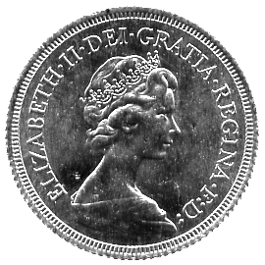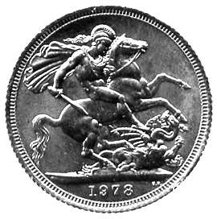  137 | 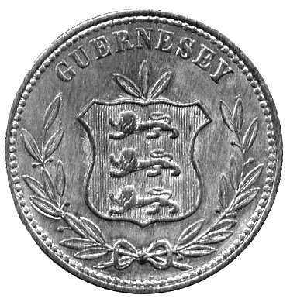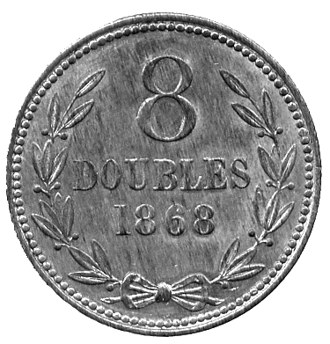  158 | 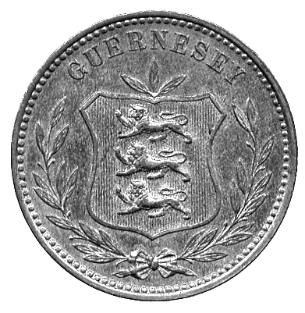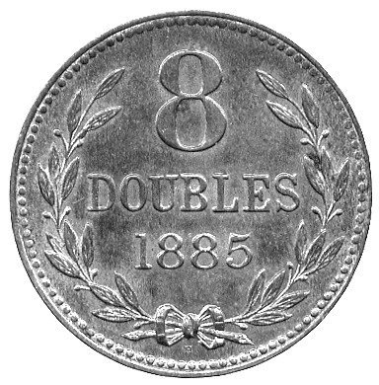  160

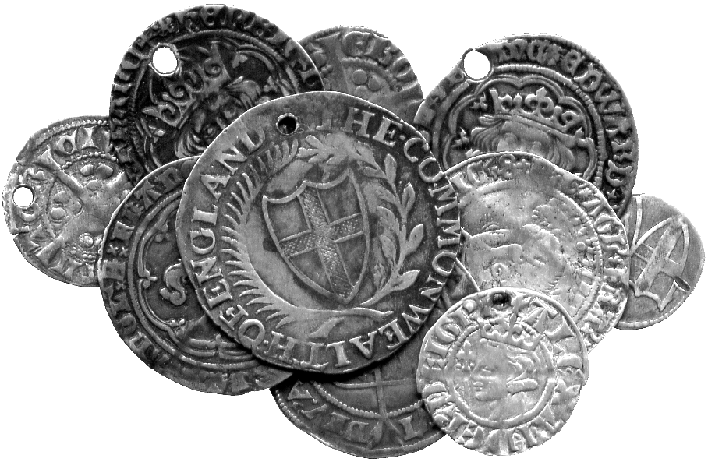  171 | 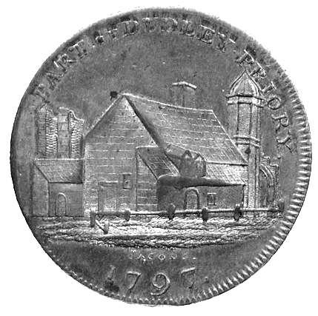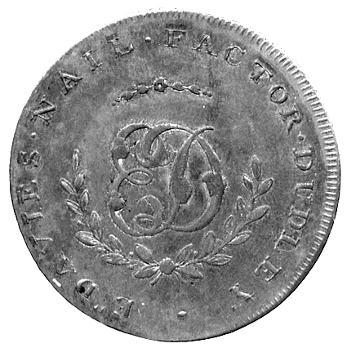  190

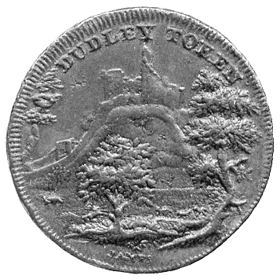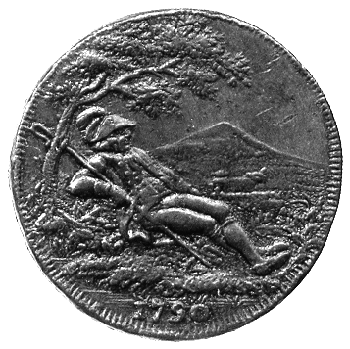  191 | 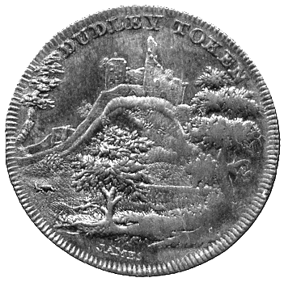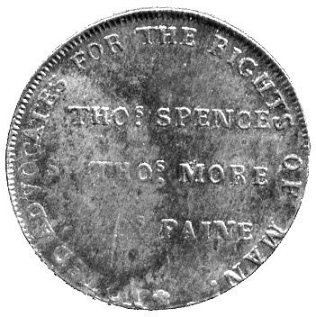  192 | 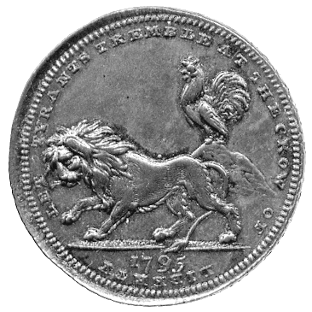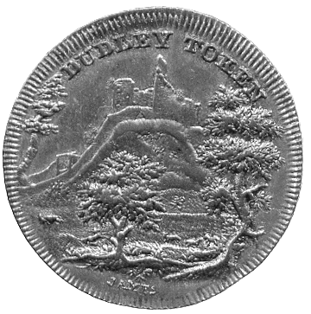  193

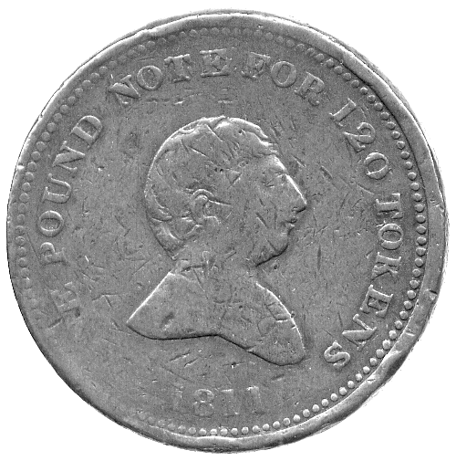194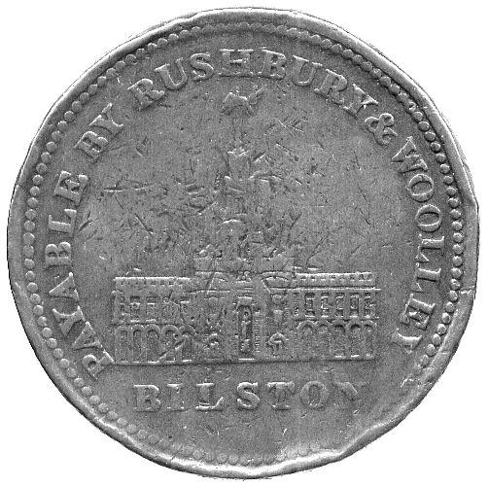 | 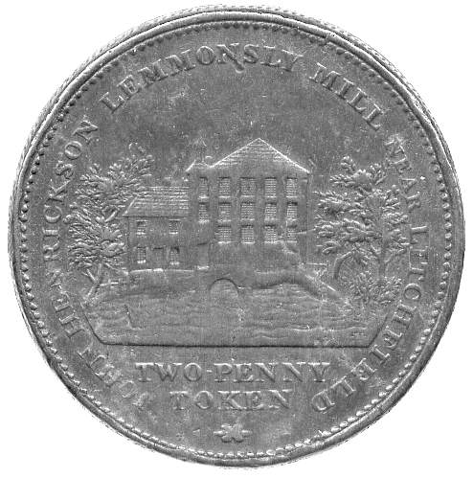199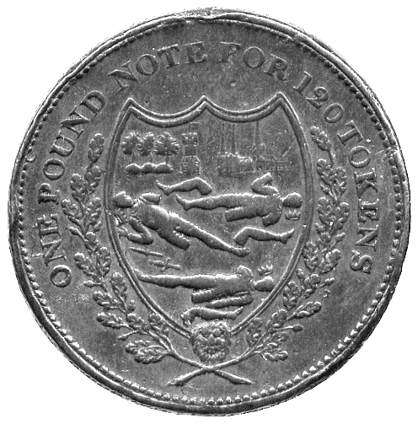

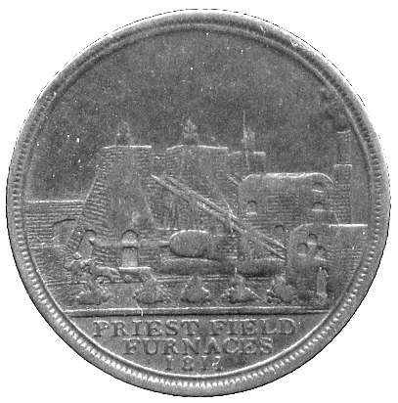196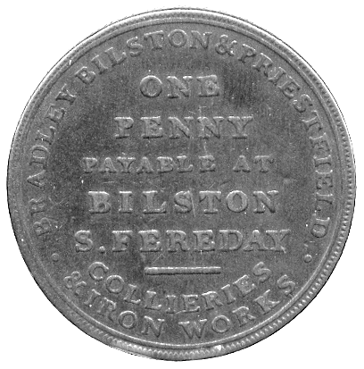 | 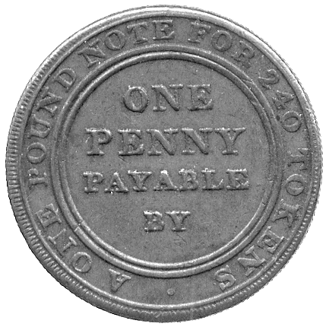197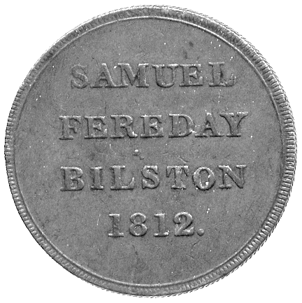 | 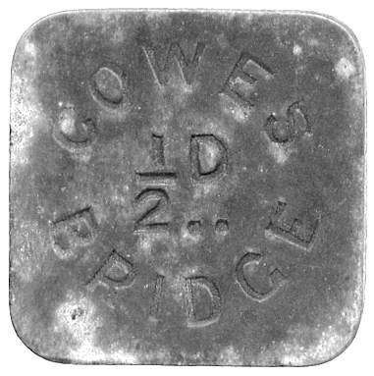  205

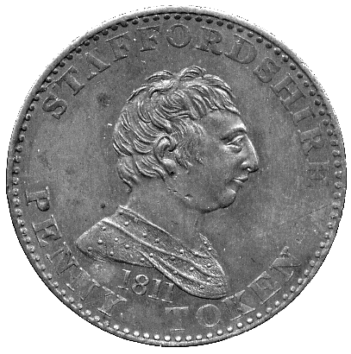202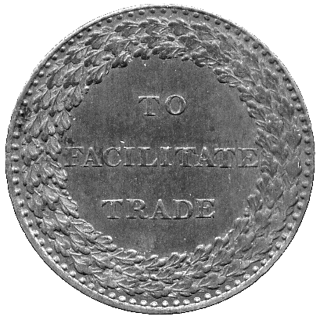 | 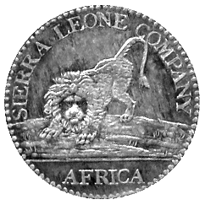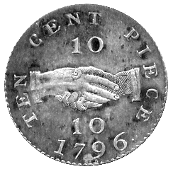  213 | 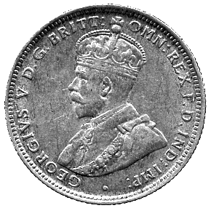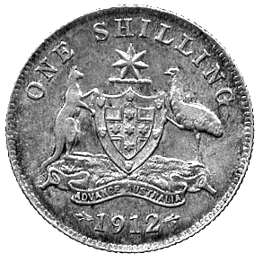  217

159 Victoria, bronze 8-Doubles (3), 1874 (S 7206). One uncirculated with almost full lustre, others very fine or thereabouts. (3) £50-70

160* Victoria, bronze 8-Doubles 1885H (S 7206). Uncirculated and with almost full lustre. £30-50

161 Victoria, bronze 8-Doubles (5), 1889H (S 7206). Three uncirculated and with almost full lustre, others very fine and extremely fine. (5) £70-90

162 Victoria, bronze 8-Doubles (4), 1893H (S 7206). Three uncirculated and with almost full lustre, one extremely fine. (4) £50-70

163 Victoria, bronze 4-Doubles (11), 1864 (9), three and one stalk varieties, 1868 (2) (S 7207). Mostly fine to very fine, a few better. (11) £60-80

164 Victoria, bronze 4-Doubles (10), 1874, 1885H, 1889H (6), 1893 (2) (S 7202). Varied state but many extremely fine with much original lustre. (10) £70-90

165 Victoria, bronze 2-Doubles (2), 1868, both varieties (S 7208). Extremely fine with original lustre, rare. (2) £100-150

166 Victoria, bronze 2-Doubles (2), 1868, both varieties (S 7208), fine and very fine, rare; bronze Doubles (2), 1868, both varieties (S 7209), good fine and good very fine, scarce. (4) £40-60

167 Victoria, bronze 2-Doubles (9), 1874 (2), wide and narrow dates, 1885H (2), 1889H (5) (S 7208), generally very fine to extremely fine, some better; bronze 1-Double (11), 1885H, 1889H (5), 1893H (3), 1899H (2) (S 7209), generally uncirculated to fleur de coin. (20) £50-70

168 Edward VII, bronze 8-Doubles (8), 1902H (5), 1903H (2), 1910H (S 7210), fine to very fine, bronze 4-Doubles (5), 1902H, 1903H (2), 1906H, 1910H (S 7211), uncirculated and with almost full lustre, other bronze 4-Doubles (4), 1902H (2), 1906H, 1908H (S 7211), very fine to extremely fine. (17) £50-70

169 Edward VII, bronze 2-Doubles (6), 1902H (2), 1903H, 1906H (2), 1908H (S 7212), 1-Double (4), 1902 (2), 1903 (2) (S 7213). Mostly uncirculated with almost full lustre. (10) £120-150

170 George V, bronze 8-Doubles (12), 1911H (2) (S 7214), 1914H, 1918H (3), 1920H (4), 1934H (2) (S 7214A), 4-Doubles 1920H (S 7215A), 2-Doubles 1918H (S 7216A); George VI and Elizabeth II, 10-Shillings (2), 1966 (S 7223), Threepence (3), 1956 (2), 1959 (S 7221), 8-Doubles (9), 1938H (2), 1945H, 1947H (2), 1949H (S 7218), 1956, 1959 (2) (S 7225), 4-Doubles (5), 1945H, 1949H (2) (S 7219), 1956 (2) (S 7226), 1-Double (3), 1938 (S 7220). Mostly good very fine to extremely fine and better, some with original lustre. (36) £60-80
MISCELLANEOUS

171* English hammered coins (10), including Common-wealth Shilling, Groats of Edward III, Edward IV, Henry VII, all pierced but interesting. Fine to very fine. (10) £80-100

172 Charles II to Victoria, Shillings (17), all different. Fair to very fine. (17) £100-130

173 William III to Edward VII, Sixpences (14), other minor silver (8). Fine to very fine, some pierced. (22) £60-80

174 Charles II to George IV, Maundy oddments (26). Fine to very fine, some pierced. (26) £80-100

175 17th - 20th Century, milled silver, including Sixpence 1696, good fine, Shilling 1723 SSC, almost very fine but portrait worn, Crowns 1935 (2), extremely fine, other British and foreign coins, including Crown-size silver (4), a small quantity of hammered coinage and some Roman. Varied state. (lot) £200-250

176 Copper and bronze coins (51), George II to George V. Fine to very fine. (51) £80-100

177 Victoria to Elizabeth II, bronze Pennies (45), many different dates, fair to fine, some better; Halfpennies 1860, 1917, very fine, 1967 (7), generally extremely fine. (54) £20-30

178 Silver Proof Crowns (2), 1977, silver jubilee commemorative (S 4227), Silver Proof 1-Pound, 1983 (S 4221), Proof Sets (4), 1970 (2), 1981, 1982 (S PS20, PS31, PS32), Currency Sets (7), 1953 (4), 1966/67, 1968/71 (2), Commemorative Crowns (12), other coins (4). Mostly uncirculated. (lot) £80-100

179 Assorted British and world coins in silver and base metal (lot). Varied state, an interesting group, viewing recommended. (lot) £200-250

180 British and World coins, 19th-20th Century, including a quantity of worn or impaired silver (c.750g), and silver Threepences (c.290). Varied state. (lot) £100-120

181 A quantity of British and foreign coins (c.130), mostly 20th century base. Varied state. (lot) £10-15

BRITISH TOKENS

18th Century Copper Tokens
Cheshire
182 Macclesfield, Halfpenny (3), 1789, 1790, 1792 (DH 12, 20, 59). Fine and better. (3) £15-25

Hampshire
183 Portsmouth, Halfpenny (2), 1795, 1797, Portsea, Halfpenny 1794 (DH 57b, 60a, 70). Very fine or nearly so. (3) £15-25
Kent
184 Halfpennies (10), Appledore 1794 (2), Deptford 1795, Dymchurch 1794, Dover 1794, Hawkhurst 1794, Hythe 1794, Lamberhurst 1794 (2), Sandwich, undated (DH 3, 3a, 13, 15, 16, 30, 31, 34, 35, 39). Generally very fine or nearly so. (10) £50-70

Lancashire
185 Halfpennies (5), Lancaster 1792, Liverpool (3), 1791 (2), undated, Rochdale mule, undated (DH 29, 62, 88, extremely fine, 114, 150, extremely fine). Very fine except as stated. (5) £40-50

Norfolk
186 Halfpennies (8), Aylsham 1795, Norwich (7), 1792 (3), 1793 (2), 1794 (2), 1796 (DH 5a, 14, 19, 22, 33, 40, 44, 46, 46a). Generally very fine or nearly so. (8) £40-60

Somerset
187 Halfpennies (5), Bath (4), 1794 (3), undated (DH 26, 33, 50, 36d); Dorset, Poole 1795 (DH 6). Very fine or better, last extremely fine. (5) £30-40

Suffolk
188 Halfpennies (5), Beccles (2), 1795, Blything 1794, Bungay 1795, Bury, undated (DH 16, 16a, 19, 21, 28). Generally very fine or nearly so. (5) £20-30

Warwickshire
189 Halfpennies (4), Birmingham 1791, Coventry 1794, Wilkinson (2), 1790, 1792 (DH 80, 248, 387, 390). Fine or better. (4) £15-25

Worcestershire
190* Worcester, Penny, 1797 (DH 2). Some weakness, very fine. £40-50

191* Worcester, Halfpenny, 1790 (DH 7). Darkly toned, about very fine. £25-35

192* Worcester, Halfpenny, 1790 (DH 9). Some weakness, very fine. £25-35

193* Worcester, Halfpenny, 1790 (DH 16a). Darkly toned, good very fine. £40-60

19th Century Copper Tokens
Staffordshire
194* Bilston, Rushbury and Woolley, Twopence 1811, draped bust of George III, rev view of building with grasshopper weathervane (D 30; Withers 89). Weak fine, many surface nicks and minor edge knocks. £20-30

195 Bilston, Edward Beebee, Penny 1812 (2), bust of John of Gaunt right, rev horseman right (D 35; Withers 37), nice very fine and very fine; Royal Exchange, Penny 1811 (D 63; Withers 128), fine, scarce. (3) £50-70
196* Bilston, Samuel Fereday, Penny 1811, view of blast furnaces and engine house, rev legend (D 40; Withers 50). Only fine but an extremely rare variety. £50-80

197* Bilston, Samuel Fereday, Penny 1812, legend both sides (D 44; Withers 60). Good fine, scarce. £30-40

198 Cheadle, Cheadle Copper and Brass Co, Penny 1812, legend both sides (D 82; Withers 667), very fine, West Bromwich, Oldbury, Tipton & Brierley, W Whitehouse & Co, Penny 1811, legend each side (D 121; Withers 1193), about fine, an extremely rare variety. (2) £70-90

199* Lichfield, Lemmonsly Mill, John Hendrickson, Twopence, undated, view of the mill on a river, rev the ‘arms’ of Lichfield (D -; Withers 821). Good fine, a few surface dings and mild edge knocks, scarce. £80-100

200 Stafford, Penny 1803 (D 97); Walsall, Penny 1811 (D 99; W 1145), Halfpenny 1811 (D 115; W 1155); Nottinghamshire, Newark, Penny 1811 (D 13; W 880); Nottingham, Penny 1812 (D 17; W 941). Mostly very fine. (5) £30-50

201 Walsall, Joseph Parker, Penny 1811, druid’s head left, rev legend in wreath (D -; Withers 1171), fine, very rare, another variety (D 107; Withers 1169), weak fine. (2) £30-40

202* Issuer unknown, Penny 1811, barehead bust of George III right, rev TO FACILITATE TRADE (D 23; Withers 1102). Good very fine. £30-50

Miscellaneous Tokens
203 18th Century Halfpenny Tokens (6), Leighton Buzzard 1794 (DH 3c), Aylesbury 1796 (DH 7), Exeter 1792 (DH 1), Wanfleet 1793 (DH 8a), Shrewsbury 1793 (DH 19), Eastbourne 1796 (DH 21), and a ‘For Publick Accommodation’ copper token 1830. Generally fine and better. (7) £30-40

204 Scotland, Halfpennies (10), Angus, Dundee (2), undated, 1796 (DH 12, extremely fine, bronzed, 16), Inverness 1793 (DH 1b), Lanarkshire, Glasgow 1791 (DH 2), Lothian, Edinburgh (5) 1790 (2), 1791, 1792, 1796, Leith 1796 (DH 10, 26, 29, 34, extremely fine, 36, 59). Fine to very fine, except as stated, a few with signs of past cleaning. (10) £60-80

205* Isle of Wight, Cowes Bridge, uniface square zinc Toll Token, ½d, 32mm. Slight corrosion, very fine, rare. £20-30

206 Pub checks, Somerset, Bath, Brass pub checks (11), The Old Fox, value 1½d, OLD FOX W.J.W. around, rev HOLLOWAY BATH, 24mm, several extremely fine or thereabouts, others fine to very fine, two with heavy verdigris and corrosion, scarce, another, uniface obverse striking only, fine; and a 1794 Bath Halfpenny, fine, cleaned. (13) £120-150
WORLD COINS

AFGHANISTAN

207 ‘Abd al-Rahman (AH 1297-1319), Rupees (2), ½-Rupee, Abbasi, Sanar, Paisa (2); Habibullah (AH 1319-1337), 5-Rupees, Rupees (5), ½-Rupees (2), Abbasi, Sanar (2); Amanullah (AH 1337, SH 1298-1307), 2½-Rupees, Abbasi, 3-Shahi (3), Shahi, Paisa; decimal coinage: Afghani, ½-Afghani, 20-Pul. Fine to extremely fine. (28) £150-200

208 Milled coinage, Rupees (11), minor denominations (22), assorted dates and types. Mostly very fine to extremely fine. (33) £120-140

AFRICA

209 Botswana, silver proof 5-Pula 1976, 10- and 5-Pula 1978, base metal currency coins (7) (KM 9a, 12a, 11a, 1, 3-8); Gambia, silver proof commem-orative 8-Shillings 1970, 40- and 20-Dalasis 1977, 10-Dalasis 1975, base metal proofs 1966, 4-, 2- and 1-Shilling, 6-, 3- and 1-Penny, currency 8-Shillings 1970, 10-Dalasis 1975 (KM 7a, 18a, 17a, 6, 5, 4, 3, 2, 1, 16, 7), low denomination currency coins (7); Ghana, Independence proof set 1958 (7) (KM 1-7), low denomination currency coins (10). Mostly uncirculated. (46) £30-50

210 East Africa and Uganda, Victoria, 1-Pice 1898, Edward VII, 50- and 25-Cents 1906, 10-Cents 1907, aluminium 1-Cent 1907, ½-Cent 1908, CuNi 1- and ½-Cent 1909, George V, 1-Florin 1920, 1-Shilling 1925, 50-Cents 1922, 25-Cents 1920, Edward VIII, 10-Cents 1936H, 5-Cents 1936KN (KM 4, 3, 2 5, 6, 5a, 6a, 19, 21, 20, 17, 24, 23), other coins of British East Africa and independent Uganda (48). Fine to uncirculated. (62) £30-50

211 Kenya, 2- and 1-Shilling, 50-, 25-, 10- and 5-Cents 1966, 2- and 1-Shilling, 50-, 25-, 10- and 5-Cents 1969, 5-Shillings 1973, 1-Shilling 1989, 10-Cents 1991, 5-Cents 1990 (KM 6, 5, 4, 3, 2, 1, 16, 15, 14, 13, 12, 20, 18, 17); Lesotho, 50-Licente 1966, 10-Maloti 1976 (KM 4.1, 13); Malawi, proof Crown 1966, proof Half-Crown , Florin, Shilling Sixpence 1964, proof 1-Kwacha, 20-, 10-, 5-, 2- and 1-Tambala 1971, silver proof 10- and 5-Kwacha 1978, 10-Kwacha 1974, one a silver proof (3), and 1-Penny 1967 (KM 5, 4, 3, 2, 1, 16, 15, 12, 11.1, 10.1, 9.1, 8.1, 7.1, 13); Tanzania, 25-Shilingi 1974, 5-Shilingi (2), 1971, 1972, 1-Shilingi 196, 50-, 20- and 5-Senti 1966 (KM 7, 6, 5, 4, 3, 2, 1), others (3). Mostly uncirculated. (43) £30-40

212 Sierra Leone, copper Penny Token 1907, issued by Zachary Macaulay, commemorating the Abolition of the Slave Trade, copper Penny and 1-Cent 1791, proof 1-Leone, 20-, 10-, 5-, 1- and ½-Cent 1964, 2-Leone 1976, silver proof 1-Leone 1974, 1-Leone 1974, 50-Cents 1972 (KM 2, 1, 21, 20, 19, 18, 17, 16, 26a, 26, 25); Swaziland, silver proof 1-Luhlanga, 50-, 20-, 10- and 5-Cents 1968, silver proof 10-Emalangeni 1975, and currency coins of 1974 and 1975 (13) (KM 5, 4, 3, 2, 1, 25). Mostly uncirculated. (32) £40-50

213* Sierra Leone, silver 10-Cents 1796 (KM 3). Extremely fine with speckled tone, scarce thus. £150-200

214 Nigeria and British West Africa, a collection of coins (c.50) in silver and base metals from 1908-1973, all different. Fine or better, many uncirculated. (50) £30-50

215 Rhodesia and Nyasaland, Half-Crown 1932, 2- and 1-Shilling 1932, Half-Crown 1937, 2- and 1-Shilling 1937, 2- and 1-Shilling 1946, other colonial period coins in silver (5) and base metals (37), all different (KM 5, 4, 3, 13, 12, 11, 19a, 18a), first, fifth and seventh almost extremely fine, others fine to uncirculated; Republic of Rhodesia, 25-, 20- and 10-Cents 1975, 5-Cents (2), 1973, 1975, 2½-, 1- and ½-Cent 1970 (KM 16, 15, 14, 13, 12, 11, 10, 9), uncirculated; Zambia, silver proof 10- and 5-Kwacha 1979, proof 1-Kwacha 1974, proof 50-Ngwee 1972, 5-Shillings 1965 and minor currency coins (13) (KM 19a, 18, 17, 16, 4), uncirculated. (74) £80-100

AUSTRALIA

216 George V, Florins (15), 1910, 1911 (2), 1913, 1914 (3), 1918, 1922, 1925, 1926, 1927 Canberra, 1928, 1931, 1934, 1936. Earlier fair to fine, later generally very fine, 1927 extremely fine. (18) £150-200

217* George V, Shilling, 1912 (KM 26). Good very fine. £40-60

218 George V and George VI, Pennies (approx 200), many different dates. Generally about fine, some better. (lot) £15-25

219 George V and George VI, bronze Halfpennies (70), many different dates. Fine to very fine. (70) £10-15

220 George V to Elizabeth II, silver minors and base coinage, includes Halfcrown 1937 (c.100). Varied state. (lot) £40-60

221 George V to Elizabeth II, silver Florins (5), including 1927, extremely fine, Shillings (5), Sixpence (5), Threepence (9), bronze (10). Varied state, although much silver extremely fine. (37) £30-50

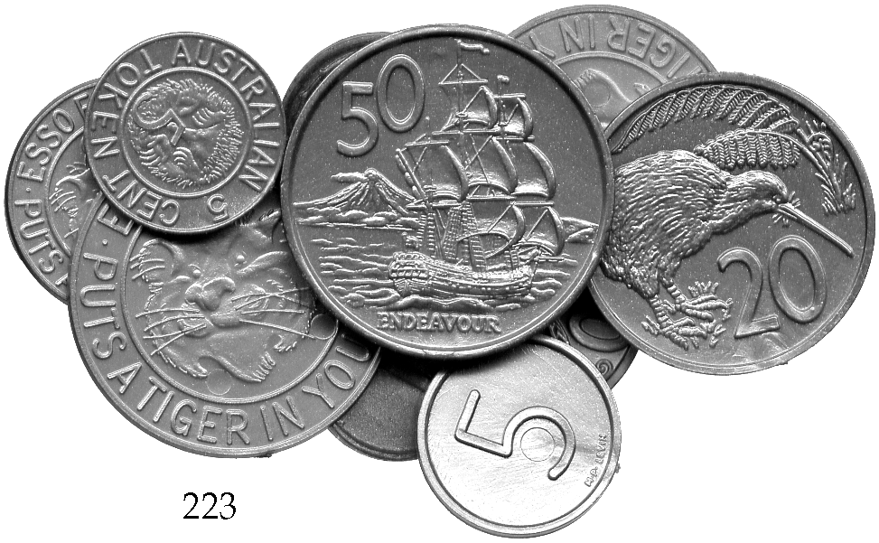 | 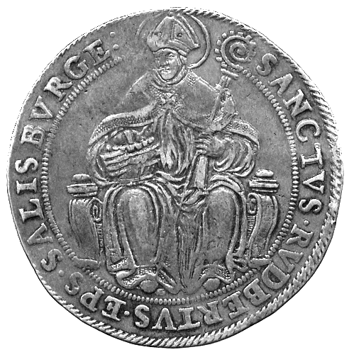224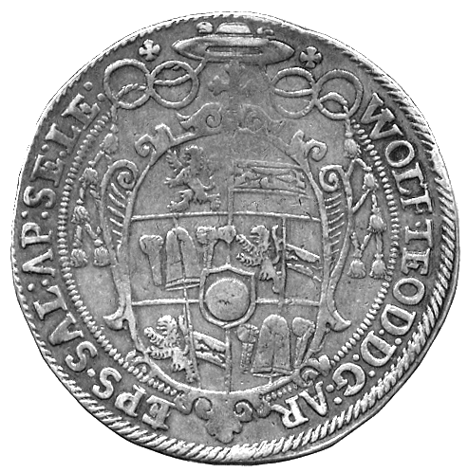

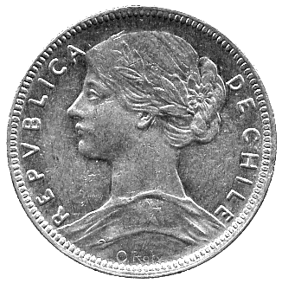230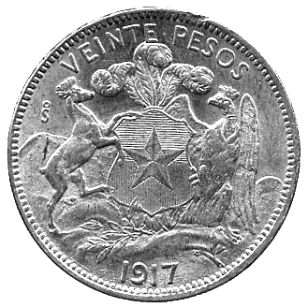 | 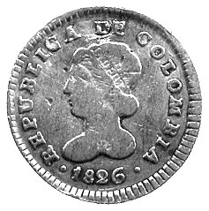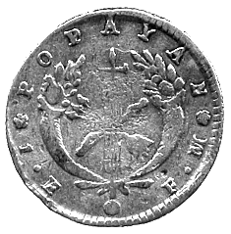  231 | 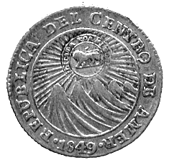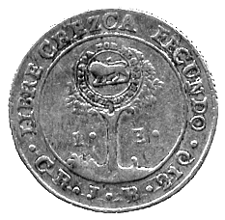  236 | 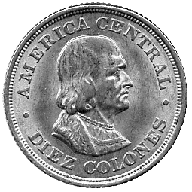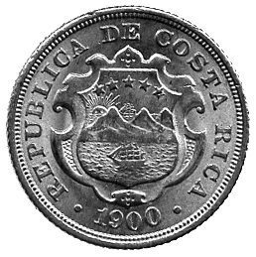  238

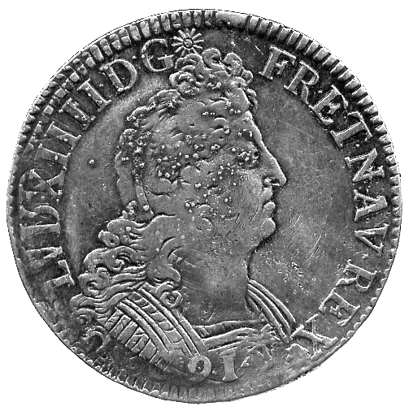245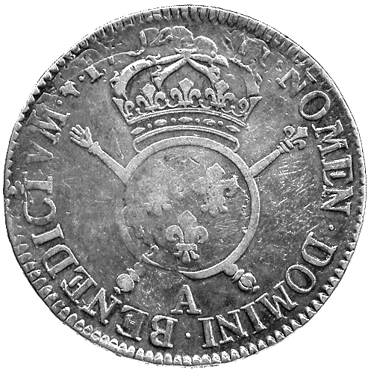 | 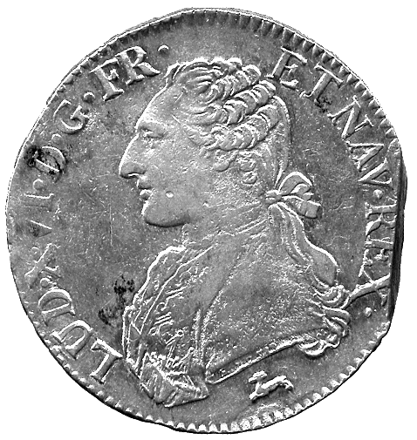247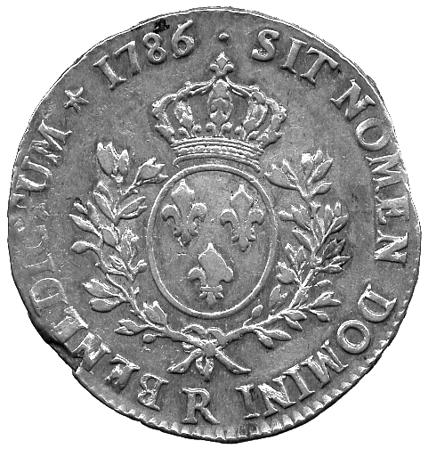

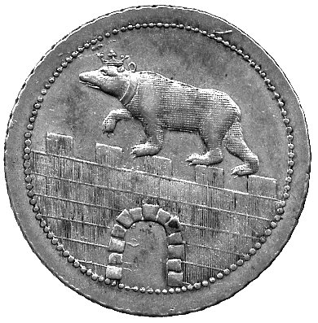248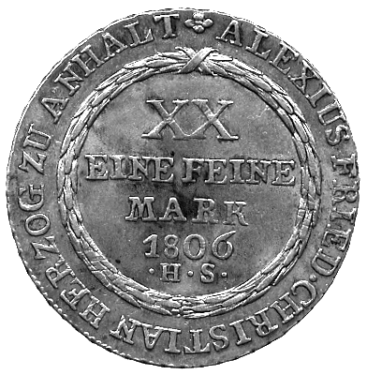 | 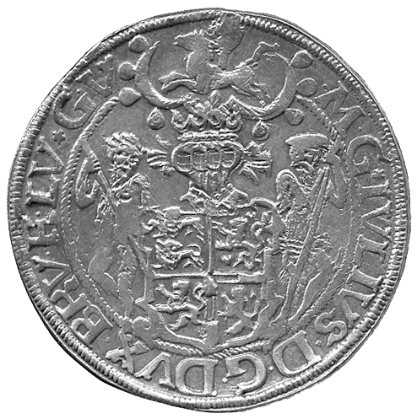249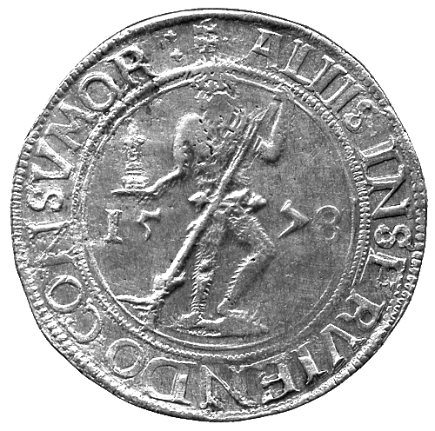

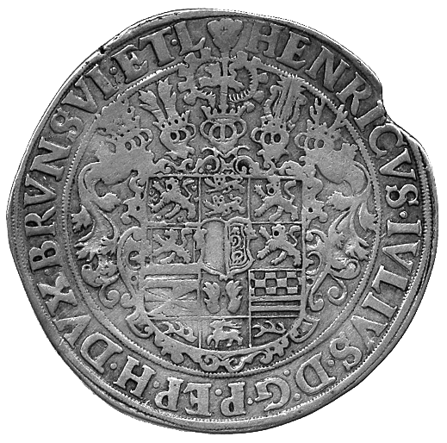250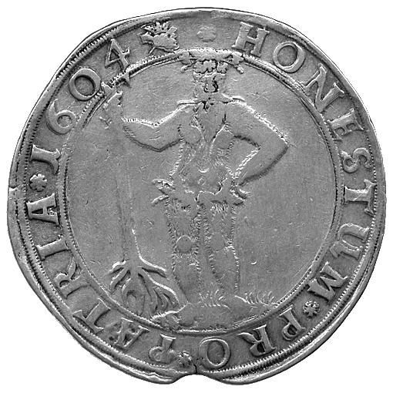 | 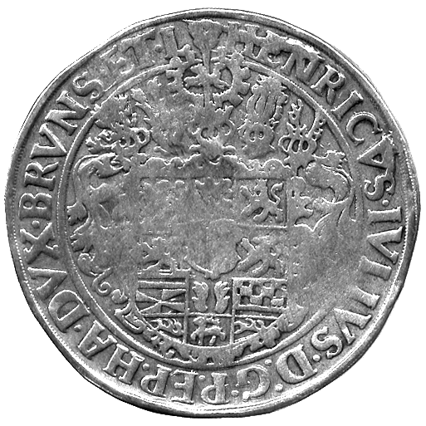251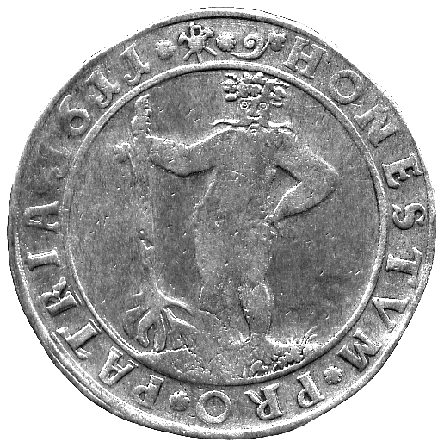

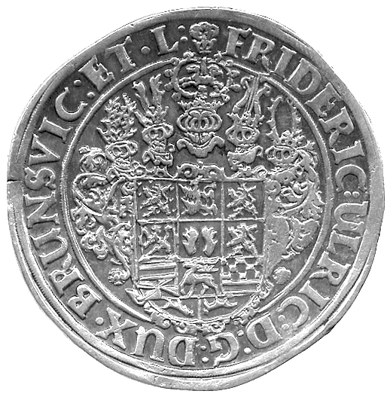252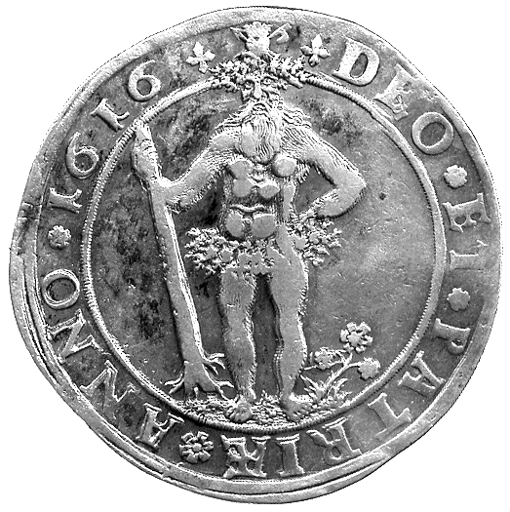 | 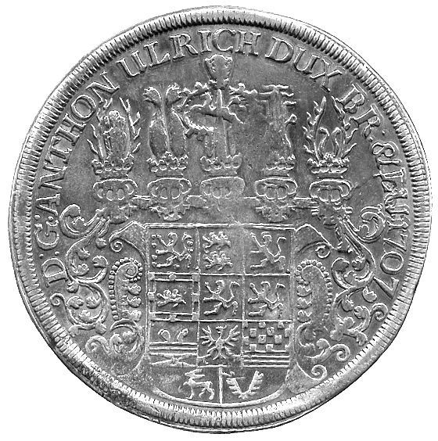254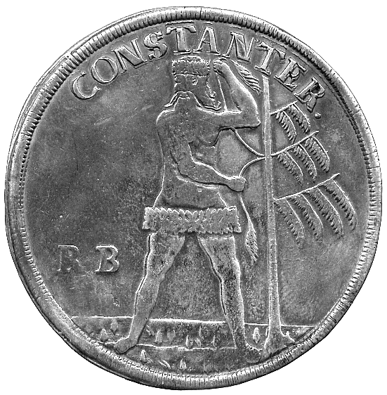

222 George V to Elizabeth II, silver and base coins (36), including Florins (8), Shillings (5), Sixpence (5), Threepence (11). Varied state. (36) £80-100

223* Plastic Tokens, Esso Australia, set of six, 50-Cents to 1-Cent; New Zealand, set of six toy coins 50-Cents to 1-Cent; a Japanese mint set 1989 and a French silver 10-Francs 1988 in mint holder. Extremely fine. (lot) £10-20

AUSTRIA

224* Salzburg, Wolf Dietrich von Raithenau (1587-1612), undated Thaler, seated archbishop facing, rev arms (Probszt 826). Very fine. £80-100

BELIZE

225 Proofs, 10-Dollars 1974, 5-Dollars (2), 1974, 1975, 1-Dollar (2), 1974, 1977, 50-, 25-, 10-, 5- and 1-Cent 1974 (KM 45, 44 (2), 43 (2), 42, 41, 40, 39, 38), other minor coins (16). Generally mint state. (28) £30-40

BRITISH EAST AND WEST AFRICA

226 20th century currency coinage (50), c.1909-1952. Varied state, some very fine. (50) £20-30

CANADA

227 George VI and Elizabeth II, silver Dollars (11), earlier copper tokens (7), Quebec, Upper Canada, Nova Scotia, other minor coins (75) in silver, cupro-nickel and copper. Silver dollars good extremely fine or better, others generally very fine, some better. (93) £100-120

228 Assorted coins and tokens, mostly 19th and early 20th century, includes silver 10-Cents (4), 5-Cents (8). Fine to very fine, some better. (38) £50-70

CAYMAN ISLANDS

229 Elizabeth II, silver proof 5-, 2- and 1-Dollar, 50-Cents 1972, silver 50-Dollars 1975, silver 25-Dollars (3), 1972 Silver Wedding, 1974 Churchill, 1977 Jubilee, proof 25-, 10-, 5- and 1-Cent 1972 (KM 8, 7, 6, 5, 12, 9, 10, 14, 4, 3, 2, 1), CuNi 1-Buck token, Buck Island, British Virgin Islands. Generally mint state. (13) £30-40

CHILE

230* 20-Pesos, 1917 (KM 158). About extremely fine or better. £100-120

COLOMBIA

231* Republic (1821-1837), 1-Escudo, 1826 FM, Popayan (KM 81.2). Fine. £30-40
COOK ISLANDS

232 Silver proof 25-Dollars (2),1977, 7½-Dollars 1973, 5-Dollars (2), 1976, 1977, 2½-Dollars 1973, 2-Dollars (2), 1973, CuNi proof 1-Dollar (2), 1972, 50-, 20-, 10-, 5-, 2- and 1-Cent 1972, silver currency issue 7½- and 2½-Dollars 1973 (KM 18, 10, 15, 17, 10, 9a, 9, 8 (2), 7, 6.1, 5, 4, 3, 2, 1). Mint state. (18) £40-60

COSTA RICA

233 Real Series, ½-Onza, 1850 JB (KM 100). Scraped in obverse field, otherwise good fine. £100-120

234 Real Series, 2-Escudos, 1854 JB (KM 99), 1-Escudo, 1850 JB (KM 98). Good fine. (2) £120-140

235 Real Series, 1-Escudo (2), 1850 JB, 1851 JB (KM 98). Good fine and very fine. (2) £100-120

236* Countermarked coinage, Central American Republic 1-Escudo, 1849 JB, countermarked on both sides with lion within circular legend (KM 84). About very fine. £80-100

237 Decimal Coinage, 2-Pesos (3), 1866 GW (KM 113). Fine to very fine. (3) £80-100

238* 10-Colones, 1900 (KM 140). Small edge knock, otherwise extremely fine. £60-80

239 Assorted 19th-Century coins in silver and base metal (27). Varied state, two pierced. (27) £80-100

CYPRUS

240 Edward VII, 18-Piastres and 9-Piastres, 1907 (KM 10, 9). Fine and very fine, both scarce. (2) £50-70

EGYPT

241 Ottoman Egypt, Gold Zeri-Mahbub (16), 18th-Century, assorted dates and types. All pierced, otherwise very fine or better. (16) £300-350

242 Ottoman Egypt, Gold Zeri-Mahbub (15), 18th-Century, assorted dates and types. All pierced, otherwise very fine or better. (15) £300-350

243 Hussein Kamil (AH 1333-1336), 5-Piastres, 2-Piastres and 2-Milliemes, 1916, 20-Piastres, 10-Piastres, 10-, 5-, 1- and ½-Millieme, 1917; Fu’ad I, as Sultan (AH 1336-1341), 10-, 5- and 2-Piastres, AH 1338; Fu’ad I, as King (AH 1341-1355), 20-, 10- and 5-Qirsh, AH 1341, 2-Qirsh, AH 1342, 10-, 5-, 2-, 1- and ½-Millieme, AH 1342, 20-, 5- and 2-Qirsh, 10-, 2- and ½-Millieme, AH 1348, 10-Qirsh and 2½-Milliemes, AH 1352, 5-Milliemes and Millieme, AH 1354; Farouk (AH 1355-1372), 10-Qirsh and 2-Qirsh, AH 1356, 10-, 5-, 2-, 1-Millieme (2) and ½-Millieme, AH 1357, 20-Qirsh and 5-Qirsh, AH 1358, 10- and 5-Milliemes, AH 1362, 2-Qirsh, AH 1363. Very fine or better, some scarce. (44) £200-250
244 First Republic (1953-1958), 50-Qirsh, 25-Qirsh, 20-Qirsh, 10-Qirsh, 5-Qirsh, 10-Milliemes (2), 5-Milliemes (2), Millieme (2); United Arab Republic (1958-1971), Pound (2), 50-Qirsh, 25-Qirsh, smaller denominations (38), no duplication; Arab Republic (1971- ), 25-Qirsh, 1973 (KM 438), smaller denominations in base metals (33), no duplicates. Mostly uncirculated. (87) £120-140

FRANCE

245* Louis XIV (1643-1715), Ecu 1702A, reformation, struck over a piece dated 1699, bust right, rev crowned arms on crossed sceptres (Duplessy 1533). Striking weakness and strange stippling on bust, very fine. £90-110

246 Louis XIV, ½-Ecu (3), 1690S, 1694N, 1695K; Second Republic, 5-Francs 1870A. First three fair, last fine. (4) £100-120

247* Louis XVI, Ecu 1786R, bust left, rev arms (Duplessy 1708). Strip edge to right of bust, cleaned, otherwise almost very fine. £40-60

GERMANY

248* Anhalt-Bernburg, Alexius Friedrich Christian (1796-1834), Silver Gulden 1806, bear on wall, rev denomination and date in wreath (KM 72). Almost extremely fine. £60-80

249* Braunschweig-Wolfenbüttel, Julius (1568-1589), Thaler 1578, Zellerfeld, the so-called Lichtthaler, helmed arms supported by wildmen, rev wildman holding candle stick (D 9063; Fiala 238). Weakly struck, dull, possibly from a wreck, good fine. £100-120

250* Braunschweig-Wolfenbüttel, Heinrich Julius (1598-1613), Thaler 1604, Zellerfeld, arms, rev wildman with broken tree in right hand (D 6285). Flan flaw at edge, fine, scarce. £120-150

251* Braunschweig-Wolfenbüttel, Heinrich Julius, Thaler 1611, Zellerfeld, arms, rev wildman with broken tree in right hand (D 6285). Fine, scarce. £100-120

252* Braunschweig-Wolfenbüttel, Friedrich Ulrich (1613-1634), Thaler 1616, Goslar or Zellerfeld, arms, rev wildman with broken tree in right hand (D 6303). Cabinet wear on high points, very fine. £100-120

253* Braunschweig-Wolfenbüttel, Ernst August, IIII-Mariengroschen 1681, Clausthal, with title of Bishop of Osnabrück, leaping horse to left, rev denomination and legend (Fiala 2507). Toned, about extremely fine. £20-30
254* Braunschweig-Wolfenbüttel, Anton Ulrich (1704-1714), Thaler 1707, Zellerfeld, arms, rev wildman, RB in left field, tree to right, CONSTANTER over (D 2116). Fine. £80-100

255* Braunschweig-Wolfenbüttel, Anton Ulrich, Thaler 1711, Zellerfeld, arms, rev wildman, RB in left field, tree to right, CONSTANTER over (D 2116). Fine. £80-100

256* Braunschweig-Wolfenbüttel, August Wilhelm (1714-1731), Thaler 1719, Zellerfeld, arms, rev wildman with a pine tree in his left hand, HH either side of crossed bayonets in left field, PARTA TUERI over (D 2126). Small edge knock above arms, light graffiti in reverse field, almost very fine. £80-100

257* Braunschweig-Wolfenbüttel, August Wilhelm, Thaler 1725, Zellerfeld, arms, rev, Thaler 1725, crowned A W cipher, rev leaping horse to left (D 2127). Some tooling on reverse, sometime cleaned, almost very fine, scarce. £140-180

258* Braunschweig-Lüneburg, Georg Ludwig as King George of England, Thaler 1721, Clausthal, cruciform arms, rev wildman with a tree in his right hand, in exergue C (D 2077). Trace of mounting at top, very fine. £80-100

259* Braunschweig-Lüneburg-Celle, Christian Ludwig (1648-1665), Thaler 1658, Clausthal, arms, rev leaping horse to left in wreath (D 6521). Horse very smooth, otherwise very fine. £100-120

260* Braunschweig-Lüneburg-Calenburg-Hannover, Georg Wilhelm (1648-1705), Thaler 1657, Zellerfeld, arms, rev wildman holding tree to his right with both hands (D 6528). Uneven dull tone, good fine, scarce. £80-100

261 Prussia, Friedrich III, 20-Marks 1888A, 8.78g, with scroll suspension mount. About very fine. £50-70

262 Prussia, 2-Marks 1913; other silver coins of the Weimar Republic and the Third Reich (5) and other silver coins (5). Fine or better. (11) £30-40

263* Saxony, Johann Friedrich I and Heinrich (1539-1541), Thaler 1539, bust with sword right, rev half facing bust with sceptre (D 9728). Trace of mount at top, almost very fine. £50-70

264 Saxony, 2-Marks (2), 1904, on the death of King Georg, 1909, on the 500th anniversary of the University of Leipzig; Austria, 2-Schillings 1932 (2), Haydn and Ignaz Seipel (J 132, 138; KM 2848, 2849). Very fine or better. (4) £80-100

265 Wilhelm to Third Reich, mostly base, much variety (75). Varied state. (75) £50-80

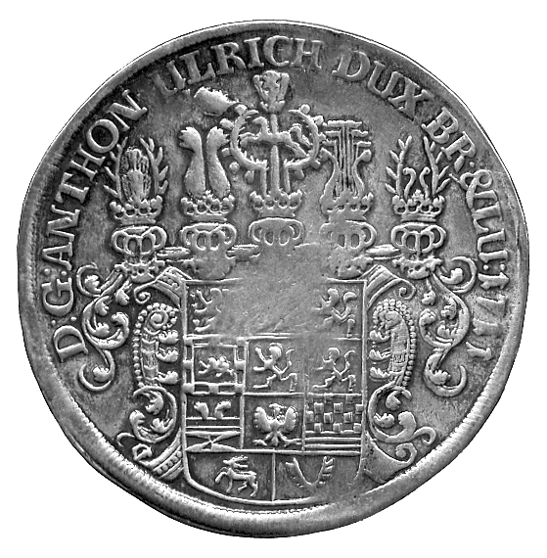255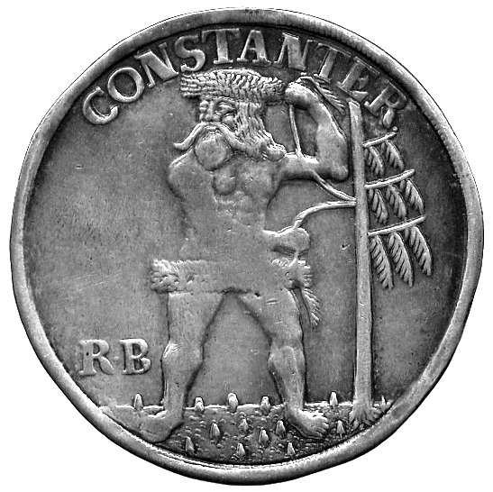 | 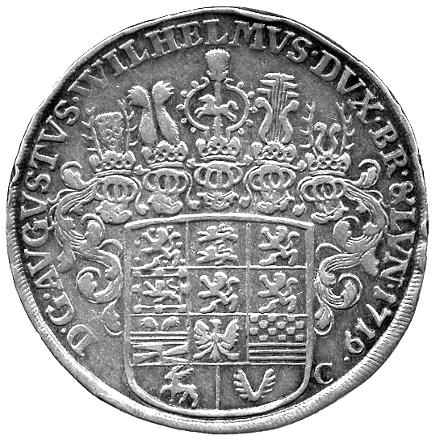256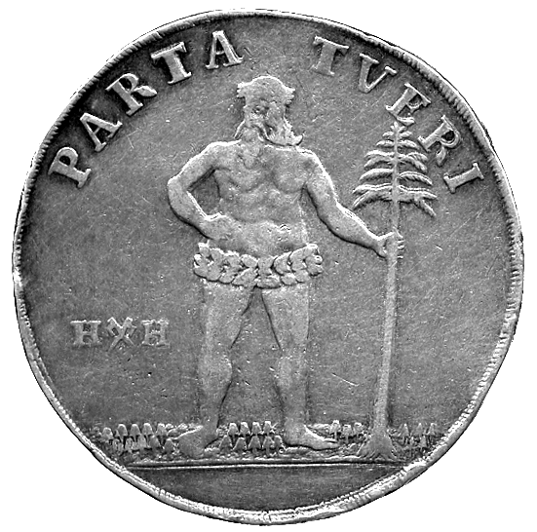

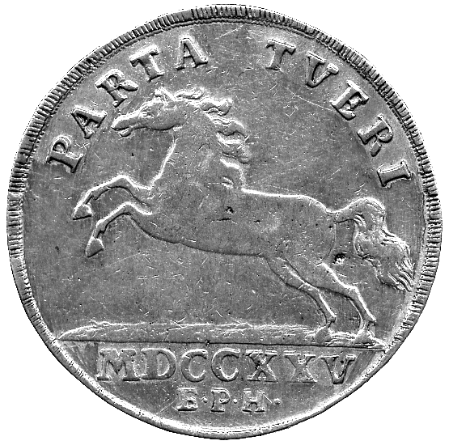257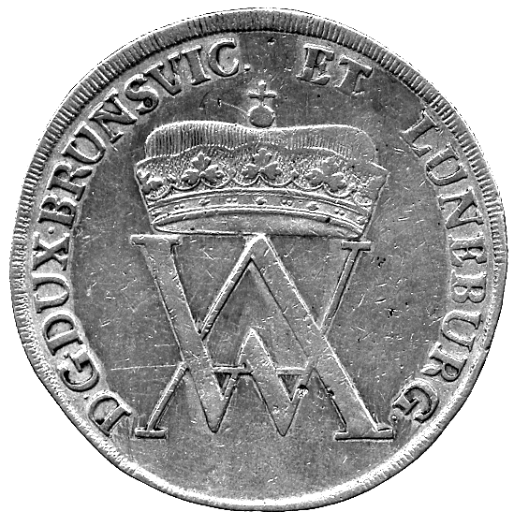 | 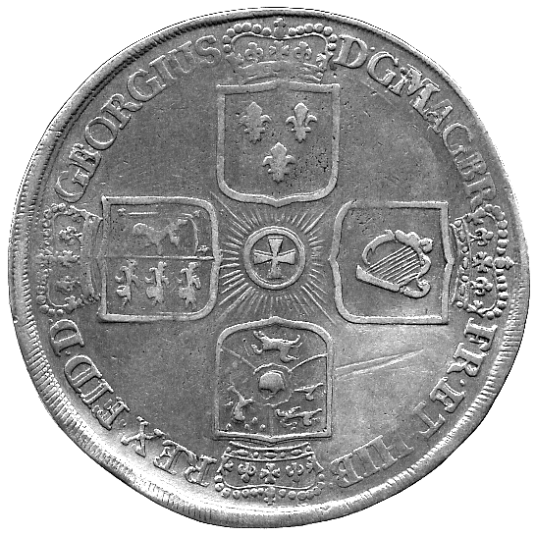258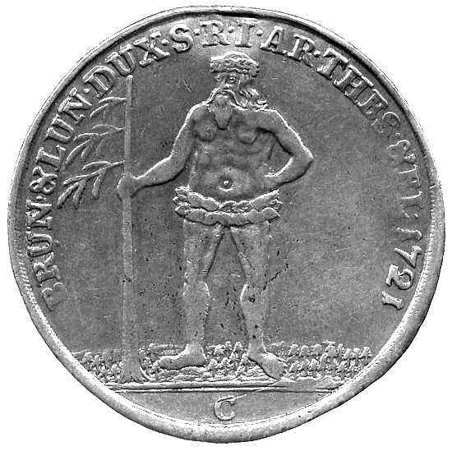

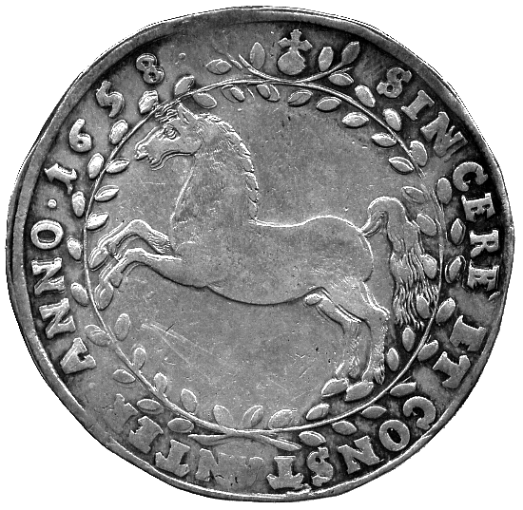259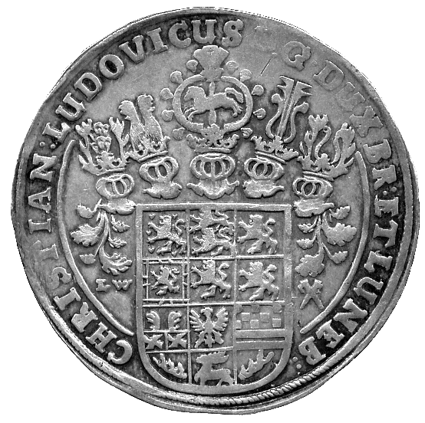 | 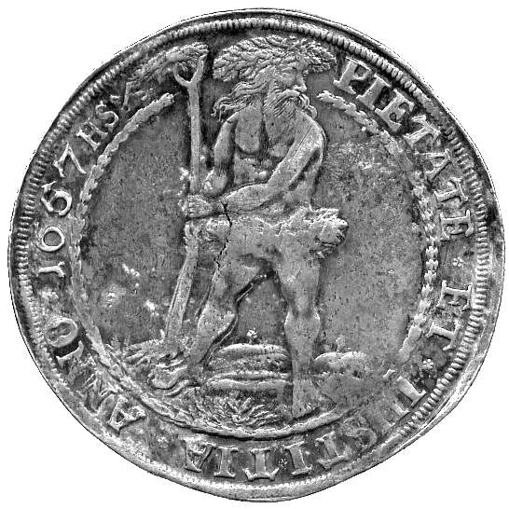260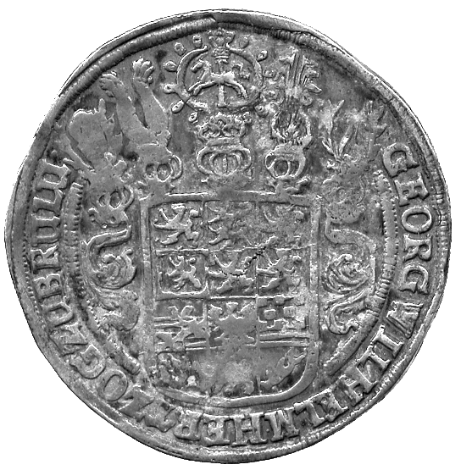

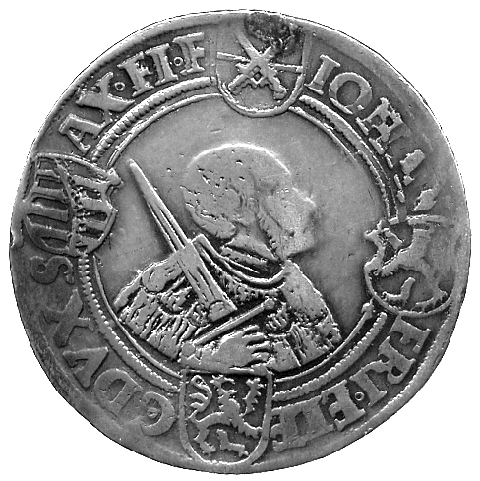263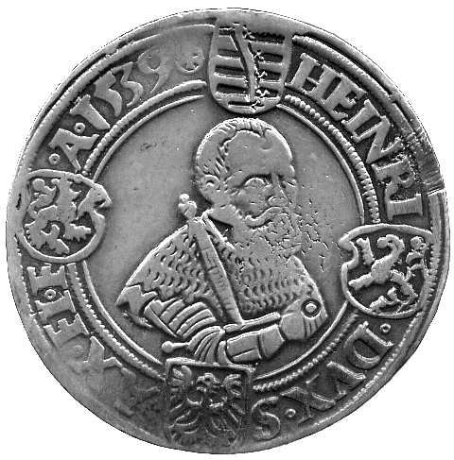 | 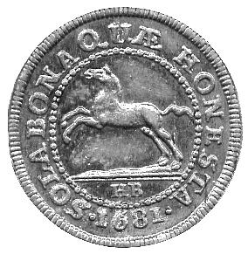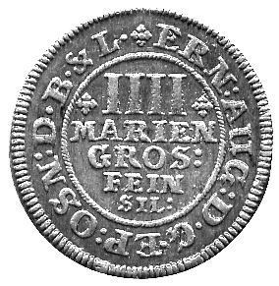  253 | 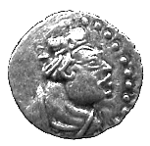 272 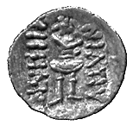  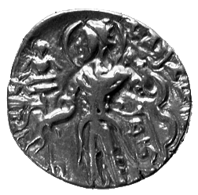274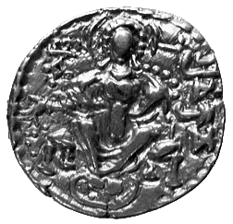

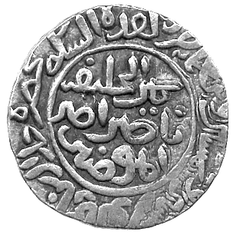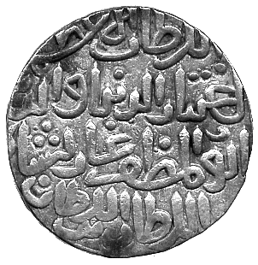  278 | 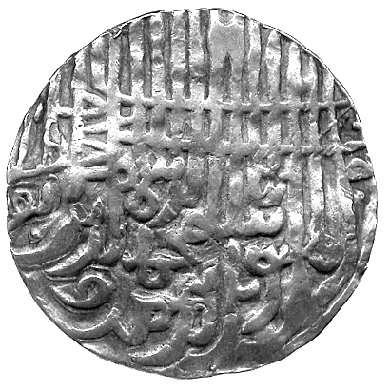279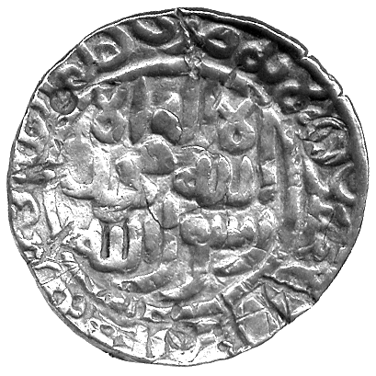 | 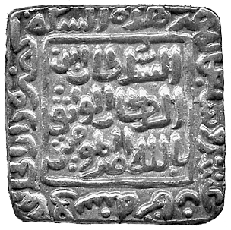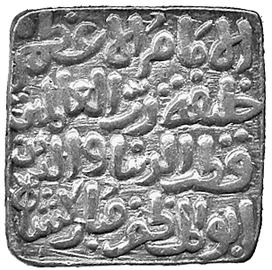  281

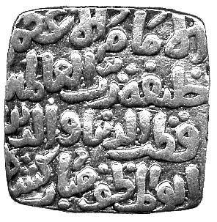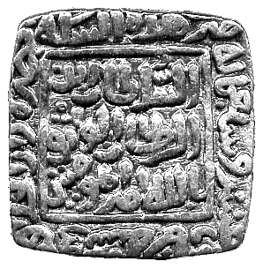  282 | 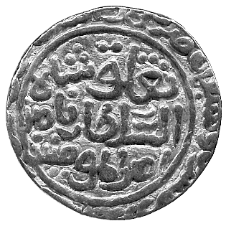283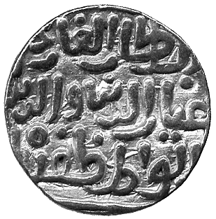 | 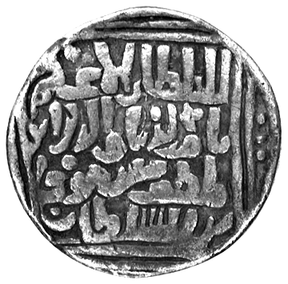284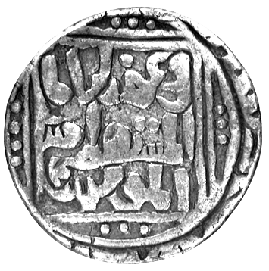

266 Currency Coinage (approx 500), c.1870-1950. Varied state, some very fine or better, a useful selection. (lot) £50-80

267 Proof silver medals, or ‘European Thalers’ (6), mid-1980s for Beroliner, different obverses celebrating aspects of European integration, common reverse an E within 12 stars of Europe, all within wreath, these are issues 25 to 30 of a series (cf pp 104-105 Ecu Katalog by G Schön). About as struck. (6) £10-15

GUATEMALA

268 Ferdinand VII (1808-1821), 8-Reales (2), 1815 M, 1820 M (CCT 456, 461), together with other Spanish and Spanish colonial coins (12). First about very fine with traces of mount on edge, second fine, the others varied state. (14) £80-100

HAITI

269 Pattern Silver 7½-Sols 1808, Liberty seated, rev HC (Henri Christophe), laurels above (KM Pn5). Very fine, rare. £120-150

HONG KONG

270 Victoria to Elizabeth II, minor silver (11), 5-Cents (8), 10-Cents (3), others (8). Generally very fine or better, a few extremely fine. (19) £40-60

INDIA

Ancient and Mediæval
271 Silver Punchmarked coins (20), rectangular and round flans. Fine to very fine. (20) £100-120

272* Kushan, Heraios (c.5-45 AD), silver Obol, Bamian province (Mitch 2840-2843). Extremely fine, rare. £80-100

273 Kushan and post-Kushan copper coins (26), other Indian copper coins (8). Generally fine. (34) £30-40

274* Gupta, Chandragupta II (c.375-414), Gold Dinar 7.56g, Archer type, Candra below arm of king left, rev Lakshmi enthroned sprinkling coins or incense (cf BMC pl.VI, 1-2). Almost very fine. £120-150

275 Post Gupta, Nagas of Narwar, Group of small copper coins (c.200), varying in weight from approx 0.4g to 1.9g, rev elephant. Very fine, an interesting group for study. (lot) £100-120

276 Post Gupta, Western Gangas, Gold Pagodas (2) (c.1080-1138), elephant right, rev ornamental scroll (M 702). Extremely fine and very fine. (2) £80-100

277 Post Gupta, Gahadavalas of Kanauj, Govinda-chandra, Base Gold Dinars (2), Lakshmi seated type (M 490-496). Good very fine, very fine. (2) £50-80

Sultanates
278* Sultans of Bengal, Ikhtiyar al-Din Ghazi, Silver Tanka, Sunargaon, AH 752 (D/B 138). Very fine and very rare. £300-350
All coins of this ruler are very rare.

279* Sultans of Bengal, Jalal al-din Muhammad, second reign (c.821-837h), silver Tanka, broad flan, ‘Arsah Chatgaon, date not clear, 10.40g (G&G B347). Very fine, some shroff marks, somewhat dished but scarce. £60-80

280 Sultans of Bengal, Nasir al-din Nusrat, Silver Tanka, Fathabad, AH 925 (G&G B810); Ghiyath al-din Mahmud, Silver Tanka, no mint or date (G&G B941); Ghiyath al-din Bahadur (AH 963-968; 1555-1560 AD), Silver Tanka, Mulk Satgaon, AH 965 (G&G B966). Very fine to good very fine and scarce. (3) £50-70

281* Sultans of Dehli, Qutb al-Din Mubarak (AH 716-720; 1316-1320 AD), Gold Tanka, Dehli, date not clear, marginal legend rather garbled (G&G D135). Very fine. £120-150

282* Sultans of Dehli, Qutb al-din Mubarak, square Silver Tanka, Hadrat Dar al-Khilafa, year 718, 10.85g (G&G D261). Very fine. £70-90

283* Sultans of Dehli, Ghiyath al-Din Tughluq (AH 720-725; 1320-1325 AD), Gold Tanka, mint and date not clear (G&G D301). Very fine. £140-180

284* Sultans of Dehli, Nasir al-din Mas‘ud’, Silver Tanka, Dehli style (G&G D141, plate specimen). About very fine, slightly crimped but extremely rare. £150-200
This curious coin is very similar in style to certain Dehli coins of Nasir al-Din Mahmud. The engraver has apparently mistakenly engraved the name of the previous ruler, Mas‘ud Shah, instead of Mahmud. A very unusual mint error. The only recorded specimen.

285 Sultans of Malwa, Ghiyath Shah (AH 873-906; 1469-1500 AD), Silver -Tankas (11), years 888 (4, different mint-marks), 895, 896, 898 (2), and three without clear date (G&G M78). Very fine, scarce. (11) £150-200

286 Sultans of Malwa, Nasir Shah (AH 906-916; 1500-1510 AD), Silver ¼-Tankas (7), years 906, 907 (2), 911?, 914, 916 and one without clear date (G&G M111, 112, 118). Very fine, scarce. (7) £100-120

Mughal
287 Jahangir (1014-1037h), with Nur Jahan, Rupees (10), Patna, year 22 (1037h) (KM 168.5). Fine to very fine. (10) £180-220

288 Shah Jahan I (1037-1068h), Rupees (24), square and round area types of Multan, Lahore, Surat and Akbarnagar. Very fine. (24) £50-80
289* Aurangzeb (1068-1118h), Mohur, Ahsanabad 1115h, year 47, 10.94g (KM 315.3). About extremely fine, scarce. £120-150

290* Aurangzeb, Mohur, Surat 1080h, 11.05g (KM 315.45). Brilliant extremely fine, an exceptional specimen. £180-220

291* Ahmad Shah Bahadur (1161-1167h), Mohur, Dar al-Khilafat Shahjahanabad 1161h, year 1, 10.88g (KM 449.12). Good very fine. £120-150

292* Shah Jahan III (1173-1174h), Mohur, Surat 117xh, year 1, 11.10g (KM -). Slightly crimped, about extremely fine with ruler’s name clear, scarce thus. £180-220

Independent Kingdoms
293 Mysore, Haidar Ali (AH 1174-1197; 1761-1782 AD), Gold Pagodas (3), god and goddess, rev He (KM 15). Very fine or better. (3) £90-110

294* Mysore, Haidar Ali, Gold Pagoda, 3.39g, god and goddess, rev He (KM 15). Very fine. £40-60

295* Mysore, Tipu Sultan (1782-1799 AD), Gold Pagoda, 3.41g, Nagar, AH 1200, year 4 (KM 109). Good very fine. £40-60

Princely States
296 Arcot, Muhammad Ali (AH 1165-1209; 1751-1795 AD), Gold Pagodas (2), three swamis, rev Ain (KM 14). Good very fine and very fine. (2) £60-80

297 Awadh, Rupees of Lucknow (11), year 26 series date run, AH 1212, 1213, 1214, 1215, 1216, 1217, 1218, 1219, 1220, 1221, 1223 (KM 103.2). Very fine to about extremely fine. (11) £70-90

298 Bhonslas of Nagpur, Rupees (2), in the name of Ahmad Shah Bahadur, Katak, year 5 (K 30.1, 50.1). Some staining otherwise very fine, scarce. (2) £20-30

299 Jodhpur, Mohur, in the names of George V and Umaid Singh, 10.98g (KM 129). Extremely fine. £150-200

300 Jodhpur, Mohur, in the names of George VI and Umaid Singh, 2001vs, 11.03g (KM -). Good very fine and rare. £180-220

301 Kutch, Khengarji III (1875-1942), 2½-Kori (2), 1934, 1937 (KM Y52a, Y74), 1-Kori (3), 1923, 1936, 1938 (KM Y51, Y65, Y73). Uncirculated. (5) £20-30

302 Sher Shah Suri (945-952h), Rupees (2), Kalpi 949h, Ranthambhor 949h (G&G D785, D793); Islam Shah Suri (952-960h), Jahanpanah Rupee, no mintname, 95xh (G&G D979). Good fine to very fine, all rare or very rare. (3) £100-120
East India Company
303 Bengal Presidency, Murshidabad 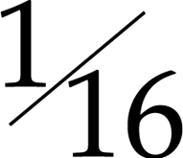-Rupees (7), years 7, 10, 19 (4), 1x; -Rupees (8), years 7, 12, 19 (6) (KM 80, 81). Very fine to extremely fine. (15) £150-180

304 Bombay Presidency, assorted coins in silver (2) and copper (7) (Pr 60, 167, 207, 217, 220, 274, 325, 327). Varied state. (9) £40-60

305 Assorted coins in silver (3), and copper (7) (Pr 105 (3), 131, 133, 142, 143, 148, 156, 163). Varied state. (10) £20-30

Miscellaneous and Modern India
306 Billon and Copper Coins (154), from India and Central Asia, including a number of bull and horseman types, coins from Sind etc. Mixed condition. (154) £40-60

307 [and Ceylon], assorted gold and base-gold coins (20), including one punch-marked coin. Varied state. (20) £250-300

308 [and Afghanistan], assorted coins (11), mostly copper, including two very base Kashmir Staters. Varied state. (11) £20-30

309 Proof restrike 8-Annas 1920, currency 4-Annas 1919, proof 1-, ½- and ¼-Rupee, 2-, 1- and ½-Anna, 1-Pice 1950 (KM 520, 519, 7.1, 6.1, 5.1, 4, 3.1, 2.1, 1.1). Second very fine, others mint state. (9) £30-40

310 FAO issues, silver proof 100-Rupees 1980, 50-Rupees (5), 1974, 1975, 1976, 1977, 1978, 20-Rupee 1973, 10-Rupees (3), 1970, 1972, 1973, CuNi 10-Rupees (6), 1974, 1975, 1976, 1977, 1978, 1982 (KM 198, 255, 256, 257, 258, 259, 240, 188, 189, 190, 191, 192, 193, 198), minor issues (3). Mint state. (19) £100-150

311 Gandhi commemorative 10-Rupees ND (KM 181), a collection of post-Independence currency coins, 5-Rupees et infra, all different (55), and a brass temple token from the Bahai Temple in Delhi, 1987. Very fine to extremely fine. (57) £30-50

IRAN

312 Nasir al-din Shah (AH 1264-1313), Qiran (4), ½-Qiran (2), 2000-Dinar (2), 1000-Dinar, 500-Dinar, Shahi Sefid (2); Muzaffar al-din Shah (AH 1313-1324), 5000-Dinar, 2-Qiran, 2000-Dinar, 500-Dinar, 50-Dinar; Ahmad Shah (AH 1327-1344), 5000-Dinar, 2-Qiran (2), 2000-Dinar (5), 1000-Dinar (4), 500-Dinar (2), Rob’i (2), Shahi Sefid (3), 100-Dinar, 50-Dinar. Fine to uncirculated. (38) £120-140
313 Muzaffar al-din Shah, Toman, AH 1316 (KM Y36), ½-Toman, AH 1323 (KM Y35), 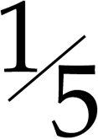-Toman, undated (KM 993); Ahmad Shah, Tomans (2), AH 1333, AH 1334, 5-Qiran (2), AH 1337, AH 1343, 2-Qiran (3), AH 1343 (2), one with date worn or effaced, Qiran, AH 1330; together with assorted Pahlavi silver coins (11). Very fine to extremely fine. (22) £300-350

314 Reza Shah (SH 1304-1320), 5000-Dinars (5), SH1304, SH1305, SH1306 (2), SH1308, 5-Rials, SH1311; Muhammad Reza Shah (SH 1320-1358), Pahlavi, SH1358, ¼-Pahlavi, MS2536. The first six mostly extremely fine, the last two uncirculated. (8) £200-250

IRAQ

315 Faisal I (1921-1933), Riyal, 1932, 50-, 20- and 4-Fils, 1931, 10-, 2- and 1-Fil, 1933; Ghazi I (1933-1939), 10-Fils, 1937, 50- and 20-Fils, 1938, 10-Fils (3), 1938, 4-Fils (4), 1938; Faisal II (1939-1958), 10-Fils and 4-Fils, 1943; together with an Iranian 5-Rials engraved SOUVENIR OF BAGHDAD 1917-18; Republic, commemorative issues: Dinar (3), medallic Proof 500-Fils, 1959 (KM M1), 500-Fils (2), 250-Fils (5); currency issues (21). Fine to uncirculated. (52) £150-200

ITALY

316 Mediæval, Venice, anonymous 4-Bagattini, undated (Gamberini 2026); Venetian Colonies, Candia, 2½-Soldini/10-Tornesi, undated (Gam 2065). Very fine and good fine. (2) £40-60

317 Kingdom of the Two Sicilies, Ferdinand III, Sicily, silver Scudo of 12-Tari 1799 (D 1425), good fine, scarce; Brabant, Philip II portrait Daalder, Holland (?), 1555, English titles (Delm 39), fair; Belgium, Leopold I, 5-Francs 1852 (KM 17), fine; Egypt, 20-Piastres 1923 (KM 338), very fine. (4) £60-80

JORDAN

318 Hussein b. Talal (1952-1999), commemorative issues, Proof 3-Dinars, 1977, Proof 2½-Dinars, 1977, ½-Dinar, 1980, ¼-Dinar (3), 1969, 1970, 1977; currency issues (14), 1949-1968. First two mint state, in capsules, others mostly uncirculated. (20) £80-100

MALAYSIA

319 Malaya, Malaya & British Borneo, George VI to Elizabeth II, silver and base coins (44). Generally extremely fine or better. (44) £15-25

MAURITIUS

320 25-Sous (KM 1). Very fine. £20-30
MALAYSIA

321 Commemorative silver proof coins, 1-Ringgit 1969, 25- (2) and 15-Ringgit 1976, 25-Ringgit 1977, 10-Ringgit 1976, CuNi 5-Ringgit 1971, 1-Ringgit (8), 1969, 1971, 1972, 1976 (2), 1977 (3), minor coins (7) (KM 7a, 20, 19, 14, 23, 17, 10, 7, 12, 9.1, 16, 13, 26, 25, 22), and provincial tin coins (4). Uncirculated. (26) £30-40

MOROCCO

322 ‘Abd al-‘Aziz (AH 1311-1326), ¼-Rials (3), Berlin AH 1318, Paris AH 1314, Paris AH 1320, ½-Dirhams (2), Paris AH 1320, 10-Mazunas (4), Fas AH 1320 (2), AH 1321 (2), 5-Mazunas, Fas AH 1320, 2-Mazunas (2), Fas AH 1320, 1-Mazuna (2), Fas AH 1320; Yusuf (AH 1330-1346), 2½-Dirhams, Paris AH 1331. Fine to extremely fine. (15) £80-100

323 al-Hafiz (AH 1326-1330), 5- and 2½-Dirhams, Paris AH 1329; French Protectorate, 200- and 100-Francs, AH 1372, 50-Francs, AH 1371, 20-Francs (3), AH 1347, AH 1366, AH 1371, 10-Francs (3), AH 1352, AH 1366, AH 1371, 5-Francs (3), AH 1347, AH 1365, AH 1370, minor denominations (8); Muhammad V (AH 1346-1381), 500-Francs, AH 1376, Dirham, AH 1380; al-Hasan II (AH 1381- ), 5-Dirhams (2), AH 1384, AH 1407, Dirham (2), AH 1384, AH 1394, 50-, 20-, 10-, 5- and 1-Santim, AH 1394; commemorative issues, Proof 50-Dirhams (4), AH 1395 (2), AH 1396, AH 1399, 5-Dirhams, AH 1395. Mostly uncirculated. (38) £150-200

NAMIBIA

324 Trial proofs for Independence coinage 1990, silver 10-Mark, cupro-nickel 1-Mark, arms, rev lion left, silver 10-Dollars, cupro-nickel 1-Dollar, arms, rev bushman draws bow. As struck. (4) £50-70

NEW ZEALAND

325 Cu-Ni Dollars (4), 1967, 1969, 1973, 1974 proof, proof 50-, 20-, 10-, 5-, 2-, 1-Cent 1968, 50-Cents 1969, 10-Cents 1971. Mint state and uncirculated. (12) £20-30

326 George V to Elizabeth II, silver and base coins (43), a varied selection. Varied state. (43) £40-60

OTTOMAN EMPIRE

327 Small gold coins (10), mostly pierced, mounted or damaged, 23.34g. Fine to about very fine. (10) £140-180

PAKISTAN

328 Silver proof commemorative 150-Rupees 1976, 100-Rupees (4), 1976 (2) different types, 1977 (2) different types, and a collection of low denomination currency coins of Pakistan (43) and Bangladesh (14). Very fine to uncirculated. (62) £30-40

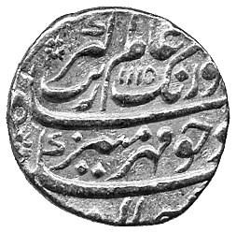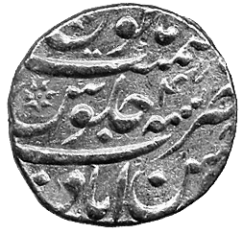  289 | 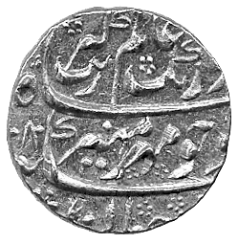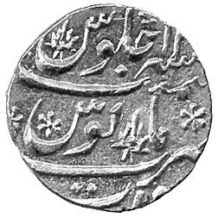  290 | 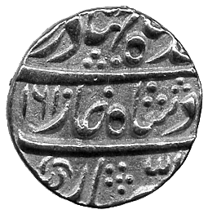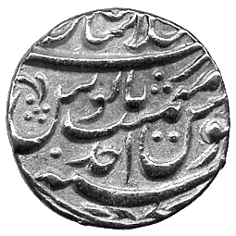  291 | 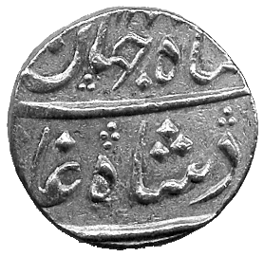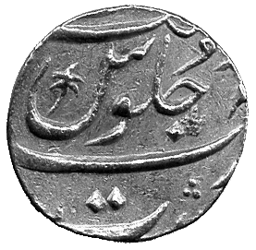  292

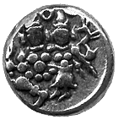294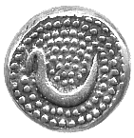  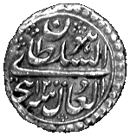295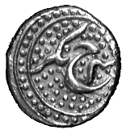 | 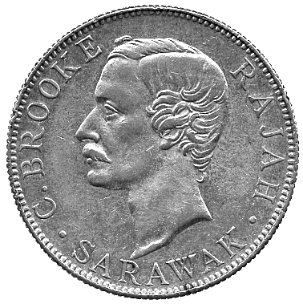337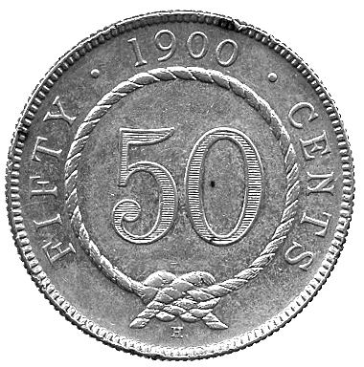 | 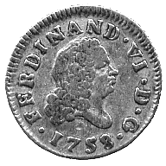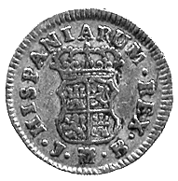  349 | 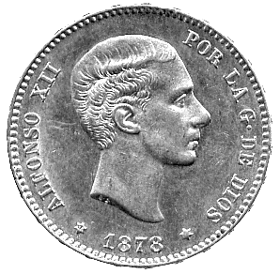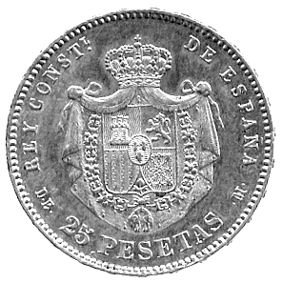  350

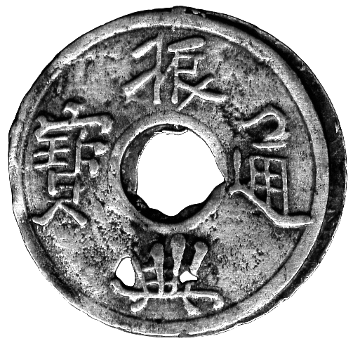354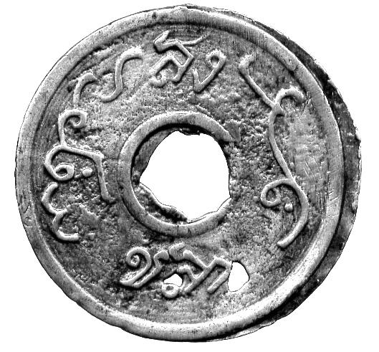 | 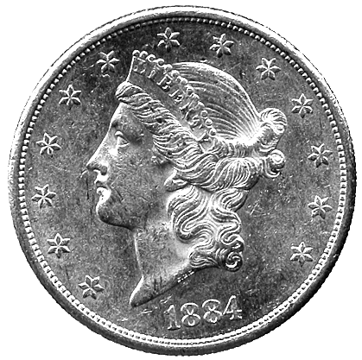357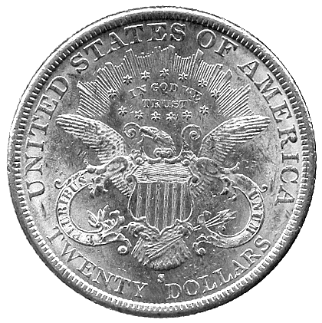

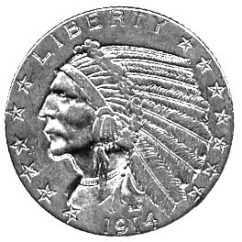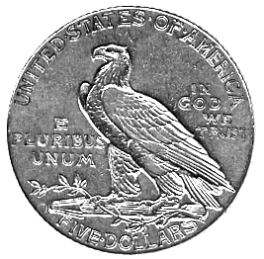  358  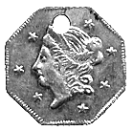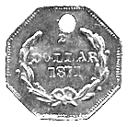  359 | 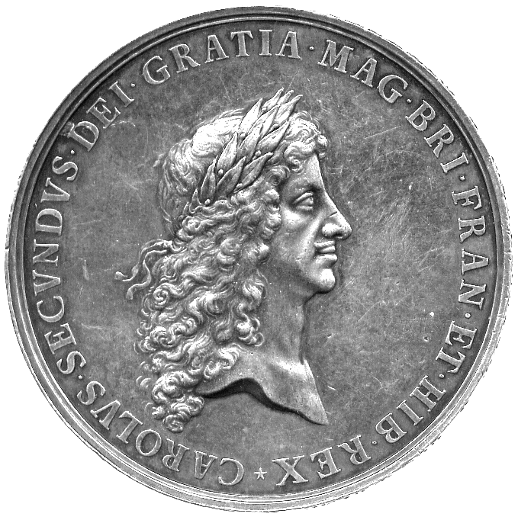372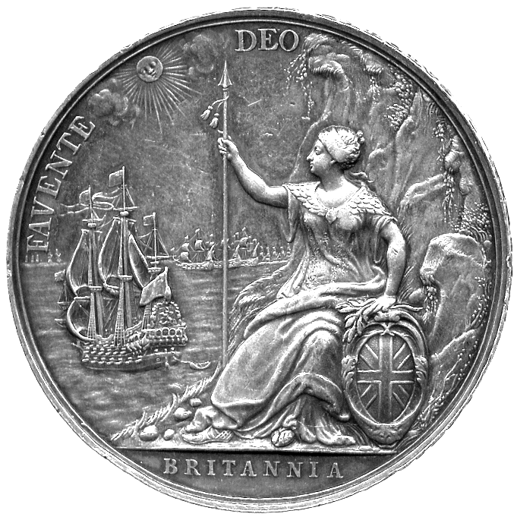

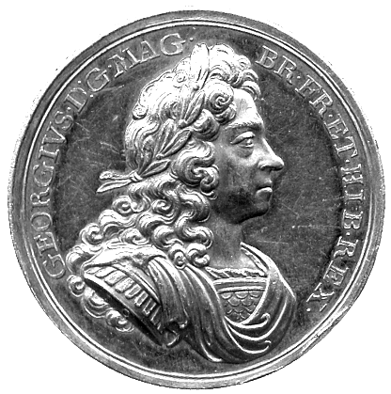 | 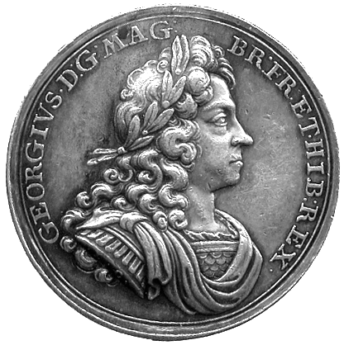 | 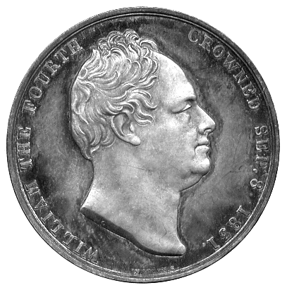 | 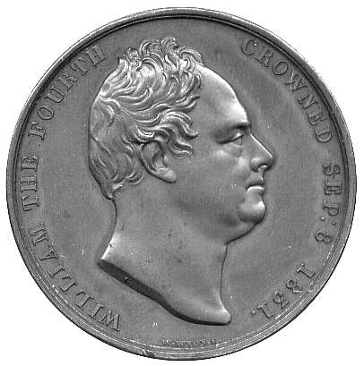 | 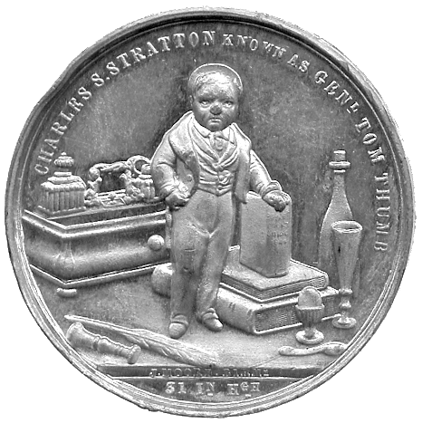
373 | 373 | 376 | 378 | 381
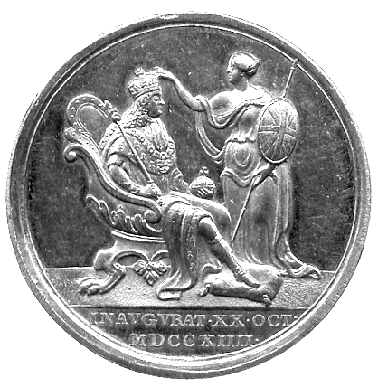 | 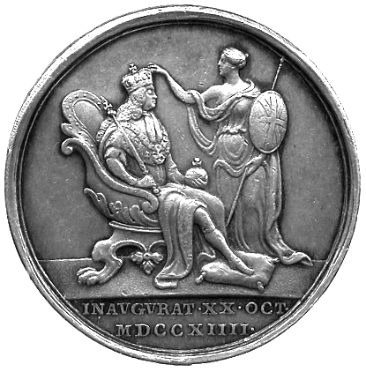 | 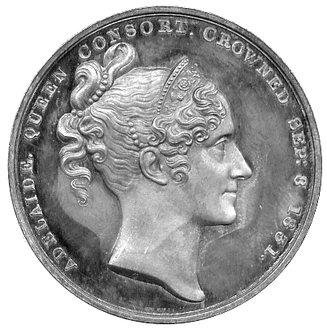 | 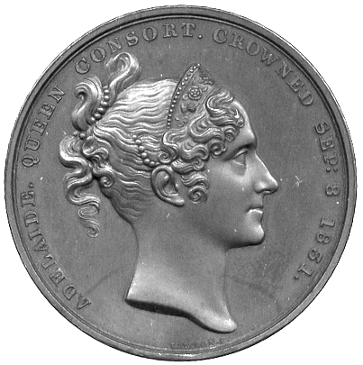 | 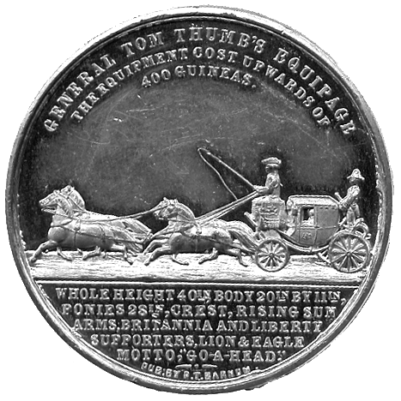

329 Papua New Guinea, silver proof 10-Kina, 5- and 1-Kina, 20-, 10- and 5-Toea 1976, CuNi 10-Kina 1980 (KM 8a, 7, 6, 5, 4, 3, 8), other coins in base metals (9); Tuvalu, silver proof 5-Dollars 1976, CuNi 1-Dollar, 50-, 20-, 10- and 5-Cents and bronze 2- and 1-Cent 1976 (KM 8, 7, 6, 5, 4, 3, 2, 1). Uncirculated. (24) £30-40

PALESTINE

330 Silver 100-Mils 1933, 50-Mils (4), 1933, 1935 (2), 1939, good very fine and better, base coins (approx 25), including 20-Mils 1934, about very fine. Except as stated, generally very fine, a few better. (lot) £50-80

POLAND

331 Danzig, Stephan Bathori (1575-1586), Solidus, 1578, eagle, rev crowned arms (Hcz 621). Very fine. £50-70

PORTUGAL

332 John V, 4000-Reis, 1714; a jeweller’s copy of a Mohur and thirteen small British and European gold coins, all worn, mounted, pierced or buckled, 50.90g. The first with traces of mounting, good fine, gilt. (15) £300-350

333 Peter II, 1000-Reis 1699 (3), 5.80g. Pierced, fine or better. (3) £40-50

RHODESIA

334 20th Century currency coinage (100), c.1932-1977, mostly minor denominations. Varied state, some very fine. (100) £20-30

335 An assortment of 20th century currency coinage (approx 200), c.1932-1977. Varied state, some very fine. (lot) £40-60

RUSSIA

336 Russia, 5-Kopeks, 1791 (KM 59.5). Very fine. £30-40

SARAWAK

337* Charles Brooke, 50-Cents 1900H (KM 11). About extremely fine. £100-120

SEYCHELLES

338 George VI, Rupee 1939, ½-Rupee 1939, 25-Cents (2), 1943, 1951, 10-Cents (2) 1944, 1951, 5-, 2- and 1-Cent 1948 (KM 4, 3, 2, 8, 1, 9, 7, 6, 5); Elizabeth II, silver proof 5-Rupees 1972, CuNi 5-Rupees 1972, proof 1- and ½-Rupee 1969, proof 25-, 10-, 5-, 2- and 1-Cent 1969, aluminium 5- and 1-Cent 1972, silver proof 10-Rupees 1974, CuNi proof 10-Rupees 1074 (KM 19a, 19, 13, 12, 11, 10, 16, 15, 14). First nine coins fine to very fine, later new issues virtually mint state. (14) £40-60
339 Independence issues 1976, silver proof 10-, 5- and 1-Rupee, proof 50-, 25-, 10-, 5- and 1-Cent, currency 10- and 5-Rupees (KM 28a, 27a, 26, 25, 24, 23, 22, 21, 28, 27); other silver proof com-memorative issues, 25-Rupees 1977, 10- and 5-Rupees 1978 (KM 38a, 40, 39), currency coins (9). Generally mint state, two in capsules. (22) £40-60

SOUTH AFRICA

340 ZAR, Paul Kruger, Ponds (4), 1897 (2), 1898 (2), 32.57g. First with scroll mount, second and third showing traces of mounting, last fine, the others better. (4) £160-180

341 ZAR, Paul Kruger, Half-Ponds (6), 1892, 1893, 1894, 1895 (2), 1896, 24.00g. Mostly showing traces of mounts, fine and better. (6) £140-180

342 Crown-size Silver (45), 1947 (6), 1948 (27), 1949 (7), 1950 (4), 1954. Very fine to extremely fine, last a scarce date. (45) £80-100

343 George V to Elizabeth II, Silver Threepences (approx 360). Generally very fine, some better. (lot) £20-30

344 George V to Elizabeth II, bronze Halfpennies (500). Fine to very fine. (500) £15-25

345 Republic, Proof Sets (4), 1965, slight damage to cases (KM PS 64). Coins much as issued. (4) £20-30

346 Republic, modern currency coinage (approx 400), c.1965-1989, mostly minor denominations. Many as issued. (lot) £20-40

347 Republic, currency coins 1967-1989 (200), in sealed plastic holders, all different. Uncirculated. (lot) £10-20

348 Republic, currency coins 1967-1989 (200), mostly minor denominations in sealed plastic holders, all different. Uncirculated. (lot) £10-20

SPAIN

349* Ferdinand VI (1746-1759), ½-Escudo, 1758 JB, Madrid (CCT 229). Fine. £30-40

350* Alfonso XII (1874-1885), 25-Pesetas, 1878 (CCT 5). About extremely fine. £80-100

STRAITS SETTLEMENTS

351 Victoria to George V, minor silver (11), 20-Cents 1895, 10-Cents 1896, 1926, 5-Cents (8); others (6). Silver fine and better, others fair to fine. (17) £40-60

SWITZERLAND

352 Zürich, City Thaler 1739 (KM 143.3); ½-Thaler of 36-Schillings, rev legend (KM 145); Confederation, 5-Francs 1851 (KM 11). Fine. (3) £100-120

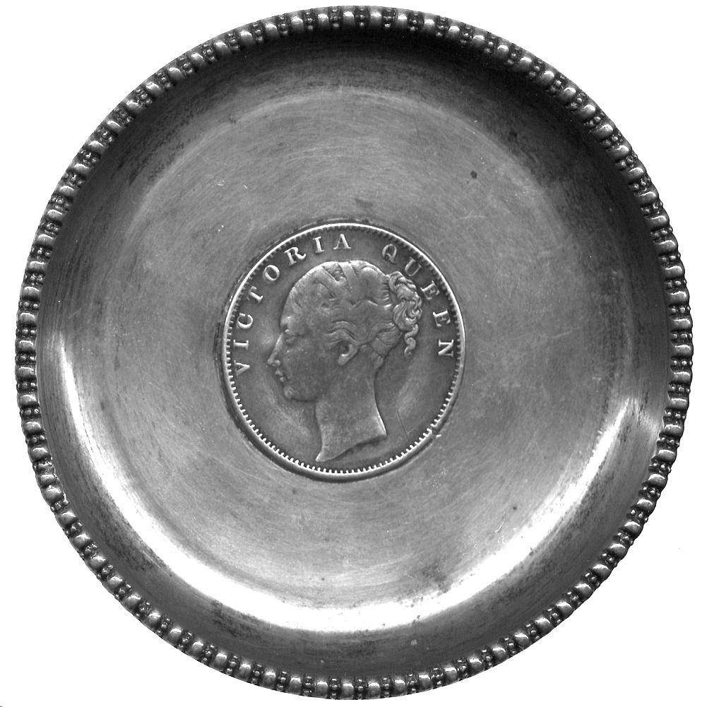380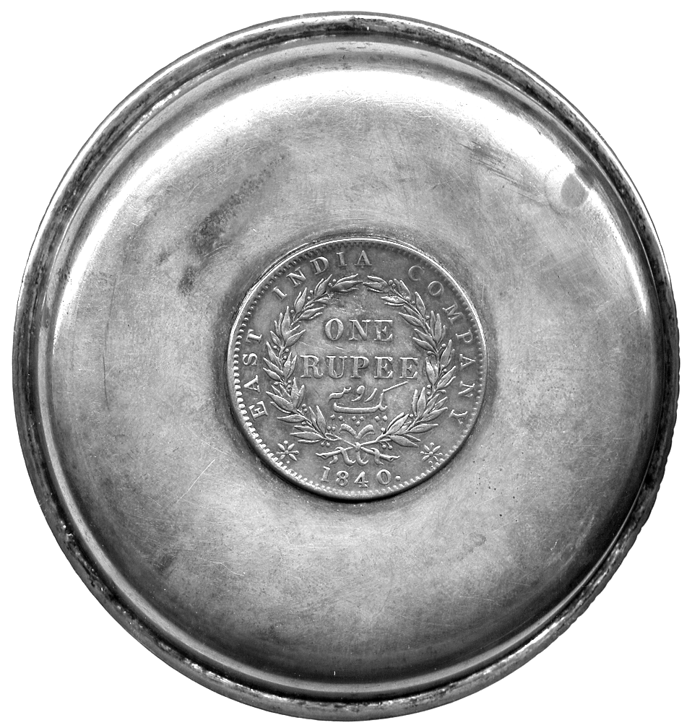

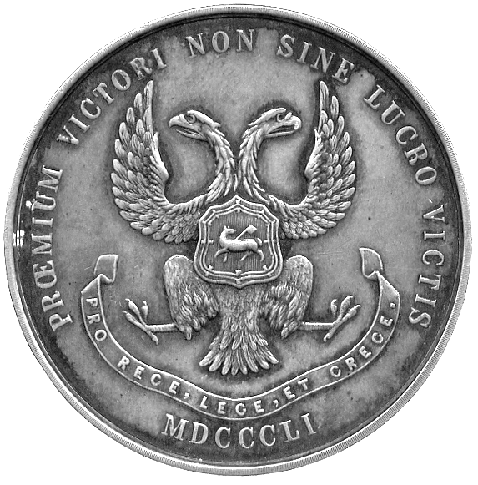383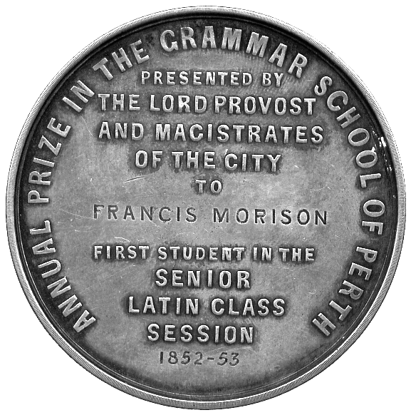 | 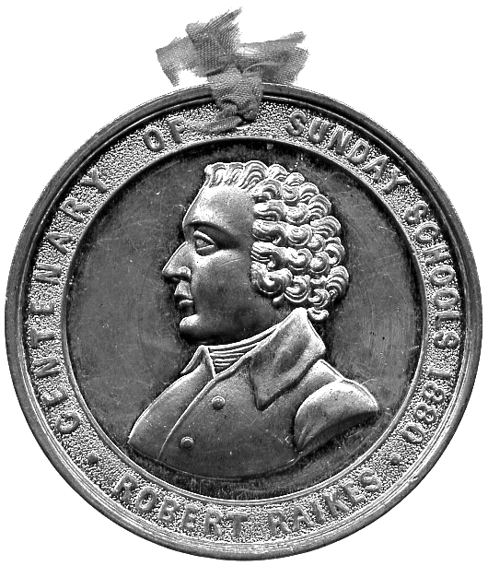384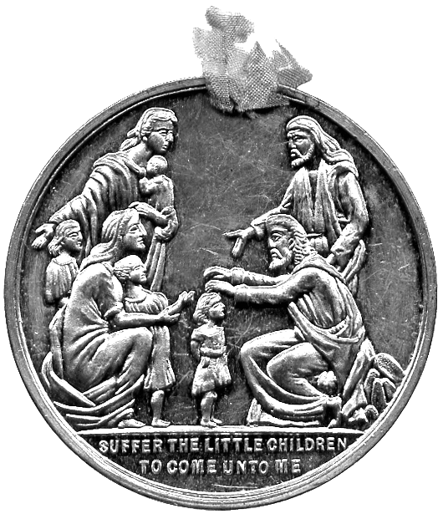

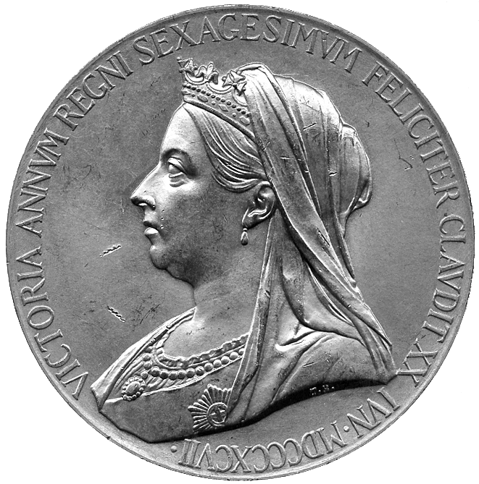 | 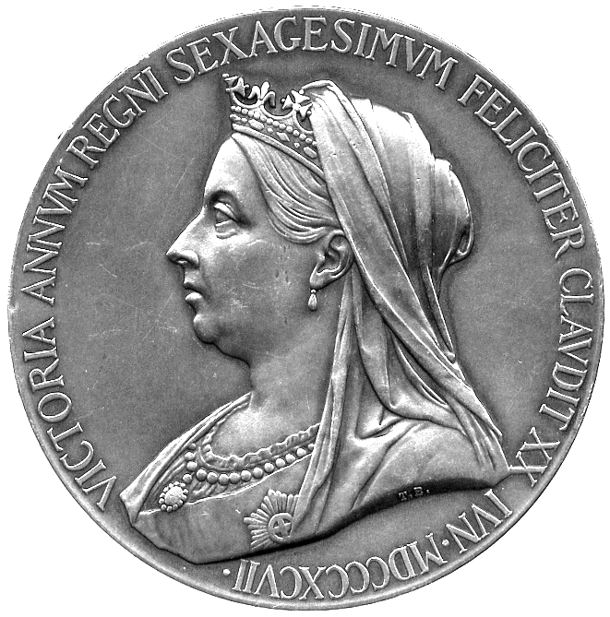 | 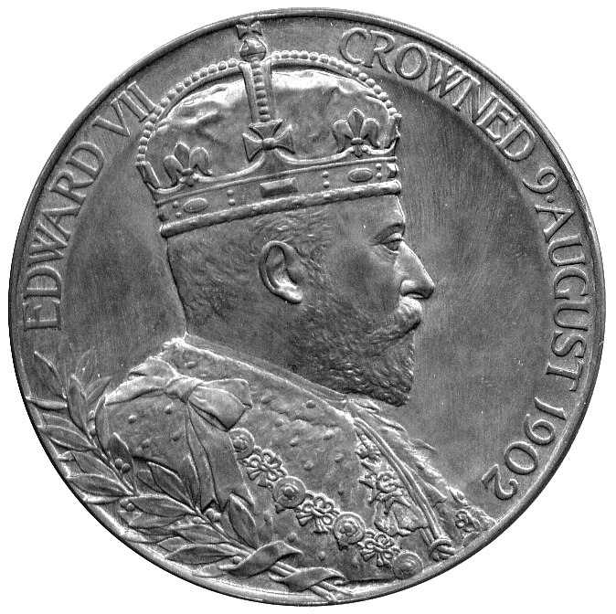
387 | 387 | 389
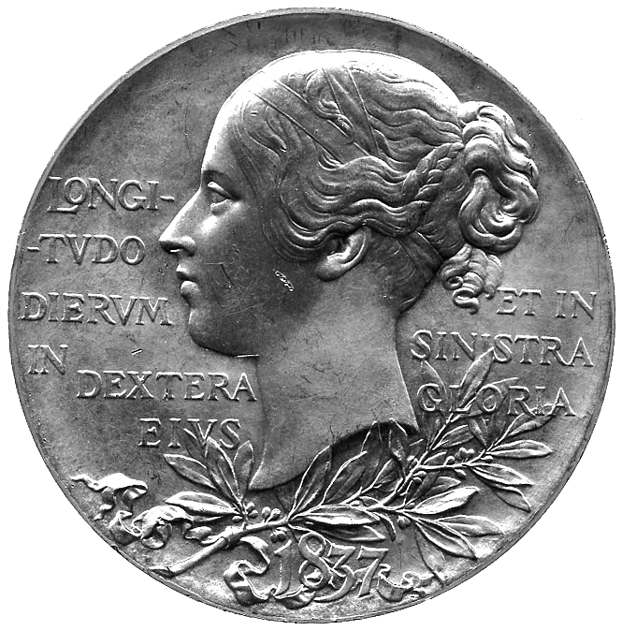 | 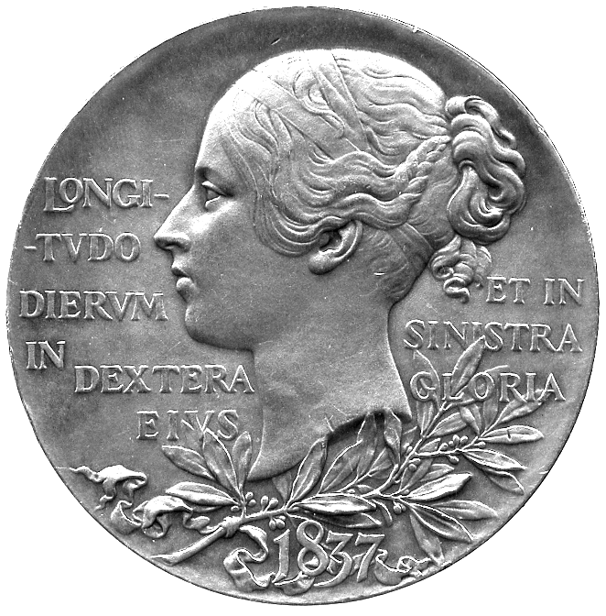 | 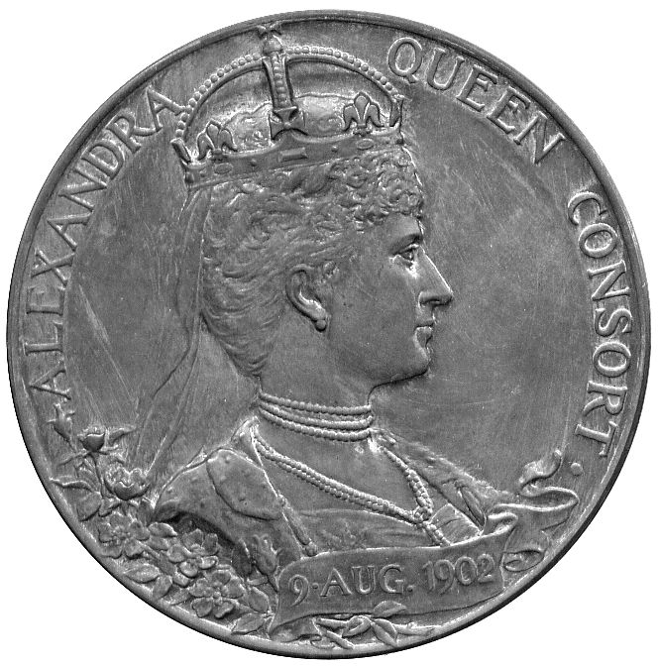

SYRIA

353 French Protectorate, 25-Piastres, 1936, 10-Piastres, 1929, 5-Piastres, 1926, 2½-Piastres, 1940, 2-Piastres, 1926, Piastre (2), 1935, 1940, ½-Piastre (2), 1921, 1936; World War II, emergency issues, 2½-Piastres and Piastre, undated; Syrian Arab Republic (1961- ), 1-Pound (7), 50-Qirsh (4), 25-Qirsh (4), 10-Qirsh (4), 5-Qirsh (4), 2½-Qirsh (2). Very fine to uncirculated. (36) £80-100

THAILAND

354* Singgora, Pitis, cast tin, obv Arabic and Siamese legends, rev Chinese legend (KM 1; Pr 213). Two small casting holes, minor tooling on obverse, otherwise very fine, very rare. £250-300

TURKEY

355 Mehmed V (AH 1327-1336), Qustantiniya AH 1327: 100-Kurush, year 6, 25-Kurush, year 4, 20-Kurush (2), years 8, 9, 10-Kurush (2), year 7, 5-Kurush (5), years 1, 2, 7(2), 8, 2-Kurush (2), years 6, 7, Kurush (2), years 1, 3; Egypt, Mehmed V, Misr AH1327: 20-Qirsh, year 3, 10-Qirsh, year 6, 5-Qirsh, year 6, Qirsh (2), years 2, 3. Very fine to extremely fine. (20) £120-140

356 Republic, 25-Kurus (2), AH 1341, 1928, 10-Kurus (2), AH 1341, 1926, 5-Kurus (2), AH 1341, 1926, 100-Para (2), AH 1341, 1926; Decimal coinage, 100-Kurus, 1934, Lira (2), 1937, 1941, 50-Kurus, 1935, 25-Kurus, 1935, other minor coins (14); commemorative issues, Proof 5000-Lira, 1985, Proof 200-Lira, 1978, Proof 100-Lira, 1973, Proof 50-Lira (3), 1971, 1972, 1973, Proof 25-Lira, 1970; minor coins (43), 1959-1978, no duplication, and two brass telephone tokens. Mostly uncirculated, the first eight coins scarce thus. (79) £200-250

UNITED STATES OF AMERICA

357* 20-Dollars, 1884S. Fields much scuffed, otherwise very fine. £300-350

358* Gold 5-Dollars, 1914S, Indian Head type. Good very fine. £80-100

359* California, octagonal gold Half-Dollar, 1871, with a large piercing, 0.30g. Very fine. £60-80

YEMEN

360 Yahya b. Muhammad (AH 1322-1367), Imadi Riyal (2), AH 1344, ¼-Riyal (2), AH 1352, AH 1364, 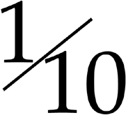-Riyal, AH 1349; Ahmad b. Yahya (AH 1367-1382), Ahmadi Riyal, AH 1375, ½-Riyal, AH (13)75, ¼-Riyal (2), AH (13)74, AH (13)77, -Riyal, AH 1370; Arab Republic, Riyal, AH 1382, 20- and 5-Buqsha, AH 1382; Tarim, 12-Khumsi (2), AH 1315, 6-Khumsi, AH 1315; Ghurfah, Saleh ‘Ubayd b. Abdat (AH 1339-1358), 30- and 15-Khumsi, AH 1344. Fine to extremely fine. (18) £120-140
MISCELLANEOUS

361 World Gold Coins (15), Europe and USA, 51.71g. Many pierced or with traces of mounts, many fine or better. (15) £250-300

362 20th Century European currency (approx 1.4kg). Varied state. (lot) £20-30

363 Assorted World Coins in silver (72) and base metal (40). Varied state, some pierced. (112) £100-120

364 Coins of the World (approx 30), mostly 19th century silver, including Crown 1935, good very fine, Irish Halfcrown 1928, about extremely fine, several British India etc. Varied state. (lot) £50-60

365 Colonial and Commonwealth Coins (approx 250), few silver. Mixed grade. (lot) £60-80

366 Assorted World Coins (approx 330), 18th century and later, few silver. Mixed grade. (lot) £60-80

367 Assorted World Coins (lot), in silver and base metal. Varied state. (lot) £200-250

368 Miscellaneous coins of the World in silver and base metals (lot). Fair to fine, should be viewed. (lot) £30-50

369 A large assortment of world coins (over 1000), mostly mid- to late-20th century, total weight approx 10kg. Varied state. (lot) £20-30

370 Tokens, Checks and Medalets (approx 160), few 16th century, and later, some plastic. Mixed grade. (lot) £40-50

371 Lead Tokens, Medals etc, including mediaeval tokens and a large portrait of Matthew Boulton, approx 1.22kg. Some corrosion, fair. (lot) £50-100

COMMEMORATIVE MEDALS

BRITISH HISTORICAL MEDALS

372* Charles II (1660-1685), The Peace of Breda 1667, the ‘Favente Deo’ medal, Silver, by J Roettier, laureate bust of Charles right, rev Britannia seated on the seashore surveys the English navy, legend on edge, 57mm (MI i 535/185). Almost extremely fine, minor surface marks. £250-300

373* George I, Coronation Medal (2), 1714, official Gold Medal, by J Croker, bust right, rev king seated in a shell form chair, crowned by Britannia, 34mm, 23.72g; another, similar in silver (MI II 424/9). First with minor edge knock and light surface marks, the second very fine. (2). £800-1000
The official medal distributed to statesmen and spectators
Only 330 specimens struck in gold

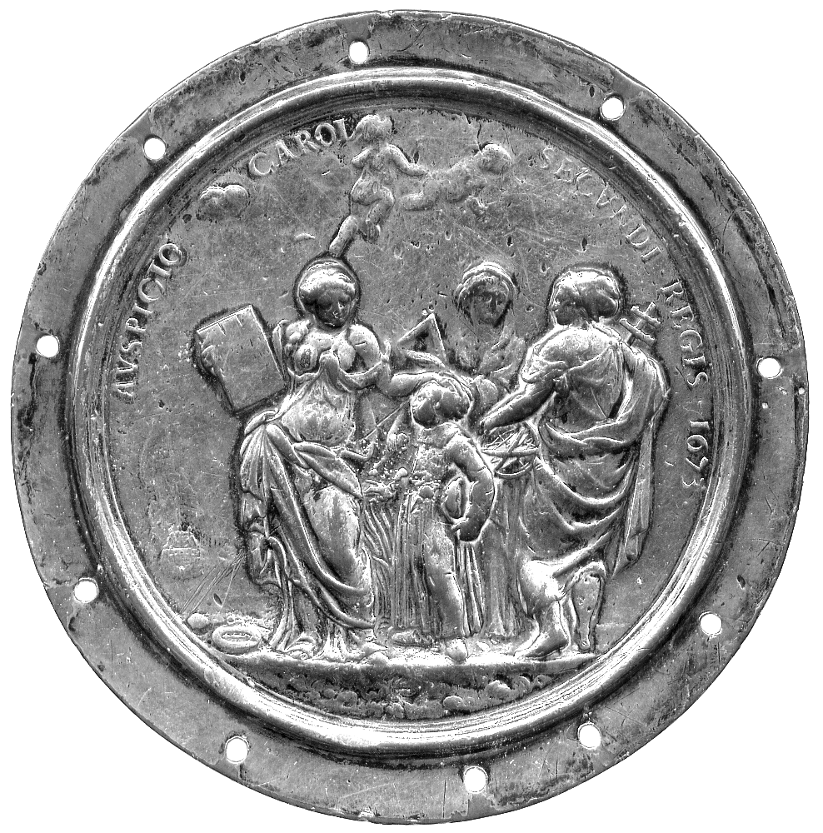  385 | 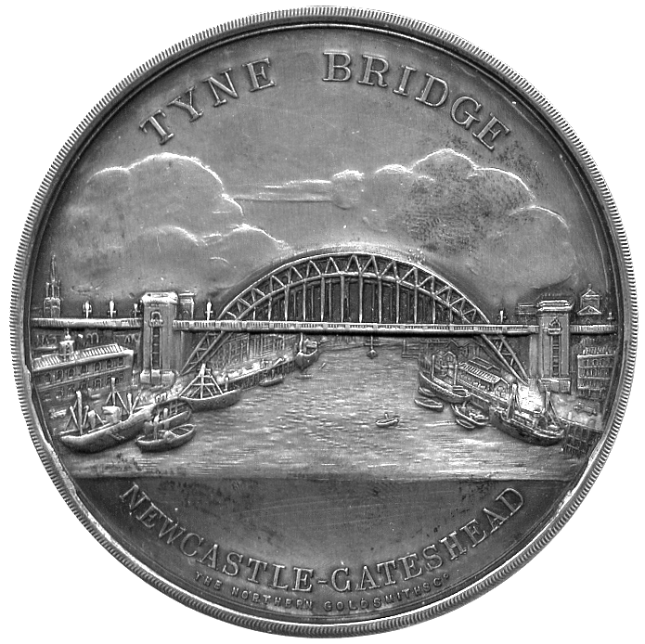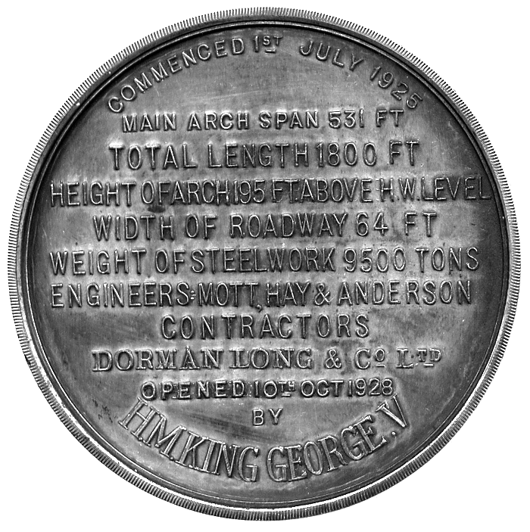  391

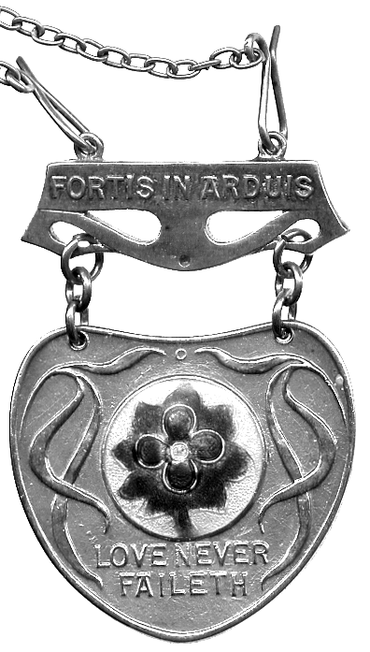390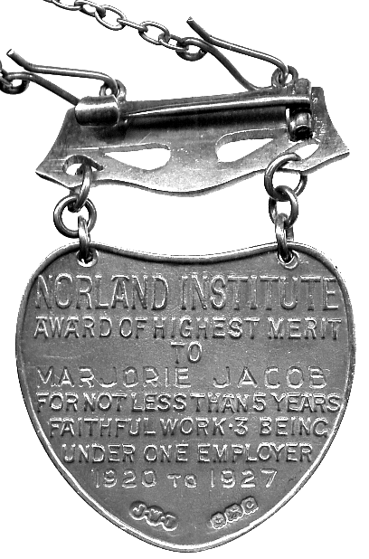 | 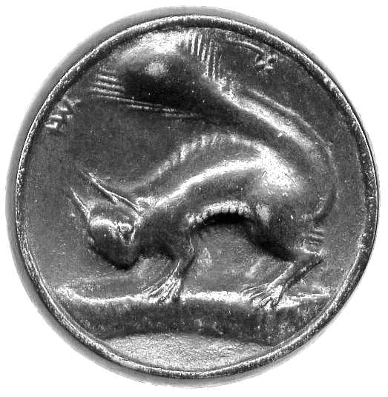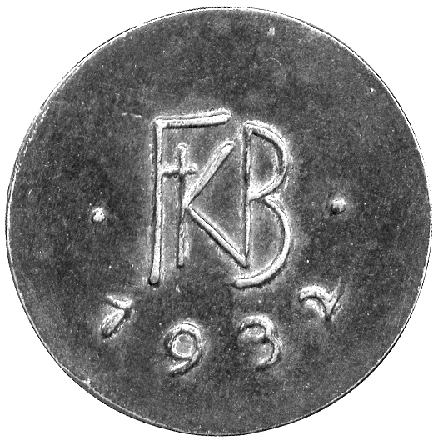  392

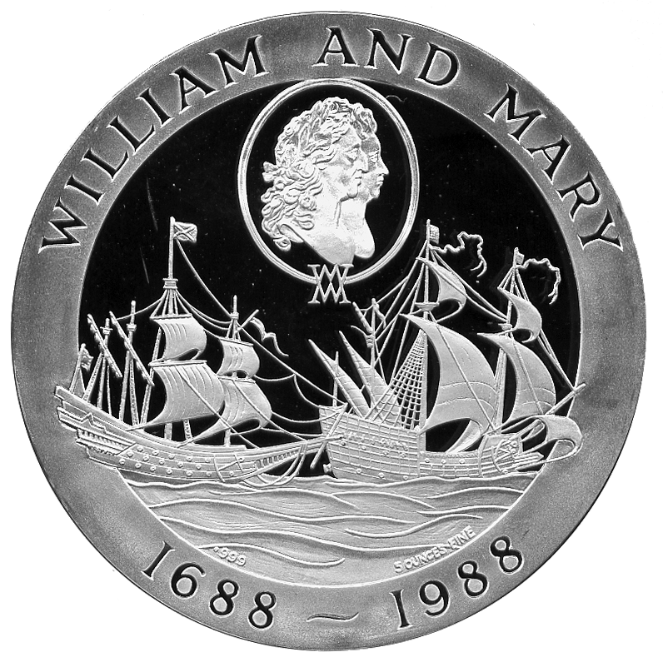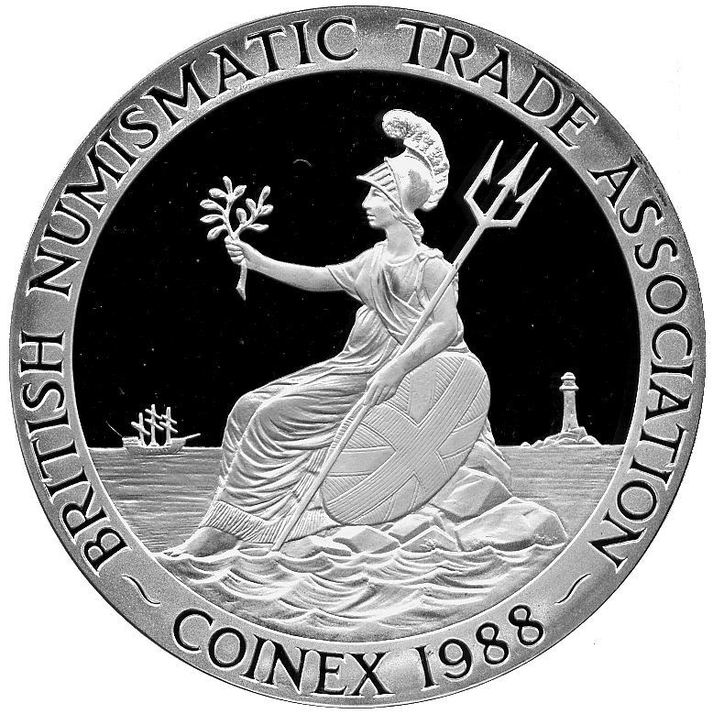  395 | 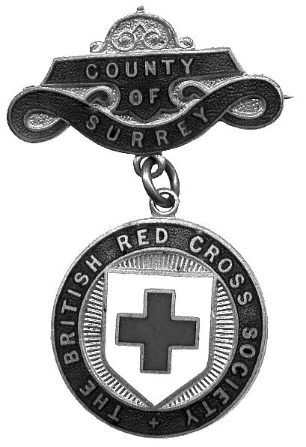  402 | 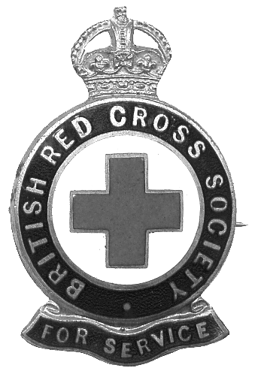  402

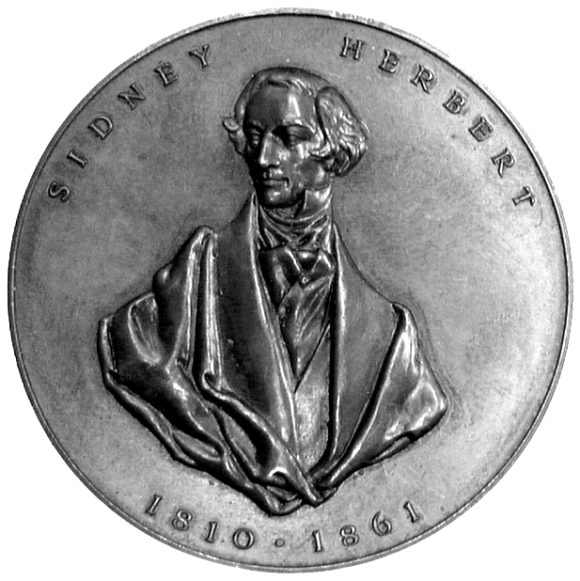404 | 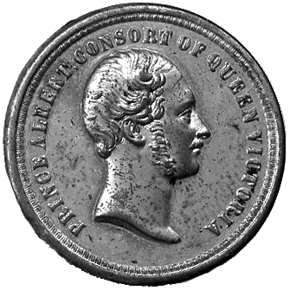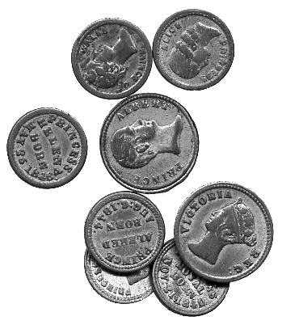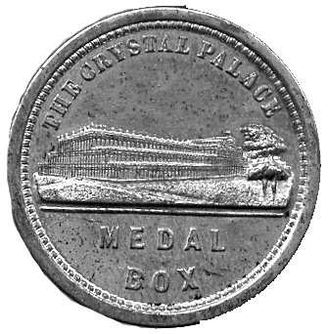  ------------- 406 -------------

374 Repeal of the Stamp Act 1766, Bronze Medal, by T Pingo, signed IW on truncation, bewigged half-bust of William Pitt the Elder left, rev ‘The Man Who Having Saved The Parent Pleaded With Success For Her Children’ in upper case, 40mm (BHM 100; Betts 516; Eimer 713; Eimer Pingo 34). Good very fine. £100-130

375 George Canning, Death 1827, Bronze Medal, draped bust left, rev names of cabinet ministers in fifteen lines, 46mm (BHM 1305). Almost extremely fine, a few minor dings. £40-50

376* William IV, Coronation 1831, Silver, by W Wyon, bust right, rev diademed bust of Queen Adelaide right, 33mm, in case of issue (BHM 1475). Good extremely fine, a little dirty. £40-50

377 London Bridge Opened 1831, Bronze Medal, by B Wyon, barehead bust of William IV, rev view of London Bridge, 51mm (BHM 1544; Welch 1; Taylor 102a). Good very fine. £40-50

378* William IV, Copper Coronation Medal, by W Wyon, 33mm (BHM 1475). Cabinet wear to high points and spot of deposit on hairline, otherwise extremely fine. £20-30

379 Marquis of Camden installed as Chancellor of Cambridge University 1835, Bronze, bust left, rev interior of the Senate House, 44mm (BHM 1685; Taylor 45a); Opening of the Royal Exchange 1842, Bronze, by W Wyon, Queen’s diademed bust left, rev legend in ten lines, 44mm (BHM 2078), good very fine, obverse better with pleasing portrait; John, Lord Russell, and the Repeal of the Corn Laws 1846, Bronze, by A J Stothard, bust right, rev FREE TRADE within corn wreath, outer legend around, 44mm (BHM 2237). Extremely fine, except as stated. (3) £40-50

380* A small silver (?) dish, 83mm set with a Queen Victoria Rupee 1840, total weight 47g. Coin fine. £30-40

381* General Thom Thumb 1844, White Metal, by J Moore, published by P T Barnum, ‘Thom Thumb’ stands on a table surface, next to books, eggcup, goblet etc, rev a coach and four, 39mm (BHM 2156). Extremely fine, very rare. £40-50
Charles Stratton (‘Thom Thumb’) was an American midget who toured with Barnum’s circus in London during 1844

382 English Cathedrals (3), Bronze Medals, by J Wiener, all 60mm, obv exterior view, rev interior views, comprising St Paul’s 1849 (BHM 2363; E 1505; Taylor 39i); York Minster 1854 (BHM 2558; E 1508; Taylor 13d), Westminster Abbey 1856 (BHM 2592; E 1506; Taylor 8b). Last two extremely fine, first very fine. (3) £60-80
383* Scotland, Perth Grammar School, Silver Prize Medal for Latin, double-headed spread eagle with motto and date MDCCCLI below, rev legend, awarded to Francis Morison session 1852-53, 48mm (Cochran-Patrick 163/2). Very fine, scarce. £40-60

384* Centenary of Sunday Schools 1880, white metal, bust of Robert Raikes right, rev Jesus and disciple receive children, 44mm, pierced with pale blue ribbon (BHM 3088), hairlines in fields, otherwise about as struck, rare; another, rev legend in field and around inner circle, 33mm (BHM -), extremely fine, rare. (2) £30-50

385* London, Christ’s Hospital School, the “Bluecoat School”, pupil’s Badge, silvered copper, uniface, Arithmetic, Geometry and Astronomy stand around pupil, 82mm (MI 577, 218). Silver a little worn on high points, pierced around rim as usual for sewing to coat. £40-60

386 Accrington, R T Hermon-Hodge MP, White Metal, by Pinches, bust left, rev 1890, Unionist legends around oval Union Jack, thistle, rose and shamrock below, 44mm. Almost extremely fine. £15-25

387* Queen Victoria, Diamond Jubilee Medal 1897 (3), Gold 55mm, veiled bust left, rev head left; with silver and bronze examples, similar, all in cases of issue (BHM 3506). Minor surface marks on gold and silver, the bronze extremely fine. (3) £700-800

388 19th Century Medals and Medalets in White Metal (7), varied state, a lead striking of Küchler’s First of June medal (BHM 383), about fine, Francis Egerton, Earl of Bridgewater, Copper (BHM 1340), good fine, others (4), varied state. (13) £100-150

389* King Edward VII, Coronation Medal, 1902, Copper, bust of Edward VII right, rev bust of Queen Alexandra right (BHM 3737). Light scratches in field, very fine. £20-30

390* Norland Institute, silver award Medal, heart-shaped badge with central coloured enamel roundel of a forget-me-not, Art Nouveau flourishes either side, LOVE NEVER FAILETH below, suspended from a brooch bar with legend FORTIS IN ARDUIS, rev AWARD OF HIGHEST MERIT TO MARJORIE JACOB FOR NOT LESS THAN FIVE YEARS FAITHFUL WORK 3 BEING UNDER ONE EMPLOYER 1920-1927, Birmingham hallmark below, fine silver neck chain attached. Extremely fine, rare. £40-60

391* Newcastle-upon-Tyne, Tyne Bridge Opened 1928, silver plated, issued by the Northern Goldsmiths Co, view of the bridge, rev legend, 58mm (BHM 4224). About extremely fine, some traces of fingerprints, rare. £40-50

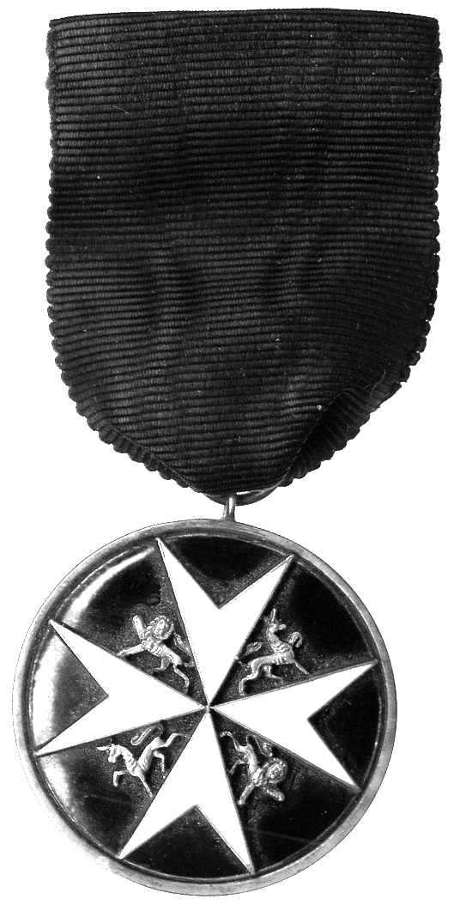401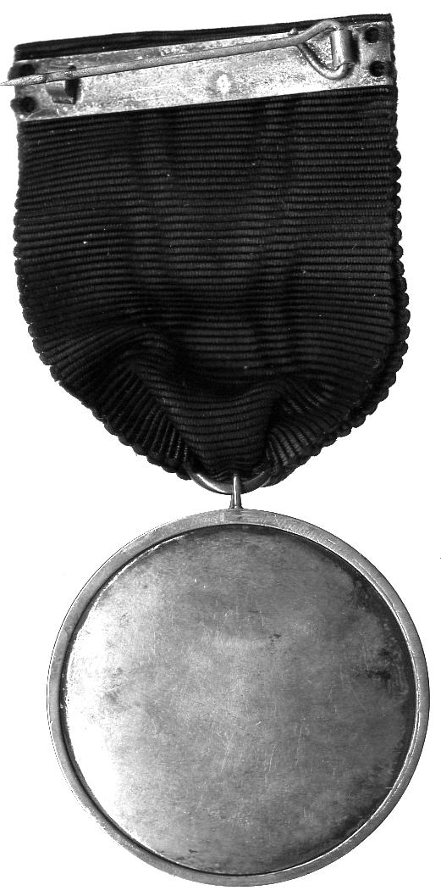 | 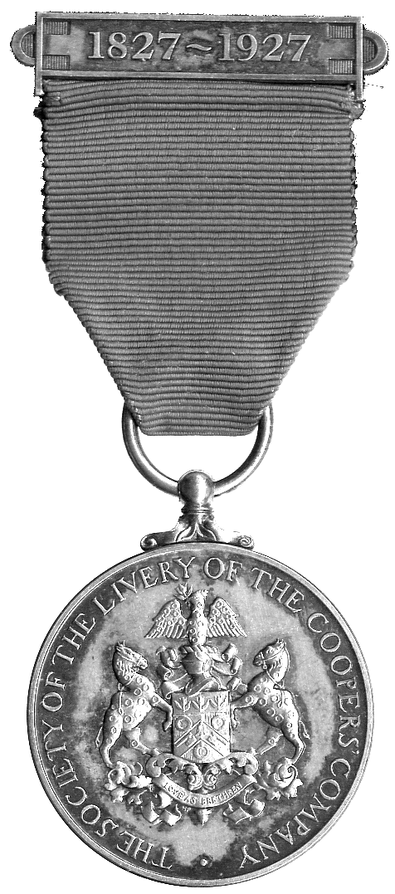405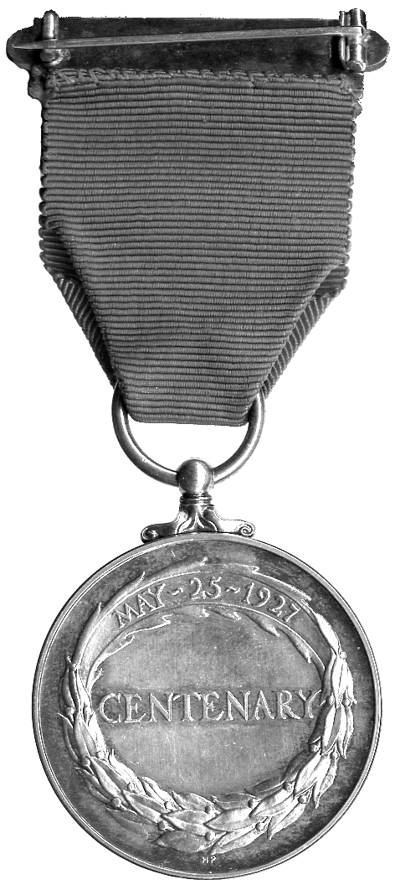

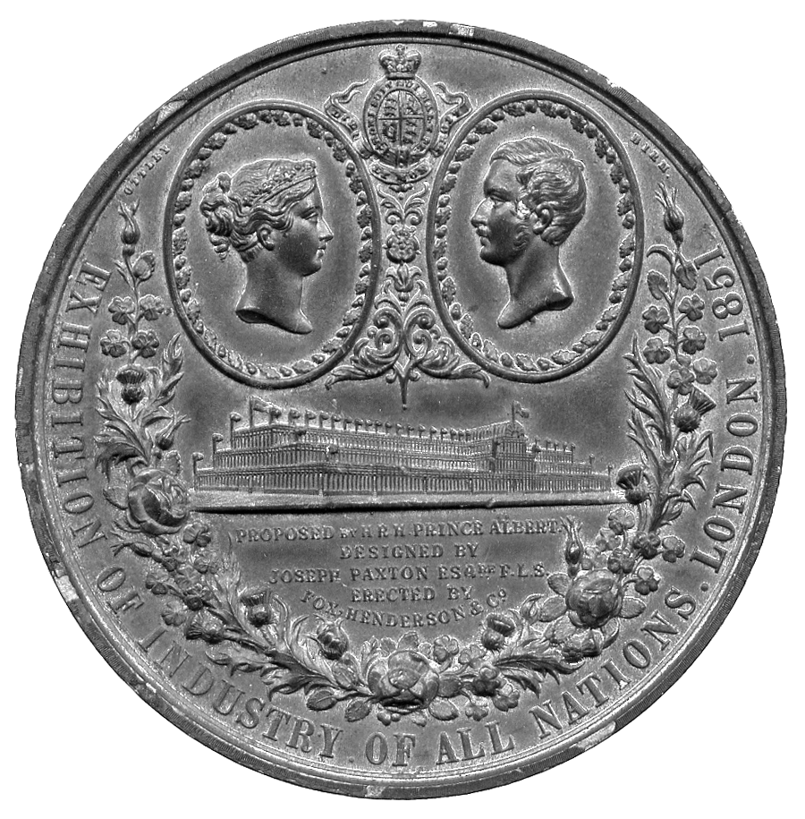407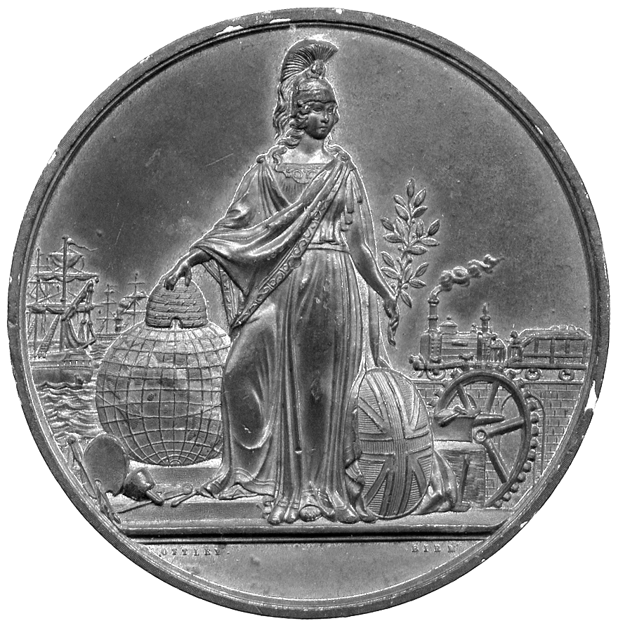

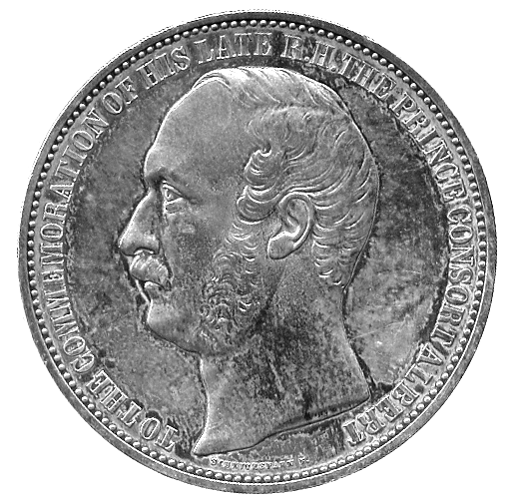409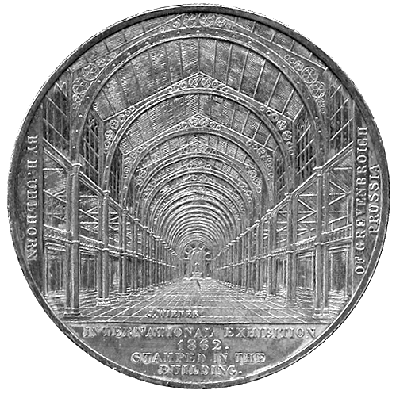 | 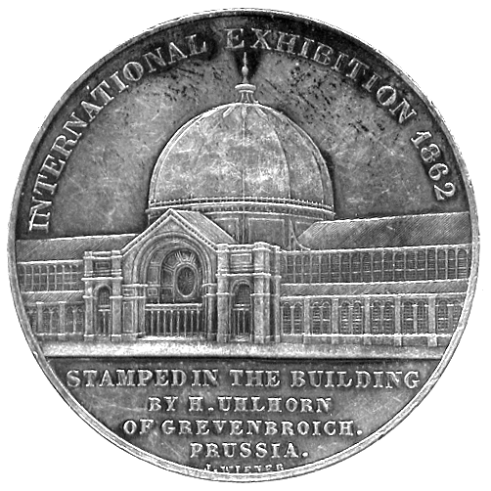410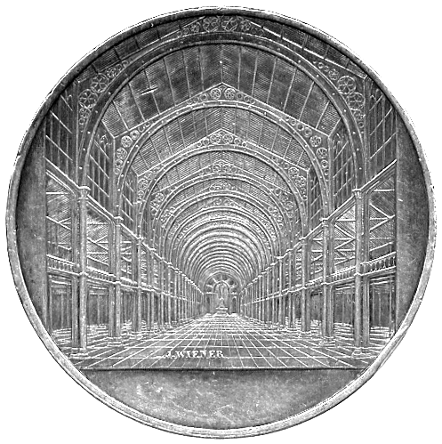

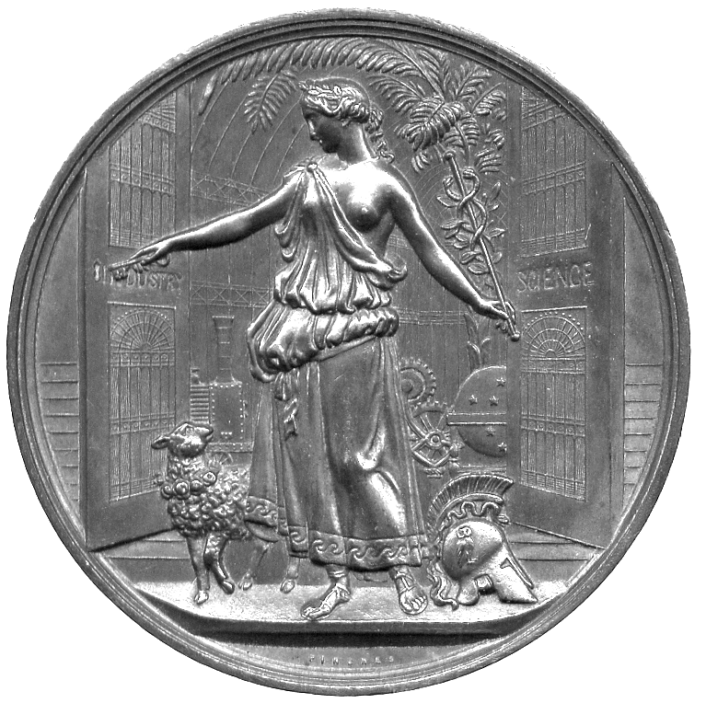411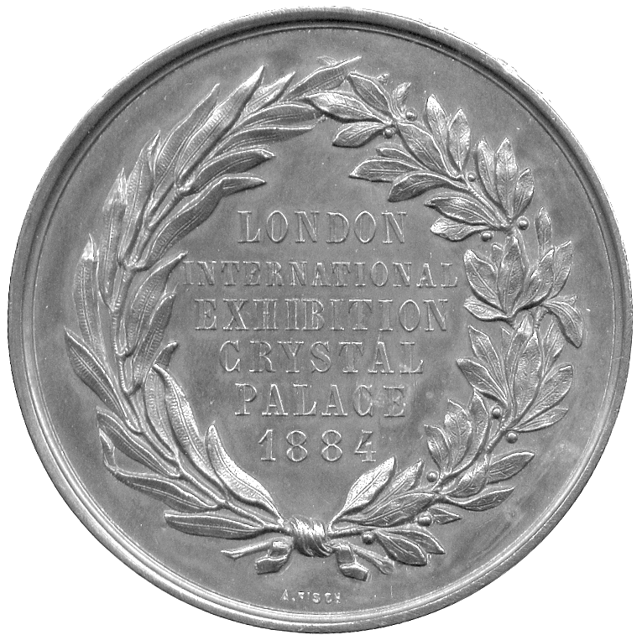

392* A small cast bronze Art Medal, signed HW, a squirrel on a branch, rev FKB monogram above date 1932, 44mm. Extremely fine, toned. £10-20

393 Samuel Pepys, Bronze laudatory medal 1984, by Ronald Searle, bewigged bust facing, rev full length bust of Pepys with hat and stick making a bow, 70mm (The Medal 6, p.45; Attwood no.20). About as struck. £60-80
From an edition of 93

394 Cornwall County Council, art and science technical instruction medal, Copper, awarded 1913 to Amelia M Bell, county arms, rev seated female with symbols, 45mm, in case of issue; Edinburgh, Commonwealth Games 1986, Copper medal, view of castle, rev chain around crown, 69mm, extremely fine, both cleaned; together with For Loyal Service badges (2), various 20th century sporting medals etc (10), good very fine and better. (14) £15-20

395* British Numismatic Trade Association, the Coinex Silver Medal 1988, William and Mary tercentenary, conjoined busts and shipping, rev Britannia, 65mm, 155.60g (5 troy ounces). Prooflike mint state, in Royal Mint case of issue. £30-40
number 21 of a limited edition

396 Pisanello, FIDEM Congress Medal 1992, Bronze, by Ronald Searle, bust facing wearing renaissance headgear, rev view from behind, 68mm, and a small silver lapel pin based on the medal’s reverse, by Fattorini. As issued. (2) £45-55

397 Handel’s Messiah, 250th Anniversary 1993, cast bronze art medal, by M Fernandez, organ pipes, rev crown of thorns, 92mm, issued by the Royal Mint, boxed. As issued. £10-15

398 ‘The Dux’, cast iron roundel, helmeted bust of a centurion left, 110mm. Pierced at 12 and 6 o’clock, as found. £5-8

399 Royal Mint, commemorative medallic issues (11), from the 1980s and 1990s, many from the Centenary Series, comprising College of Arms 1984, Æ, 63mm, Order of the Thistle 1987, Silver, 63mm, Armada 1988, Silver, 63mm, City of London Mayoralty 1989, Silver, 63mm, Mint Directors’ Conference 1990, Æ, 63mm, ‘The Original’ Lifeboat 1990, Æ, 63mm, Battle of Waterloo 1990, Silver, 63mm, London to Bristol Railway 1991, Æ gilt, 63mm, Birth of Henry VIII 1991, Silver, 63mm, High Sheriff’s Office 1992, Æ, 63mm, Barometer 1993, Æ, 85mm, The Women’s Institute 1997, Æ, 63mm, other modern issues (3), all in cases of issue. As issued. (14) £120-150
CLUBS AND SOCIETIES

400 Manchester Pitt Club, Silver Medal, by T Wyon, bust of Pitt left, rev Pitt arouses Britain to resist anarchic demons, 49mm (BHM 771), about fine but knocked and scratched, pierced through flan above head; United Ancient Order of Druids, lead medal, hooded bust of Druid left, rev warrior and druid supporters of shield with oaktrees, motto UNITED TO ASSIST below, 53mm, about fine, pierced at 12 o’clock, some knocks, the obverse field particularly tooled. (2) £15-25

401* Order of St John, black and white enamelled officer’s beast badge in silver, black ribbon, c.1900, together with a white metal badge depicting the Order’s insignia, within crowned wreath. First extremely fine, second about very fine. (2) £50-70

402* British Red Cross Society, enamelled and gilt badges, County of Surrey Division, and General Service badge. Extremely fine. (2) £40-60

403 Society of Miniature Rifle Clubs, The Bell Medal c.1900, Copper Medal, winged statue of Britannia, riflemen below, rev legend in wreath, 38mm. Good very fine. £20-30

404* Royal Army Medical College, Copper Medal, Herbert prize medal, draped bust of Sidney Herbert almost facing, rev legend around edge, 51mm. Almost extremely fine. £20-30

405* London, Coopers’ Company, silver-gilt pendant Centenary Medal of the company, 1927, awarded to Leslie Trew Burnett, arms, rev legend in wreath, name engraved on edge, suspension ring, red ribbon and brooch bar, by Pinches, 36mm. Extremely fine, rare. £70-90

EXHIBITION MEDALS

406* Great Exhibition, London, 1851, small silver plated brass souvenir box, the lid embossed with a view of the Crystal Palace, the base with a bust of Prince Albert, containing eight silvered medalets, two with busts of Victoria and Albert, the others with busts of six of their children. About extremely fine, scarce thus. £60-80

407* Great Exhibition, London, 1851, large White Metal Medal, medallion portraits of Victoria and Albert above view of the Crystal Palace, an open wreath of thistles, rose and shamrock below, rev standing Britannia with attributes of Industry and Commerce, by T Ottley, 74mm (Allen HP-B285; BHM 2447). Dull, but very fine, rare. £40-60

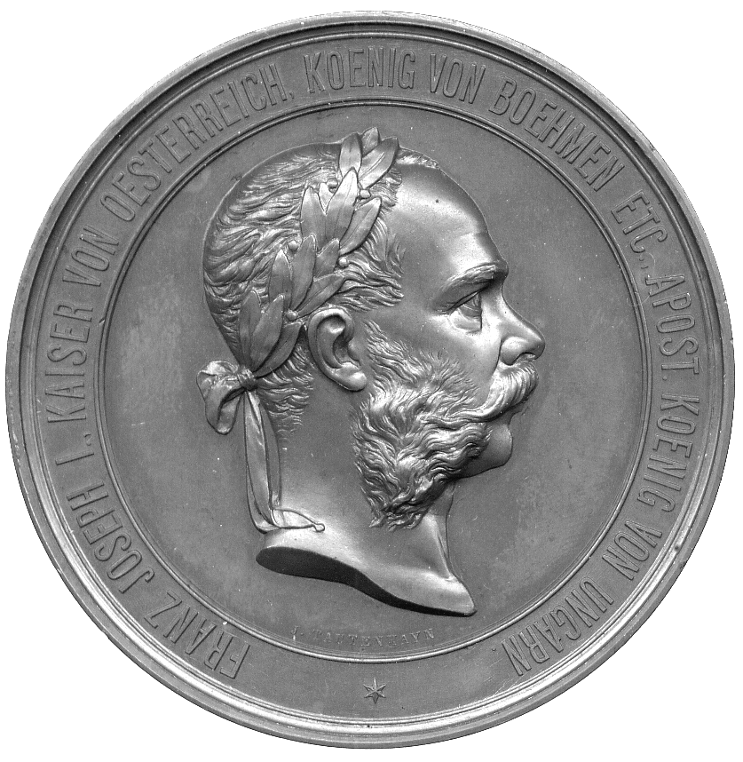412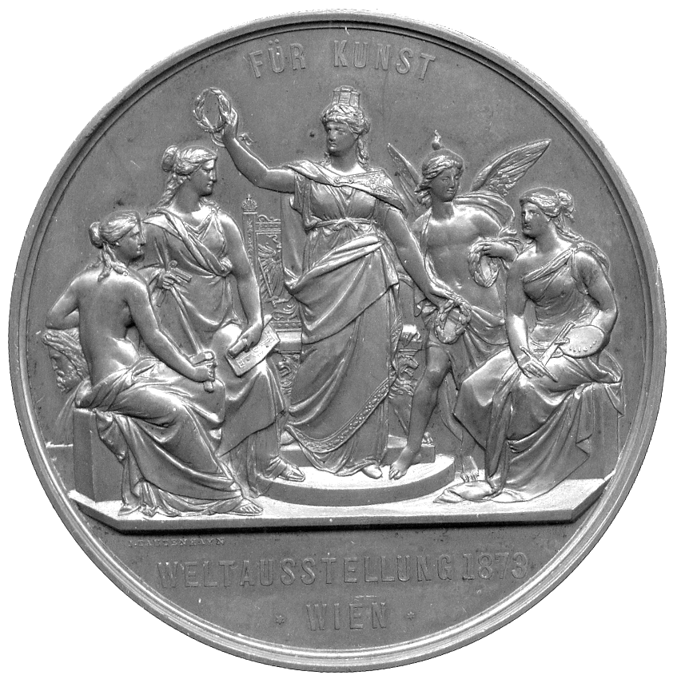

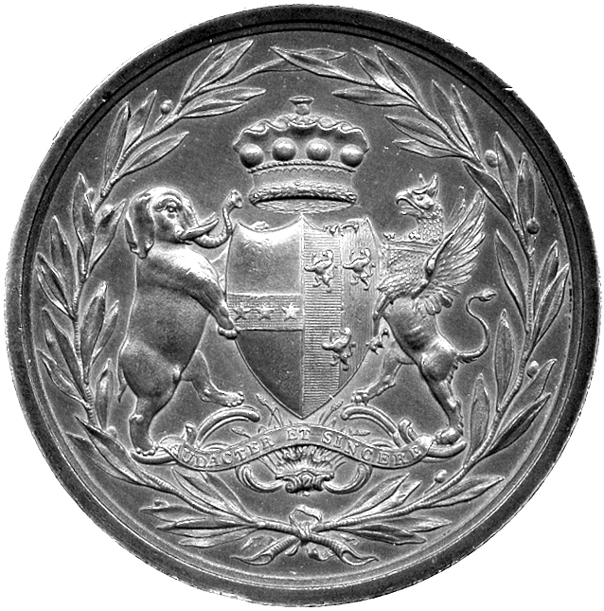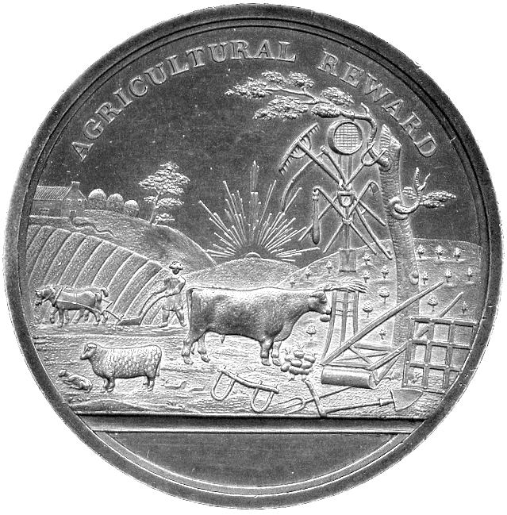  415 | 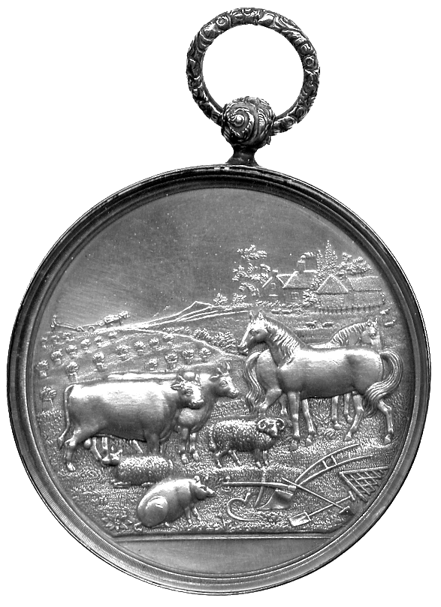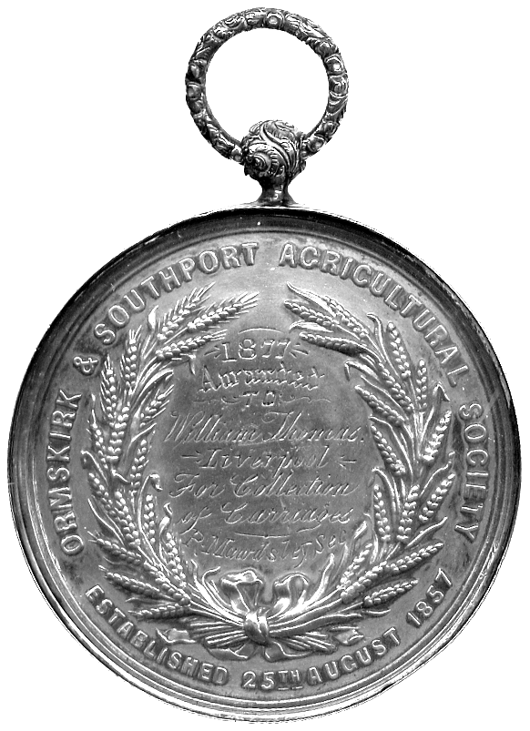  418

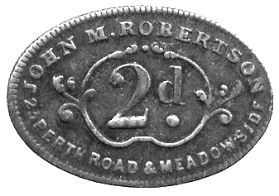  434  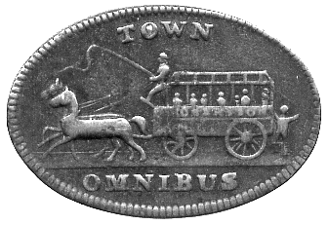 | 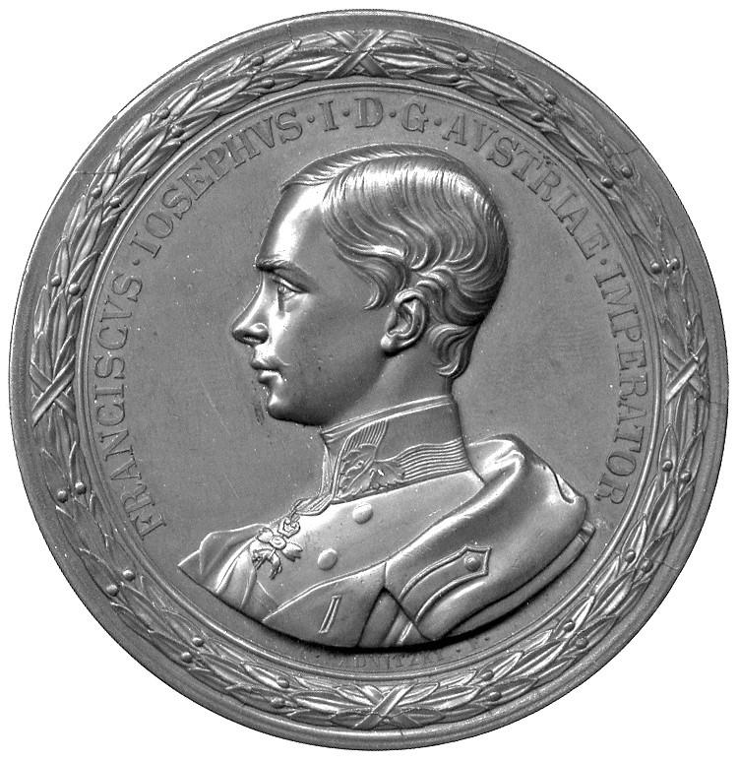438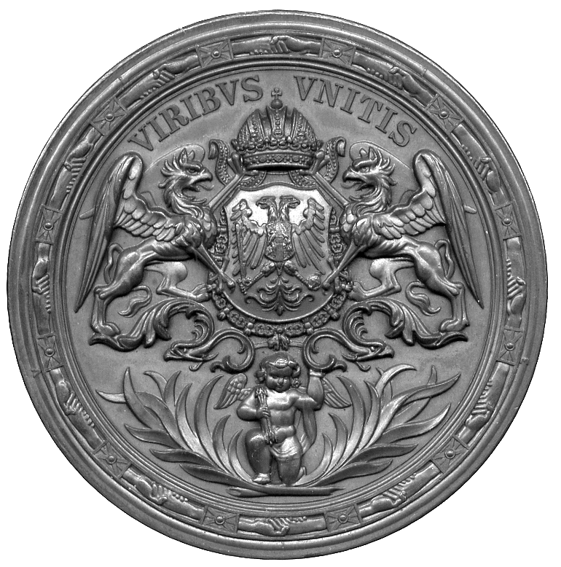

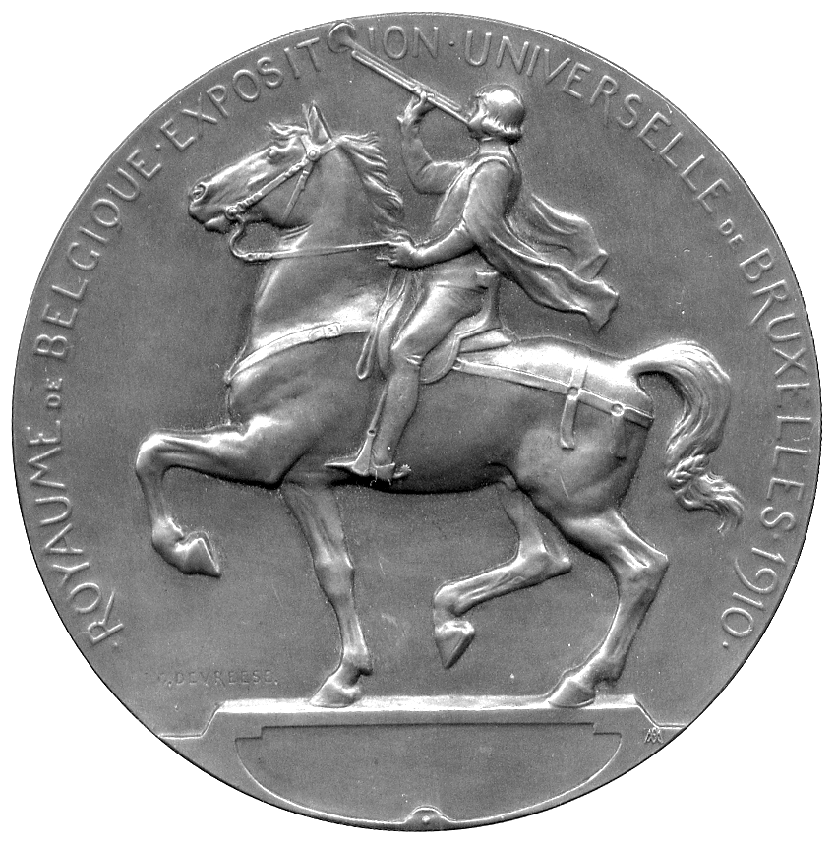441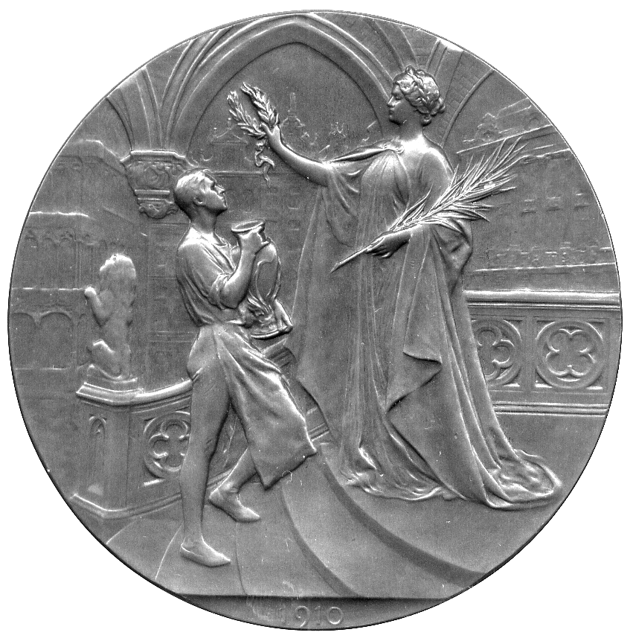

408 Crystal Palace, International Exhibition 1862 Medals (2), Silver and Silvered-Bronze, by H Uhlhorn and J Wiener, bust left of Prince Albert, rev exterior view of the palace, 41mm (Allen SK-B230; BHM 2743; Taylor 182u). Good very fine, first rare. (2) £30-40

409* Crystal Palace, International Exhibition 1862, Silver Medal, by H Uhlhorn and J Wiener, bust left of Prince Albert, rev exterior view of the palace, 41mm (Allen SK-B235; BHM 2745; Taylor 182s). Good very fine. £20-30

410* Crystal Palace, International Exhibition 1862, Silver Medal, by H Uhlhorn and J Wiener, exterior view of the palace, rev interior view, 41mm (Allen SK-B240; BHM 2746; Taylor 182t). Good very fine, rare. £25-35

411* Crystal Palace, International Exhibition 1884, Bronze Medal, Britannia holds caduceus and key, opens door to exhibition, lamb and helmet at her feet, rev legend within wreath, edge awarded to J W van Borselen, 62mm (Allen SY-1884/005; BHM 3174). About extremely fine, possibly onetime lightly cleaned, very rare. £80-120

412* Austria, Vienna, World Art Exhibition 1873, Bronze, by J Tautenhayn, laureate bust of Franz Joseph right, rev the city offers laurels to symbolic attendants, 70mm. Good extremely fine, good colour. £40-50

413 Austria, Vienna, Industrial Exhibition 1873, bronze, by J Tautenhayn and K Schwenzer [reverse], laureate bust right, rev youthful Fame hovers by figures symbolic of industry, 70mm. Good extremely fine. £40-50

414 France, Prize Medals, Science and Industry Exhibition, copper medal, 1879, by Déposé, seated figure with impliments relating to science, a balloon in the sky behind, 56mm, ornate integral suspension loop; Academy of Agriculture, Manu-facturing and Commerce, silvered bronze medal, c.1848, 51mm; International Exhibition of Beaux-Arts, London, copper medal, 1872, by Gayrard, 51mm; Temperance Medal, copper medal, 1878, by Oudine, 51mm. Very fine and better. (4) £40-60

AGRICULTURE & HORTICULTURE

415* Earl of Powis, Agricultural Prize Medal, Silver, c.1800, arms within wreath, including elephant and griffin supportsers, rev animals with rual scene, AGRICULTURAL REWARD above, 54mm. Almost extremly fine, rare. £150-200
416 Ministry of Agriculture and Commerce, Copper Prize Medal, by Gayrard, London Industry and Fine Art Expo 1872, France seated left offers laurels, rev wreath, 51mm. Extremely fine. £15-25
The International Exhibition was held in the Royal Albert Hall. Brown (BHM) records three British medals commemorating the event

417 Ministry of Agriculture and Commerce, Copper Prize Medals (2), Vienna Expo 1873, Philadelphia Expo 1876, France seated left offers laurels, rev wreath, 51mm. Extremely fine. (2) £20-30

418* Ormskirk and Southport Agricultural Society, glazed Silver Prize Medal, 1877, awarded to William Thomas of Liverpool for a collection of Carriages, obv rural scene with livestock and implements, rev engraved inscription within wreath, 48mm, with ornate suspension and ring. Good very fine, has been cleaned, indicating that at least one watch-glass is a replacement, a rare subject. £80-100

419 Staffordshire Agricultural Society, Prize Medal, frosted silver, glazed, by T Otley, awarded 1911 to George Watson, farm animals before house, rev corn wreath and legend, 48mm, with suspension loop. Almost as made. £50-80

420 Austria, Society for the Dissemination of Agricultural Knowledge, Vienna 1894, gilt Bronze Medal, by N Bachrach, Franz Joseph three-quarters facing, rev rustic social gathering, 65mm. Extremely fine although a few light field scratches, gilt faded from obverse. £20-30

421 Denmark, Horticulture, etc, small silver medal, by Conradsen, cherubs plant and water a palm, 37mm; Industrial and Agricultural Exhibition, Copenhagen 1888, copper-gilt medal, façade of building, rev allegorical figures, 52mm; Belgium, Royal Society of Agriculture and Linnean Horticulture, copper medal, by Wurden, bust of Linneaus left, rev blank shield [for naming], 50mm; France, Société d’Acclimatation, silver medal, awarded 1879, to M Meiselbrook, figure seated amongst animals, rev legends, 50mm; Agricultural Society of France, silver medal, awarded 1898, to “Comte F de Quatrebarbes”, 55mm; Antonio Canova (1757-1822), tribute medal, copper, by Caqué, for the Series Numismatica, 41mm; Louis Antoine d’Angoulême, Return to Paris from Spain, copper medal, 1823, by F A Caunois, laureate bust left, rev equestrian figure, 50mm. Mostly extremely fine. (7) £60-80

422 France, Société Centrale d’Horticulture du Département de la Seine-Inférieure, Rouen, c.1860, medals (3), silver, bronze (2), by Hamel et Lecomte, agricultural implements and produce, rev floral wreath, all 57mm. One bronze medal extremely fine, others about very fine and better, silver medal with ring for suspension. (3) £30-50
423 France, Rouen, Comice Agricole, Silver Prize Medal c.1875, by E A Oudiné, bust left of Olivier de Serres, Seigneur du Pradel, rev legend, 37mm (CGMP 3/296). Good very fine. £20-30
de Serres was a 16th century agronomist who wrote the influential book le Théâtre d’Agriculture et Mesnage des Champs

424 France, Bernay, Comice Agricole, Brionne meeting 1892, Bronze Medal, by H Dubois, Ceres in a field teaches agriculture to sow, rev wreath and legend, in case of issue, 51mm (CGMP -); Vienne, Comice Agricole, silver gilt award medal, by A Dubois, pastoral scene, horse and cow to the fore, rev wreath and legend, 57mm (CGMP 3/160 var). Extremely fine or nearly so. (2) £20-30

425 France, Cette Horticultural Society, Silver Prize Medal, awarded 1904, by A Rivet, man and woman tend to garden, rev award inscription and horticultural scene, 44mm, very fine; Société des Agriculteurs de France, Silver Agricultural Prize Medal, by G Trotin, tablet for inscription surrounded by agricultural implements and animals, 54mm, extremely fine. (2) £20-30

426 France, Agricultural Medals (2), Institut Agricole de Beauvais, Silver, obv ornate crucifix behind a plough and a wheatsheaf, rev a), farmyard animals, b) farmer and a team of horses working a field, both 40mm. Somewhat scuffed and dirty but good very fine. (2) £30-40

427 France, Art medal, “Agriculture”, rectangular Bronze Plaque, undated (1904), by L Coudray, peasant guides ox-drawn plough, rev peasant wields scythe in cornfield, 100mm x 62mm approx; “Agriculture”, rectangular Æ Plaque, undated, by Ch Pillet, semi-clad woman leads oxen and ploughman through field, rev youthful labourer rests from his exertions by field edge, 65mm x 48mm. Both extremely fine. (2) £50-70

428 France, Viticulture, a large uniface bronze medal, in imitation of the mediæval, two peasants attending a vine, 94mm; Malta, a modern silvered bronze medal of Jean de la Valette, 63mm; Nancy, a bronze medal in imitation of a mediæval religious seal, 72mm. Very fine and better. (3) £30-50

429 Netherlands, Royal Zoological Association, Golden Jubilee 1888, Copper Medal, lion and tiger beside shields with arms, an elephant prominent behind, rev laurel sprig below dates, 42mm; Overijssel Agricultural Association, Deventer Silver Medal, awarded 1900, two armorial shields crowned within wreath, rev engraved legend above plough, 48mm. About as struck and extremely fine. (2) £30-50
TRANSPORT

430 Railways, Bletchley, zinc (?) triangular paycheck, uniface, LMR YM 142 BLETCHLEY in four lines, 38mm x 41mm approx. Good fine, pierced. £15-25

431 Railway Company pay checks (4), base, LM&SR, Traffic Dept Kentish Town, stamped 38, LM&SR, Goods, Leicester, stamped 668, LNER, Loco Running Dept, Bidston, stamped 123, and a check stamped PC numbered 274. Fine. (4) £40-60

432 Railways, Argentina, Jujoy to Ledesma Railway, 1903, Bronze, by Bellagamba and Rossi, standing figure of Argentina clasping hand of seated Bolivia, rev seven line inscription, 52mm (M 666a); silvered Bronze, by J Guttuzzo, standing female figure and seated youth, train in distance, rev ten line inscription, 53mm (Swan 355). First about extremely fine, second with test mark on edge, good very fine. (2) £30-50

433* Railways, Hungary, Opening of the Prague to Dresden Railway, 6 April 1851, Bronze Medal, by W Seidan, seated female figures representing Prague and Dresden shake hands, locomotive behind, rev view of Prague’s Old Town Bridge Tower, 48mm. Extremely fine. £40-50

434* Dundee, oval brass Town Omnibus Ticket, horse bus to left, rev JOHN M. ROBERTSON PERTH ROAD & MEADOWSIDE around 2d (Smith 300A). Good fine, scarce. £20-30

WORLD MEDALS

AUSTRIA

435 Battle of Leipzig 1813, silvered copper Medalet, by Steiner, busts of Franz of Austria and Alexander of Russia facing, rev view of battle before the town, 33mm. Good extremely fine. £10-15

436 Bohemian Coronation of Empress Maria Anna, Copper Medal, 1836, by J D Boehm, diademed and crowned bust right, rev crown on pillow with sceptre and laurel sprig, lion rampant on shield below, 47mm (BDM I, 203). Extremely fine, darkly patinated.. £20-30

437 Franz Joseph I and Elizabeth, Marriage 1854, Silver, conjoined busts right, rev angel seated facing holds two cornucopia in wreath of roses, 37mm. Extremely fine. £40-60

438* Franz Joseph I, Bronze Portrait Medal c.1855, by K Radnitzky, youthful bust of Emperor left, rev double-headed eagle on shield, crown above, collar of the Golden Fleece around, griffin supporters, VIRIBVS VNITIS above, 63mm. Extremely fine. £40-60

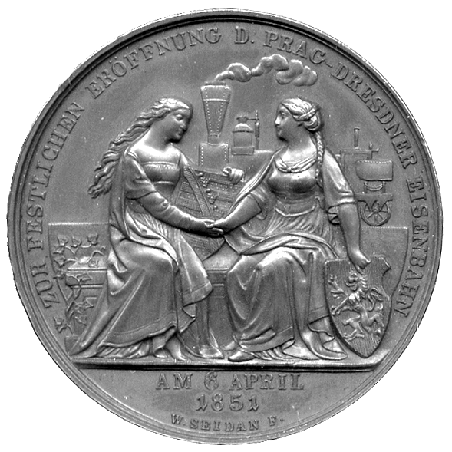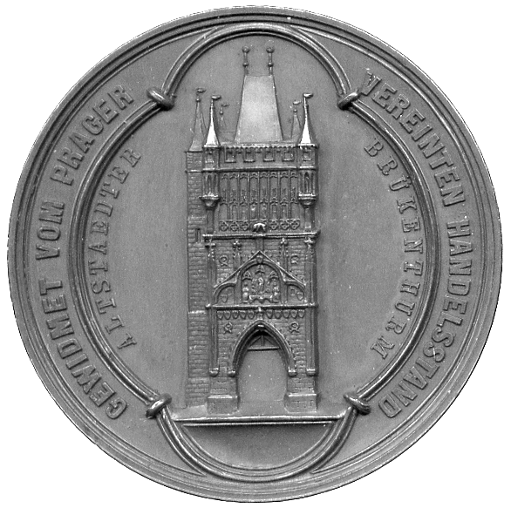  433 | 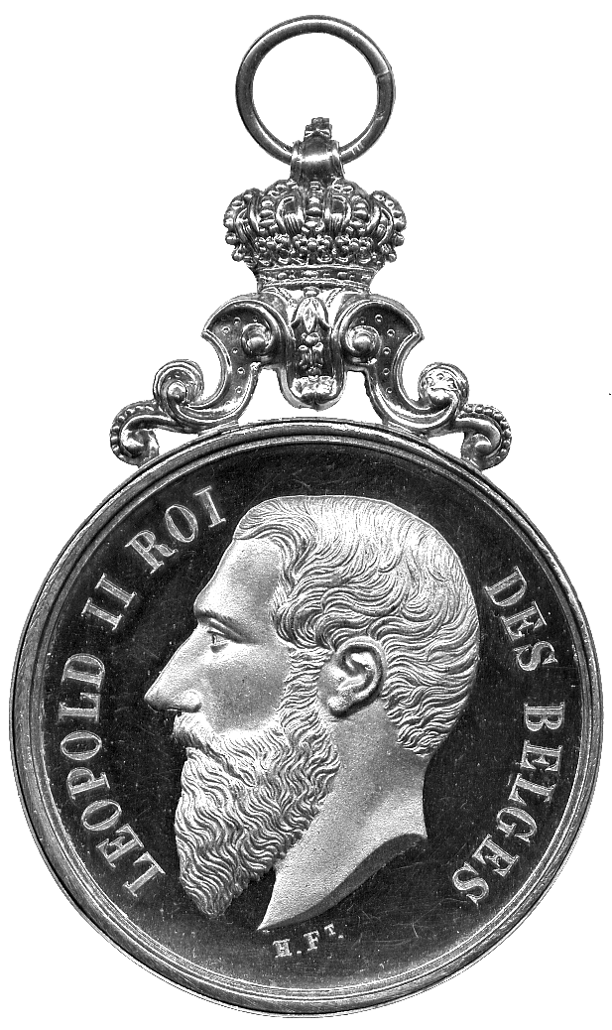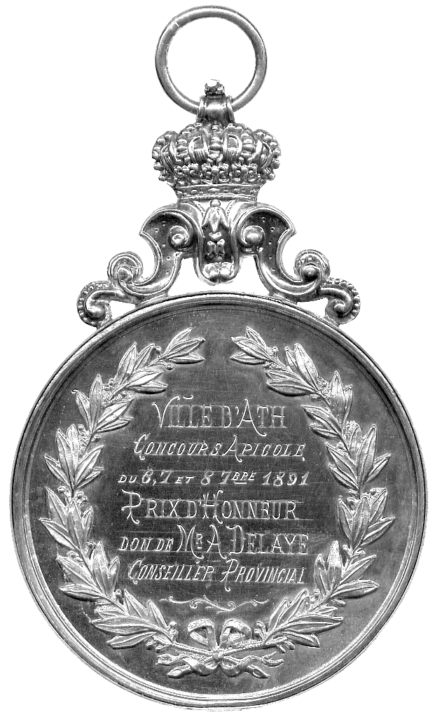  440

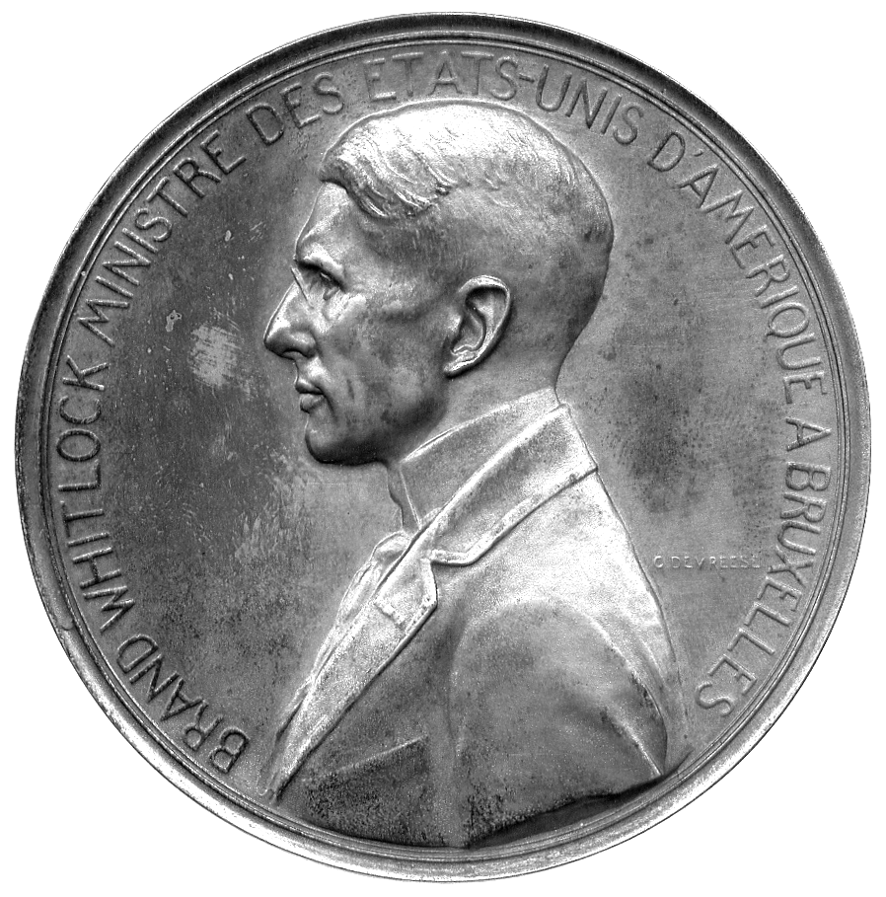442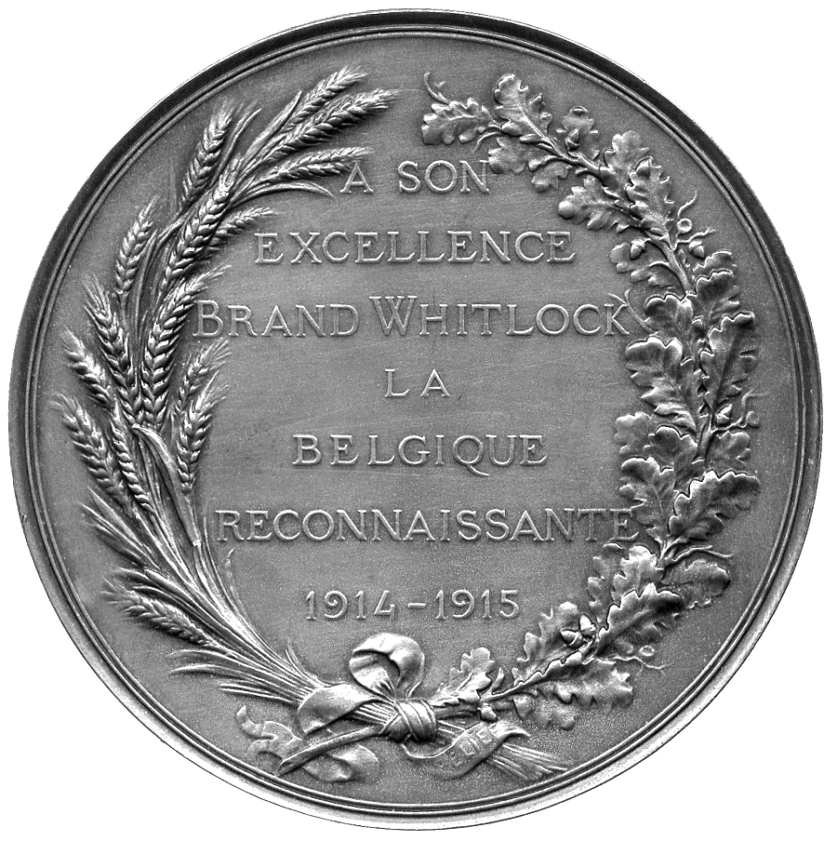

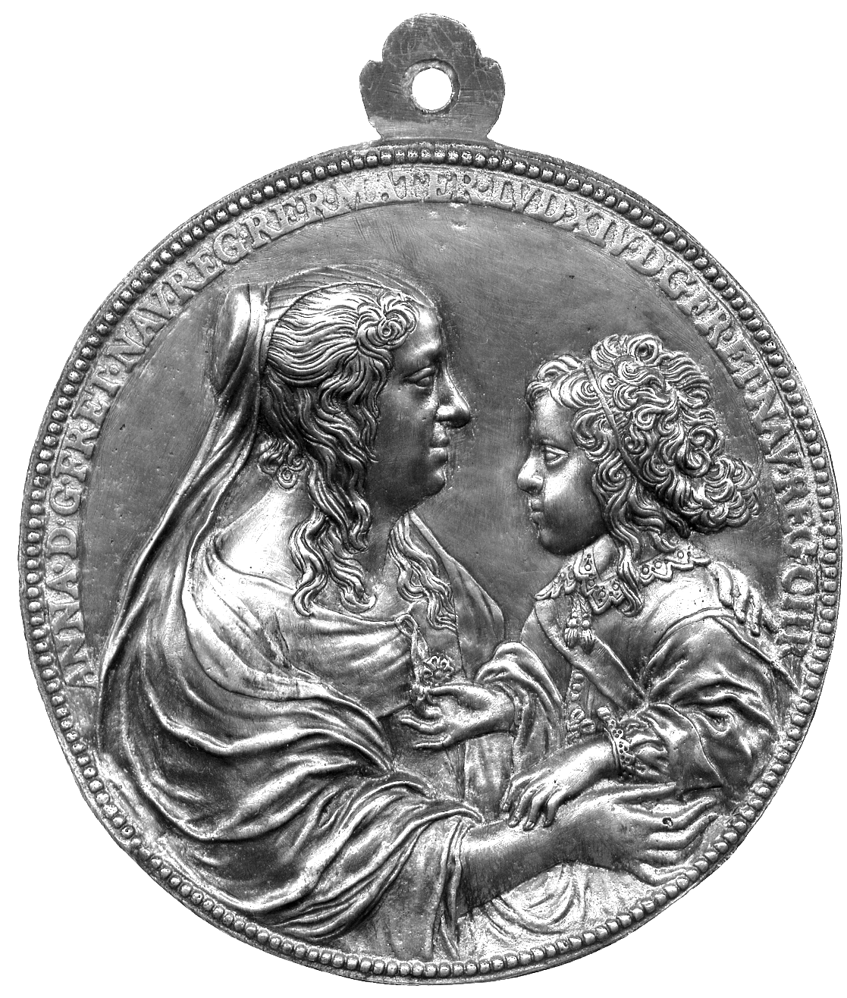  447 | 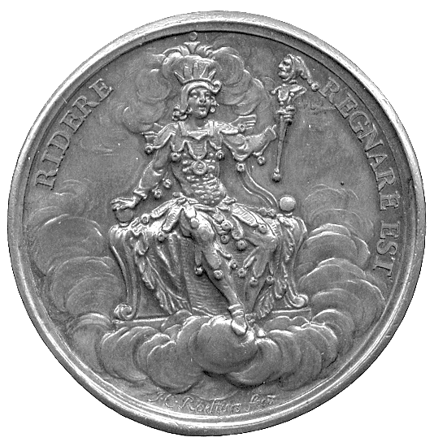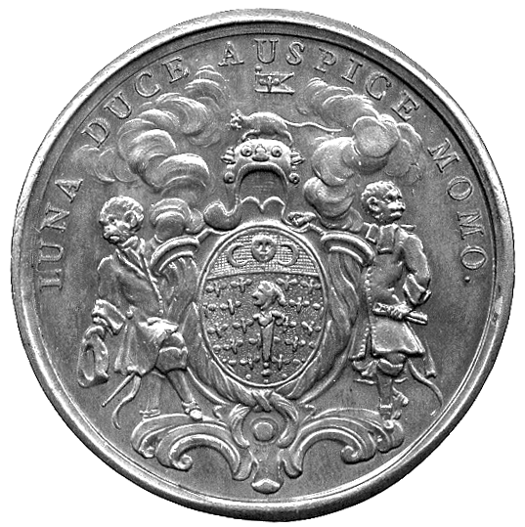  449  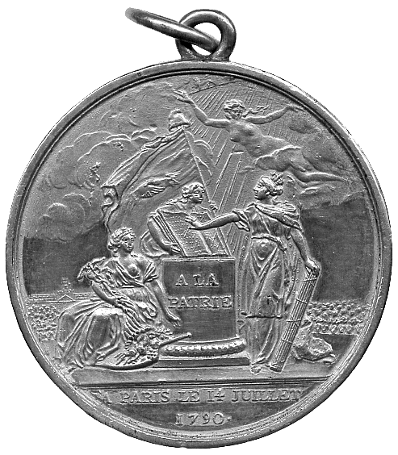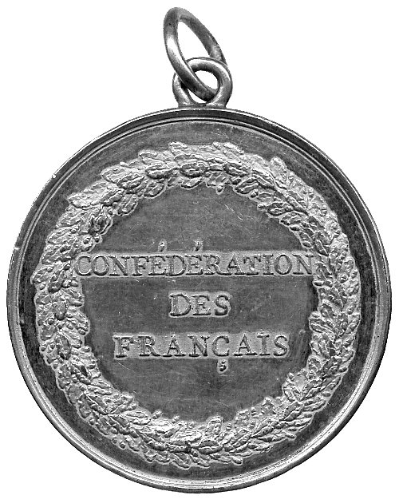  450

BELGIUM

439 Death of Pierre Simons, 1843, Copper Medal, by Delbarré and Veyrat, bust left, rev fifteen line inscription, 50mm (M 54; Swan 218). Extremely fine. £20-30

440* Ath, Beekeeping Prize Medal, silver gilt, awarded 1891, bust of Leopold II left, rev award inscription in wreath, elaborate crown suspension loop, 51mm. Extremely fine. £30-40

441* Brussels Universal Exposition 1910, Copper, statue of herald on horseback, rev Brussels holding pal branch, crowning artisan with laurel wreath, 70mm. Extremely fine in contemporary red leather case. £40-50

442* Ambassador Brand Whitlock 1915, Silver, by C Devreese, bust left, rev legend and wreath, 75mm. Good very fine. £40-50
Ambassador at the time of the Great War, he helped to expose German atrocities against the civilian population

CANADA

443 Quebec, Cyrile F Delâge, Surintendant de l’Instruction Publique 1924, Copper Medal, by J Bailleul, bust left, rev scientific instruments, 50mm, good very fine; other medals and medalets (6), Copper (5), 50th Anniversary of Canadian Confederation 1927, 25mm, visit of George VI and Queen Elizabeth 1939, 31mm (2), 25mm, Elizabeth II coronation 1953, 33mm; Hudson Bay Company, Tercentenary 1970, 45mm, generally very fine to extremely fine. (7) £20-30

444* Hudson’s Bay tokens (4), c.1857, 1, ½, ¼, (SCCC, 1976, 178-181). Attempted piercing to 1 and ½, otherwise very fine. (4) £80-100
The initials NB should be MB standing for Made Beaver which means prepared beaver skin.

CHILE

445 Bicentenary of the Mint of Santiago 1943, Silver Medal, by R Thenot, bust of Francisco Garcia de Huidobro left, rev Spanish royal arms, legend around, 70mm. Extremely fine. £10-15

EGYPT

446* Suez, Borel Lavalley et Cie, tokens (2), 50- and 20-Centimes (KM Tn1865). Very fine. (2) £80-100
FRANCE

447* Louis XIV (1643-1715), and Anne of Austria (1601-1666), uniface cast double-portrait medal, 1645, by Jean Warin, The Queen facing to right, in loose dress and widow’s veil, holds the young King facing her, his curled hair held back, and his right hand with the tassel to his mother’s dress, 96mm, suspension loop (cf BMC [Jones] 208; Maz. Varin, I, 60; Trésor II, pl. XII, 2, obv; Scher 342, 154; La Médaille…de Louis XIV, 130), a late cast, incuse image on the reverse, good very fine; ‘Le Charmeur’, silver plaquette, by C Loudray, lovers in woodland with fairy, rev children at play, 47mm x 70mm, very fine. (2) £250-300

448 Pierre Séguier, duc de Villmort 1663, attributed to Jean Warin, Copper Medal, capped bust right wearing Order of the Holy Ghost, rev lamb on a closed book resting on table draped with fleurs de lys, 54mm (Jones 273). A later striking from rusty dies, almost very fine, some spots of verdigris to reverse. £20-30

449* The Régiment de la Calotte, Copper Medal c.1730, by J Roettiers, arms of the society, rev a jester enthroned, 44mm. About as struck, rare. £70-90
This is perhaps a membership medal. The ‘Regiment’ was founded in 1702 and consisted of a group who ridiculed those in power or literary circles whose views they considered ignorant. It was disbanded at the time of the Revolution.

450* Napoleonic interest, Confedération des Français, 14 July 1790, Æ gilt, by N-M Gatteaux, Liberty holds open a book of the constitution upon which France places her hand to swear to uphold the constitution, Felicity sits at altar holding cornucopiae and caduceus, Truth flies through air, rev CONFÉDÉRATION DES FRANÇAIS within oakwreath, 41mm, with suspension loop (Henin 141). Extremely fine, fields have been tooled. £50-70
This medal commemorates the meeting held to celebrate the first anniversary of the Fall of the Bastille: deputies from across France gathered in Paris for an enormous ceremony of Federation – a declaration of loyalty and national solidarity. This medal was struck for the Municipality of Paris, to be given to the representatives of the départments attending the occasion, and others. However it was soon forbidden to wear such medals, since distinguishing oneself in such a way would run counter to revolutionary ideas of ‘égalité’. In August 1793 it was decreed that anyone wearing these medals was a traitor to the Republic.

451 Jeton, silver octagonal, dated Year 9 (1800), by NP Tiolier, view of the Ponts des Arts and the Seine, looking towards the Louvre, LES RIVES DE LA SEINE UNIES PAR DE NOUVEAUX LIENS in exergue, rev ASSOCIATION POUR LA CONSTRUCTION DES TROIS PONTS EN FER SUR LA SEINE A PARIS - LOI DU 24 VENTOSE AN 9 within wreath (Feu 5319). Extremely fine, nicely toned. £60-80

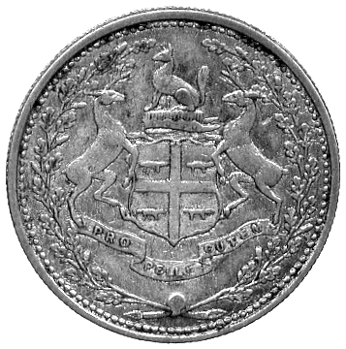444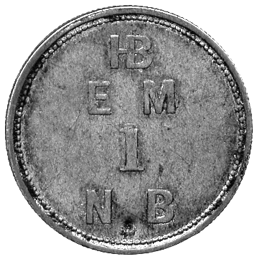 | 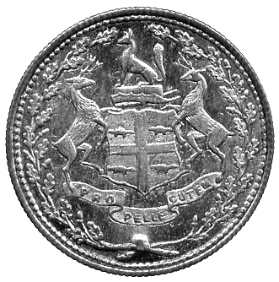444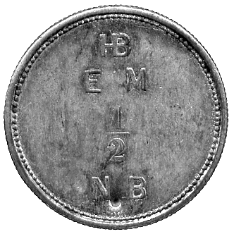 | 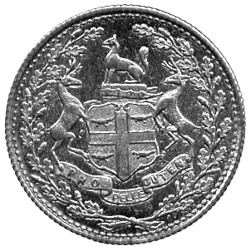444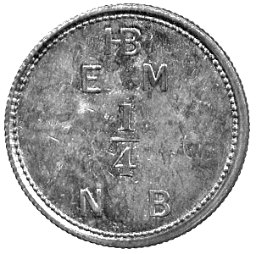

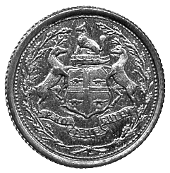444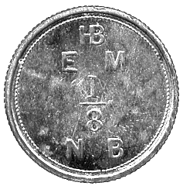 | 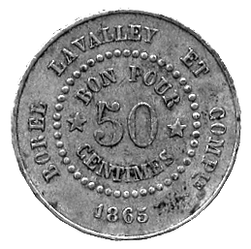446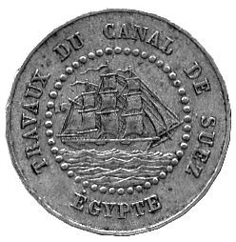 | 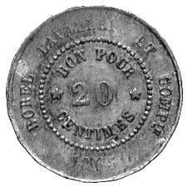446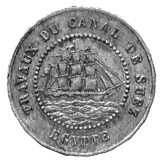

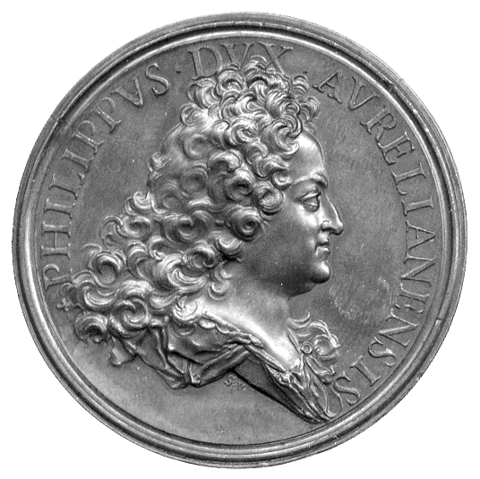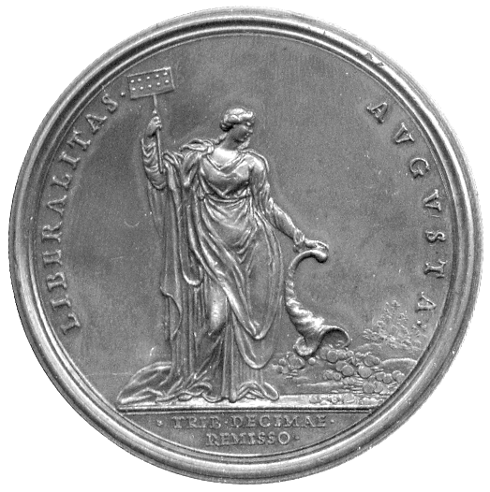  452 | 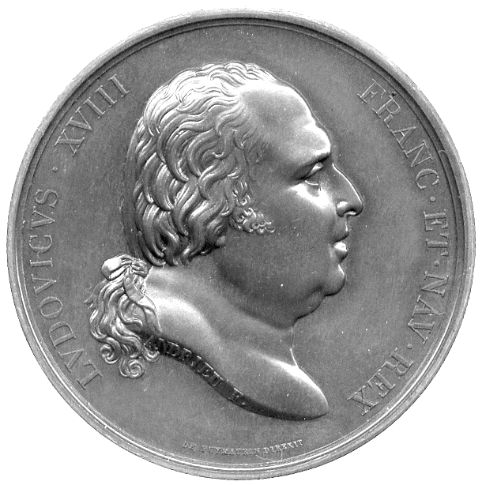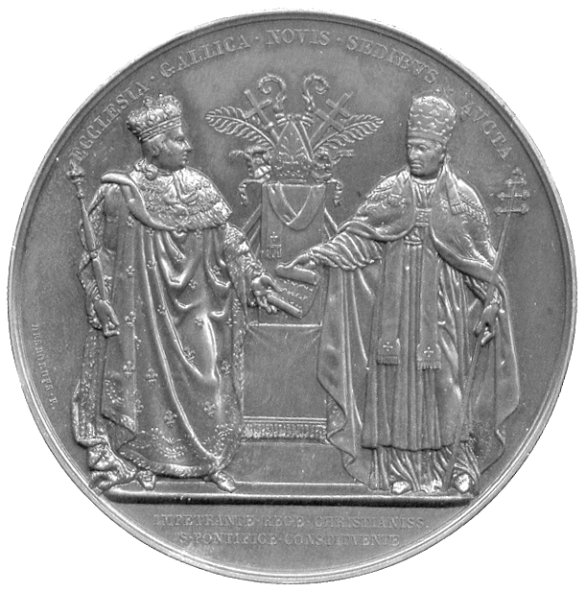  453

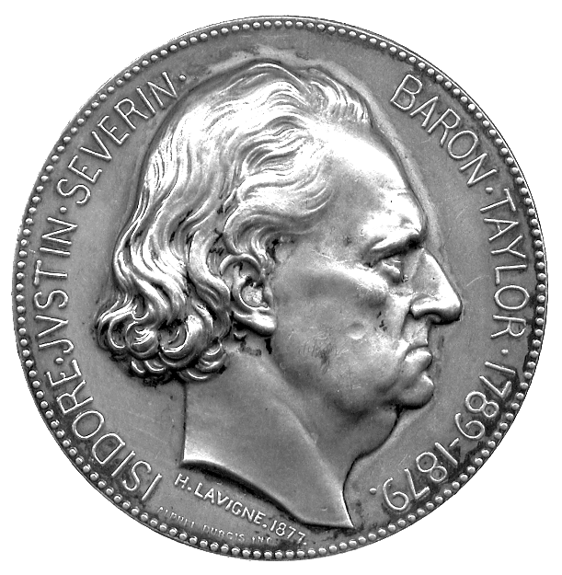462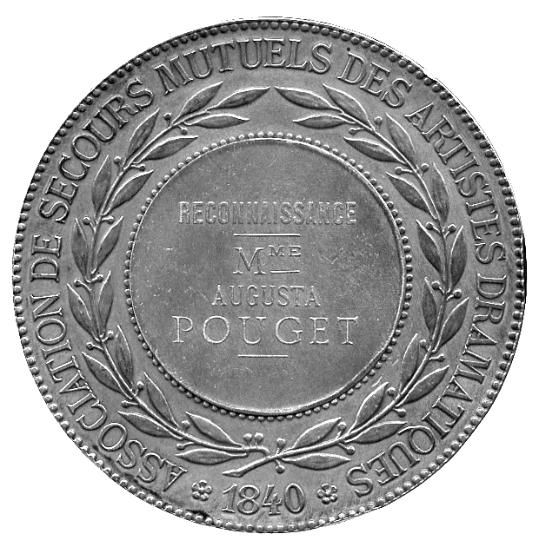 | 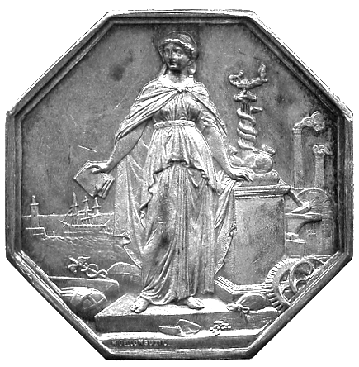  463

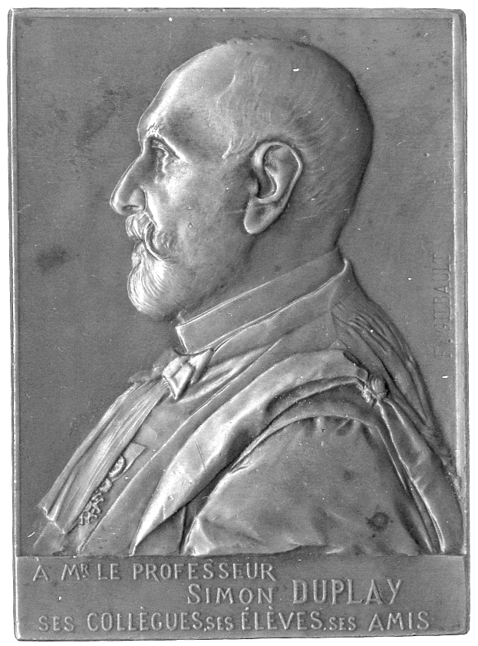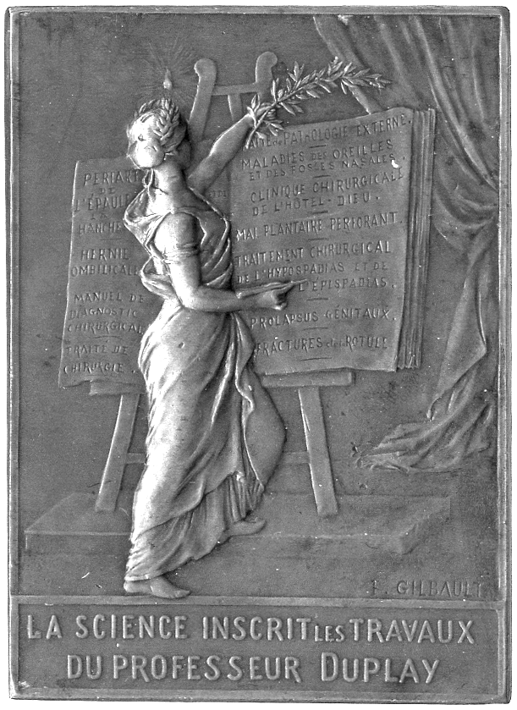  466 | 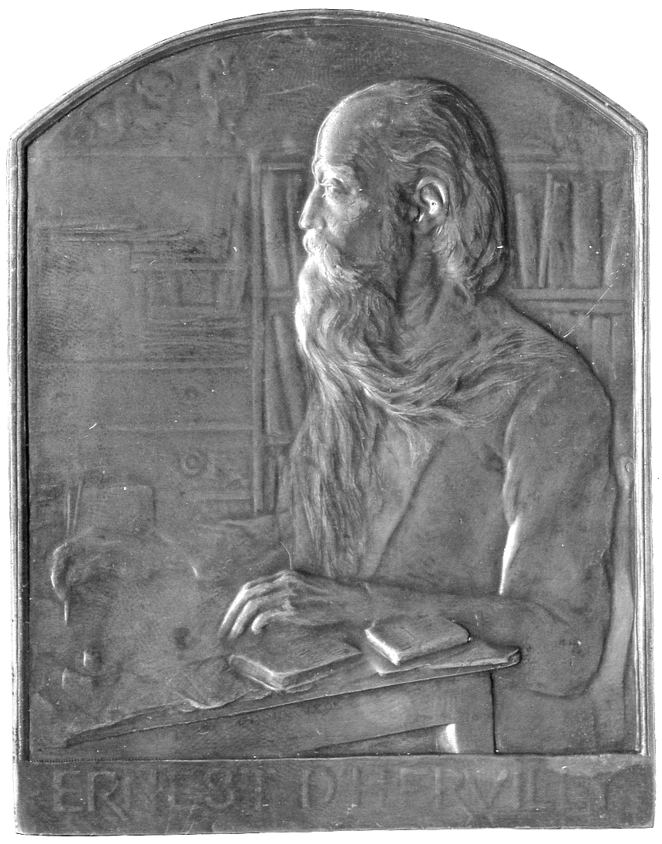  473

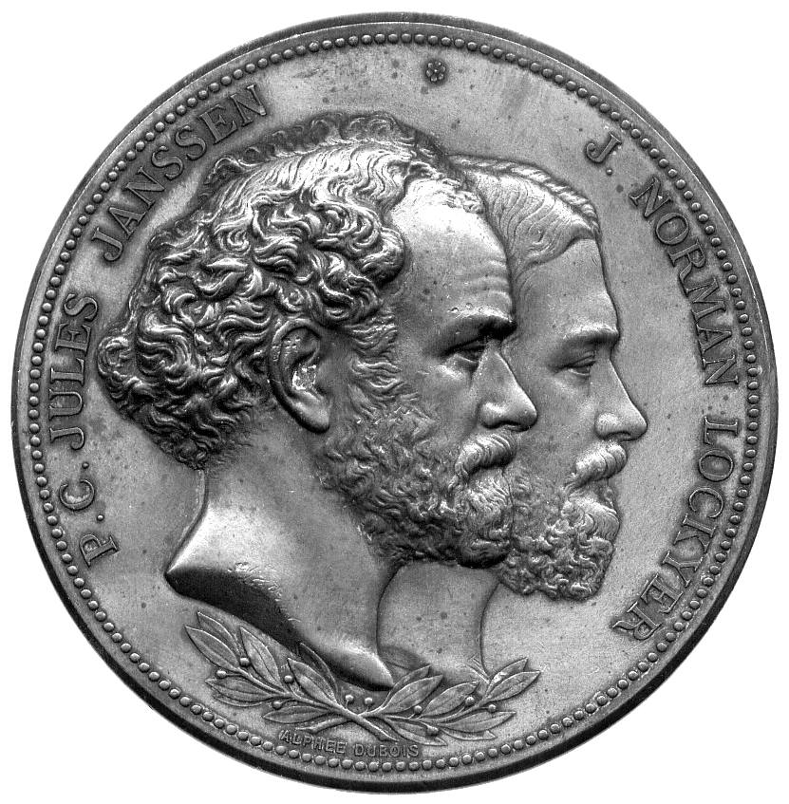467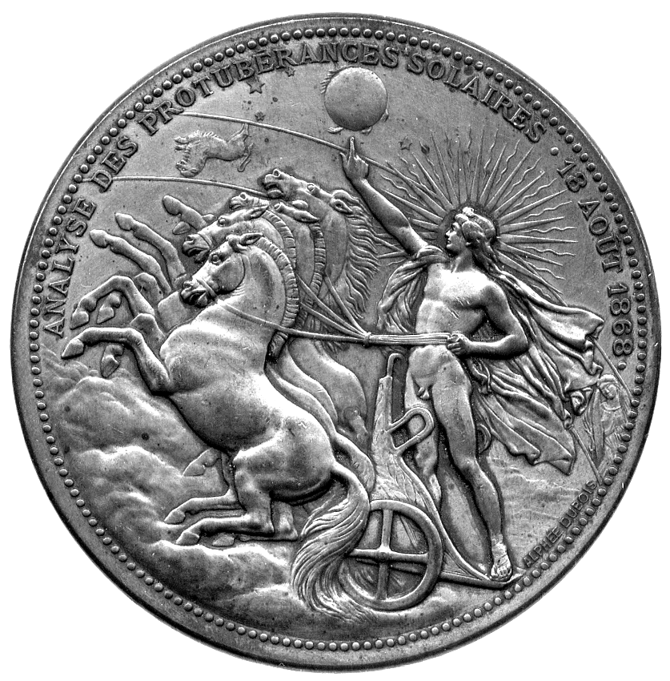

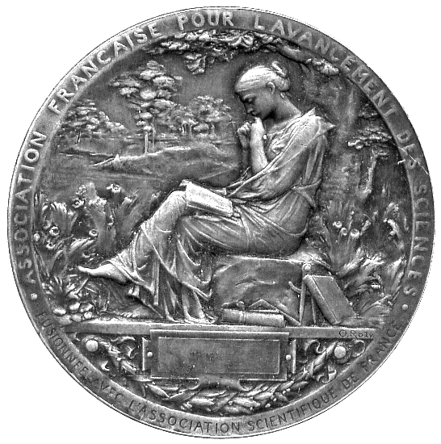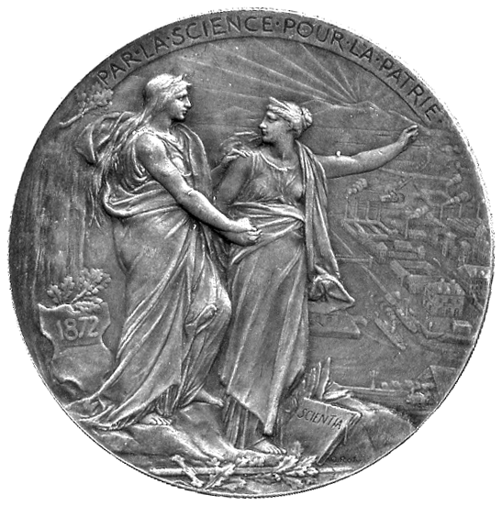  471 | 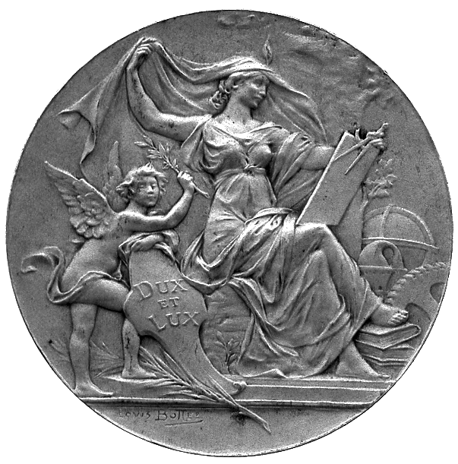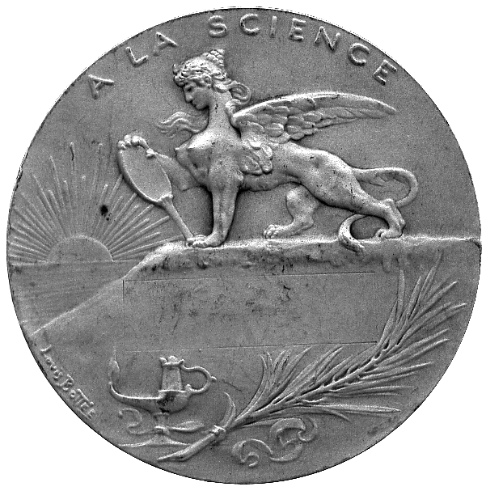  471

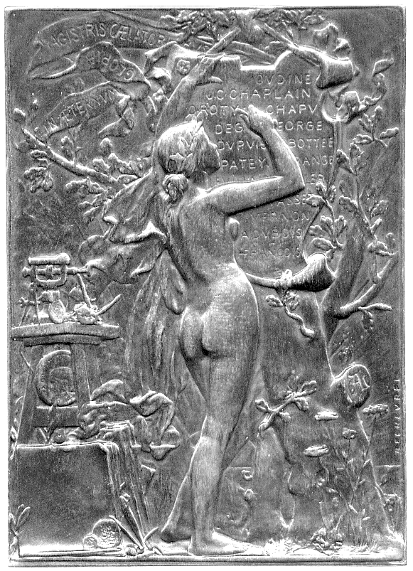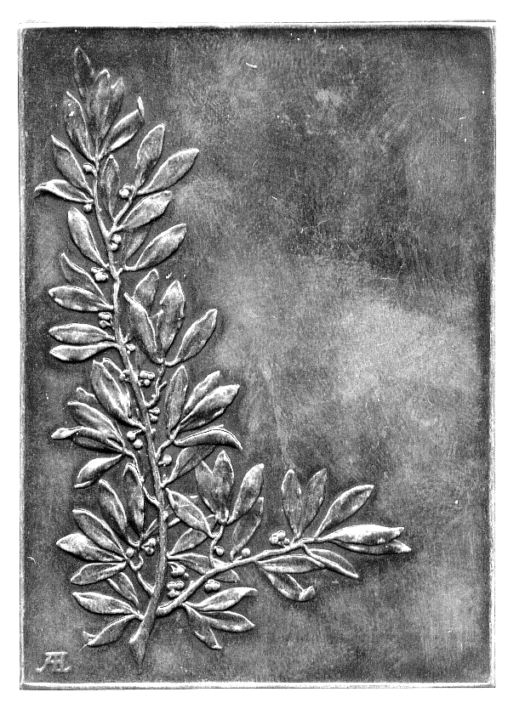  476 | 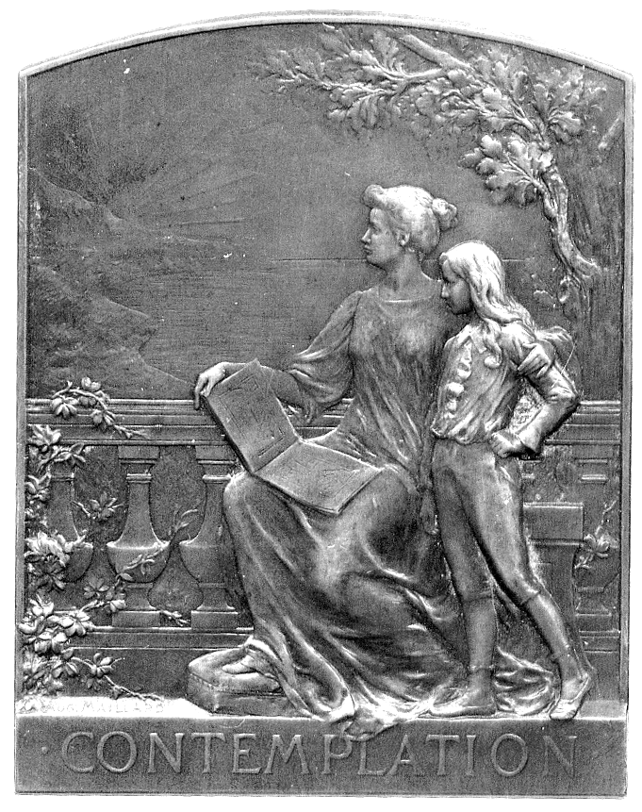  478

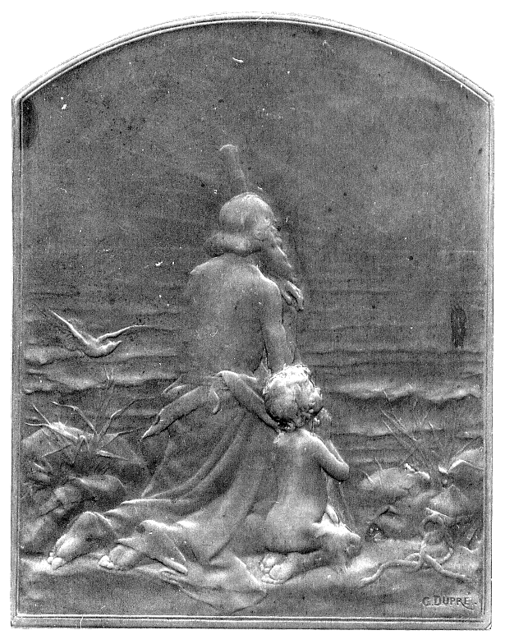477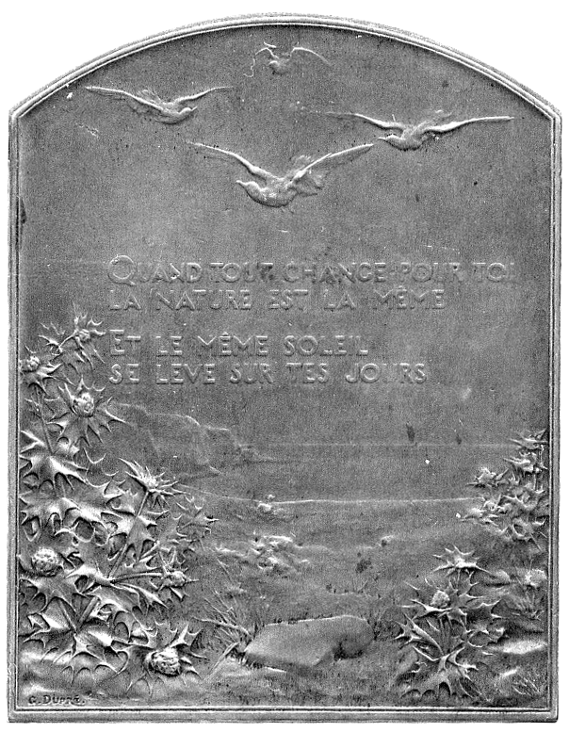 | 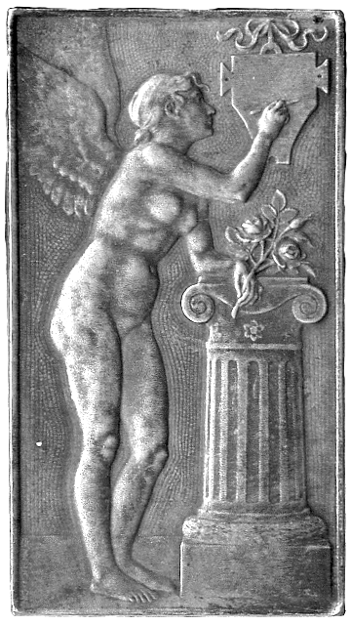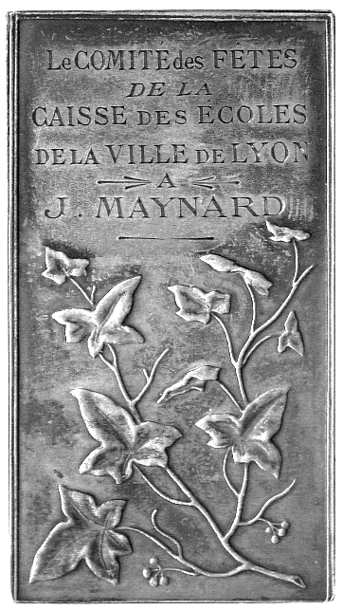  481

452* Philip Duke of Orleans, Suppression of Dimes, Copper Medal, by St Urbain, bust of Duke right, rev Liberalitas standing with cornucopiae, 43mm. Extremely fine. £60-80

453* Louis XVIII (1814-1824), Copper Medal, by Andrieu and Desboeufs, bust right, rev bishop and Louis stand facing holding scroll, 51mm. Extremely fine. £40-50

454 Pierre Jeannin, Bronze Laudatory Medal 1817, by R Gayard after G Dupré, bust left, rev legend, 41mm. Extremely fine. £8-12
Jeannin, 1540-1623, statesman. From the Series Galerie Metallique des Grands Hommes Français

455 Charles de Secondat, Baron Montesquieu, Copper Medal, 1817, by Caunois, bust left, rev legend, 41mm. About as struck. £15-25
From the Series Galerie Metallique des Grands Hommes Français

456 Jean-Jacquues Rousseau, Copper Medal, 1817, by Dubois, bust left, rev legend. About as struck. £15-25
From the Series Galerie Metallique des Grands Hommes Français

457 Arouet de Voltaire, Copper Medal, 1817, by Caunois, bust right. About as struck. £15-25

458 Insurance, Ancienne Mutuelle de Rouen, Founded 1817, plated Bronze Medal, by O Roty, seated female overlooks scene of firemen tackling blazing townhouse, rev eagle among flames looks across river towards city, 68mm, awarded on edge to Mlle Fernande Dubois 1932-62, in case of issue. Very fine. £20-30

459 Michaelangelo, Copper Medal, 1819, by R Gayrard, bearded bust left, rev legend, 41mm. Almost as struck. £15-25
From the Series Numismatica Universalis Virorem Illustrium published by Durand

460 Duke of Angoulême, Triumphant return from Spain, Copper Medal, 1823, by Caunois, laureate bust left, rev Duke on horseback attended by victories and followed by his army, rides through triumphal arch, 50mm. Extremely fine. £40-60

461 Chambre de Commerce du Dept de la Chte Infre, Silver Medalet c.1831, by N Tiolier and Sanier Père, bust left of Louis Philippe left, rev view of a port quayside, 33mm. Almost extremely fine. £25-35

462* Isodore Justin Severin, Baron Taylor, Actors’ Mutual Benefit Society Founded 1840, Silver Award Medal, by H Lavigne, bust right, rev legend and wreath, named to Augusta Pouget, cased, 50mm. About extremely fine. £30-50
French writer 1789-1879
463* Société Générale de Crédit Industriel et Commercial, Silver Jeton, octagonal, by H de Longueil, figure of Industry standing by pillar with implements, ship to sea beyond, rev dated 7 Mai 1859 within wreath, 36mm. Extremely fine. £25-35

464 Jean Auguste de Thou, Silver Laudatory Medal, 1861, bust almost facing, rev interior view of a library, 36mm. Good extremely fine. £20-30
De Thou (1553-1617), historian and scholar, whose library was famous

465 Lyon, Societé de Sciences Industrielles, Founded 1862, Copper Medal by by G Bonnet, conjoined busts of Ampere and Jacquard in high relief, rev legend and wreath, 55mm. Extremely fine. £20-30
Joseph Marie Jacquard 1752-1834, inventor, André Ampere 1775-1836, physicist

466* Professor Simon Duplay, Bronze Plaquette, by F Gilbaut, profile bust left in gown, rev Science writes the titles of Duplay’s works on a large open book supported on easel, 50mm x 70mm. Good very fine. £20-30

467* Science, Sir J Norman Lockyer (1836-1920), and P C Jules Janssen (1824-1907), the joint, though independent discoveries of helium, copper medal, 1868, by A Dubois, conjoined busts right, rev Apollo in celestial chariot points at the sun, 70mm. At one time cleaned, very fine. £30-50

468 Paris, 11e Arrondissement, Bureau de Bienfaisance, Montyon Copper Award Medal, by Caqué, awarded 1868, bust of Montyon right, rev legends and wreath, 41mm. As struck. £20-30

469 USA, Statue of Liberty erected 1876, Bronze Medal, view of the statue, rev “in remembrance of the old friendship between the United States and France” &c, 50mm; Communications Association Bronze Medal, female seated, rev Eiffel tower, 50mm. Very fine, first with a few small digs and scratches. (2) £40-60

470 Paris, Faculty of Medicine, Silver Prize Medal 1888, by A Barre, bust of Aesculapius left, serpent and staff behind, rev legend (awarded 1904) and wreath, 51mm; Société des Annales d’Hygiène et de Medecine Légale, Silver Prize Medal, by Dupré, obverse similar to previous, rev awarded 1840, within wreath, 41mm, extremely fine. (2) £20-30

471* Les Sciences, Silver Award Medal (1894), by L-A Bottée, seated figure of Science attended by Genie, rev sphinx looking at itself in a mirror, rising sun at left and oil-lamp below, unnamed, 51mm (PBE 28; CGMP 3/60-1; coll R Marx 383; For I/231); Association Française pour l’Avancement des Sciences, Silver Award Medal (1890), by L-O Roty, Science seated reading in rural setting, rev Science indicates a busy port to Gallia, 45mm (CGMP -; Forrer V/232). Very fine. (2) £40-60
472 Opening of the Musée Social, 1896, Silvered Bronze Medal, by L-O Roty, two male figures walking up the steps into the Museum, rev seated female figure with charts and shelves of books, factory scene through a window, 60mm, awarded to Charles Tantet 1907 (BDM V, 236; Roty Cat 1971, p.92), another, bronze. First good very fine and very rare, second very fine, pierced and cleaned. (2) £30-40

473* Ernest d’Hervilly 1898, Æ uniface Plaquette, by J P Legastelois, bearded half-length bust left seated at writing table, the plaquette with a lead backing, 71mm x 91mm. Softly worked, very fine. £30-40
Ernest d’Hervilly (1839-1911), artist and poet

474 Emile Loubet, elected President 1899, Bronze Medal, by J C Chaplain, bust left, rev France writes his name on tablet, 72mm (CGMP 3/76). Good very fine. £20-30

475 Nineteenth and early twentieth century medals in bronze (3) and silver (2), including Napoleon, Capture of Vienna 1805, Bronze, by Denon & Galle, laureate bust right, rev Napoleon as Hercules standing, females representing Vienna and Presbourg surrender city keys to him, 40mm (Br 443), extremely fine, Shareholders of Paris to Mediterranean Railway, silver plaque, angels and female figures join hands, rev view of public building, 45mm x 58mm, very fine. Generally good very fine and better. (6) £100-150

476* Homage to medallists, Bronze plaquette, by A Lechevrel, naked female inscribes medallists’ names on shield hanging from tree, a screwpress in the background, IN ÆTERNVM GLORIA MAGISTRIS CÆLATOR on ribband, rev laurel sprig. Good very fine, possibly onetime lightly cleaned. £50-70
Many of the foremost medallists’ names of the era are recorded on here: Oudiné, Chaplain, Roty, Chapu, Degeorge, Dupuis, Botteé, Patey &c. The medallist himself is too modest to place his own name on the shield.

477* “Salut au Soleil”, Bronze plaquette (1899), by G Dupré, old man and boy kneel by sea watching sunrise, rev clifftop view and legend, 50mm x 63mm. Very fine. £20-30

478* “Contemplation”, copper and bronze plaquettes (2), by A Maillard, late 17th century aristocratic mother seated holding book, son by her side, contemplating sunset over coastal view, 56mm x 71mm. Extremely fine and nearly so. (2) £30-50

479 Union Centrale des Beaux-Arts, oval silver medal with part openwork design, second Prize, ‘Concours des jeunes filles’ to Marguerite Devaux, a classical head atop a column, implements of art and industry around, 72mm x 52mm; Napoleon III, silver medal, “Tournoi Nautique Oriental – Lac du Bois de Boulogne, 27 Juillet 1862”, 37mm. First extremely fine, second nearly so. (2) £40-60
480 Orpheus, bronze musical prize medal, undated, by M A L Coudray, laureate bust turned three-quarters left, holding lyre, rev Genius with musical instruments, 67mm (BDM I, p.463, illustrated), very fine; and a small bronze ‘Art Nouveau’ medal for the Chamber of Commerce, Nancy, 36mm, extremely fine. (2) £30-40

481* Lyon, Silver Award Plaque c.1901, by L-E Mouchon, naked female Genius leans on column, inscribing a tablet, rev branch, engraved le Comité des Fêtes de la Caisse des Écoles de la Ville de Lyon A J.Maynard, 53mm x 29mm, in fitted case of issue (CGMP p.278; BDM IV, 177), very fine; République Française, 1901, Bronze Award Plaque, by S-E Vernier, half-length portrait of Marianne right, rev laurel branch, 74mm x 50mm (BDM VI, 227), extremely fine. (2) £40-60

482 Shooting Festivals, Rouen, 1902, bronze plaquette, by G Dupre, France points to rays of sun, a naked boy with rifle beside her, rev naked child with legend on plaque, 64mm x 48mm; Nancy, 1906, small bronze medal, by Ch Marey, 36mm; Cycling, bronze medal, 1920’s, by R Baudichon, issued by Peugeot, Cyclist, rev the Peugeot factory, 50mm. Very fine. (3) £30-50

483 Raymond Poincaré, elected President 1913, Bronze Medal, by R Lamourdedieu, France and supporters carry torches and other implements above Paris, rev two females cast vote for president in urn, National Assembly to right, 73mm (CGMP -). Very fine. £20-30

484* Rennes, Visit of President Poincaré 1914, Bronze Plaque, by P Lenoir, the figure of Rennes awaits at bottom of staircase, hand of welcome outstretched, rev city arms below view of buildings, 70mm x 100mm, in fitted case of issue. Extremely fine. £60-80

485 Bombardment of Rheims 1915, Æ Plaquette, by L Chavalliaud, German soldier with dagger in hand leaves murdered family, Rheims cathedral burning in background, avenging angels in sky, rev dawn rises over town square, la semeuse before sunrise, French cock vanquishes German eagle in foreground, 60mm x 80mm. About extremely fine, reverse a little dirty. £40-60
Rheims was the medallist’s home town

486* Marseille, La Commission des Hospices Civils de Marseille 1919, Silver Award Plaquette for services rendered in the Great War, by H Dubois after F Rude, the Departure of the Volunteers 1793, rev legend and award inscription to Mme Albert Domergue, 50mm x 67mm, in fitted case of issue. Extremely fine. £100-120
The Departure of the Volunteers, by François Rude, is a relief on the Arc de Triomphe in Paris (1833-1836). It symbolises the departure from Marseille of the Volunteers on their long march to Paris in 1793.

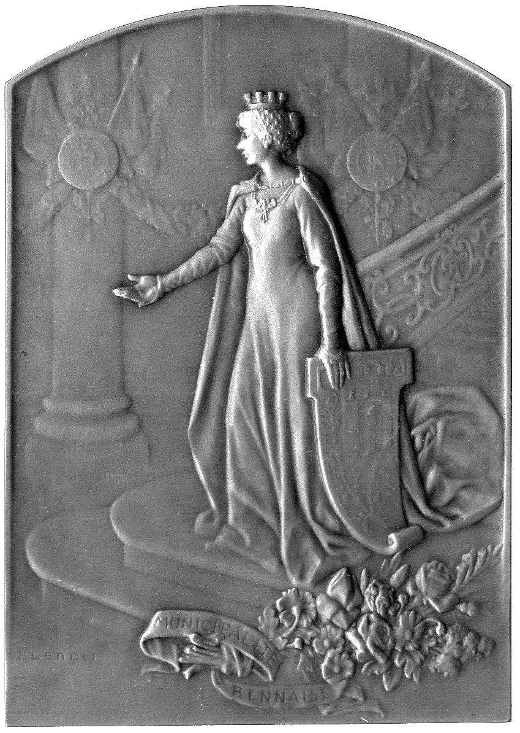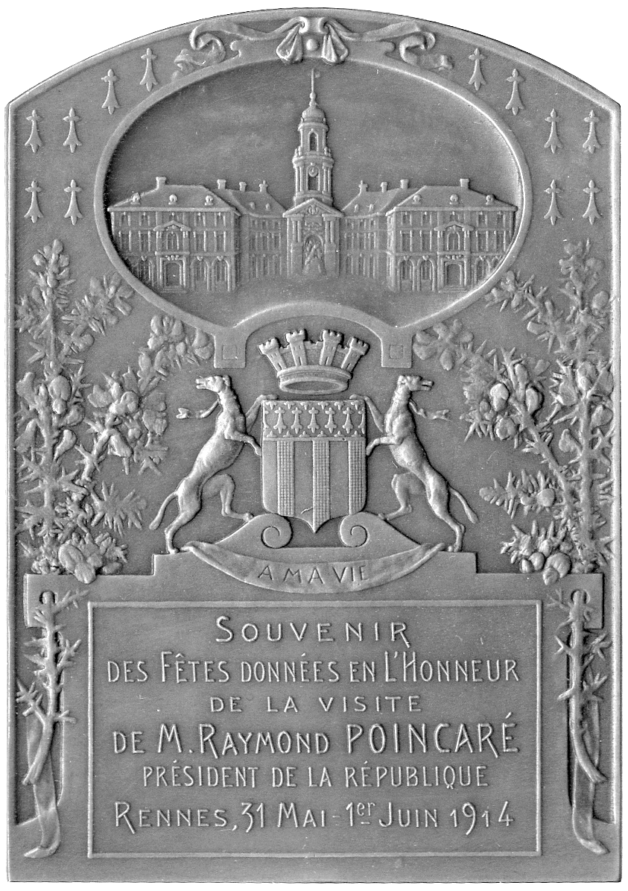  484 | 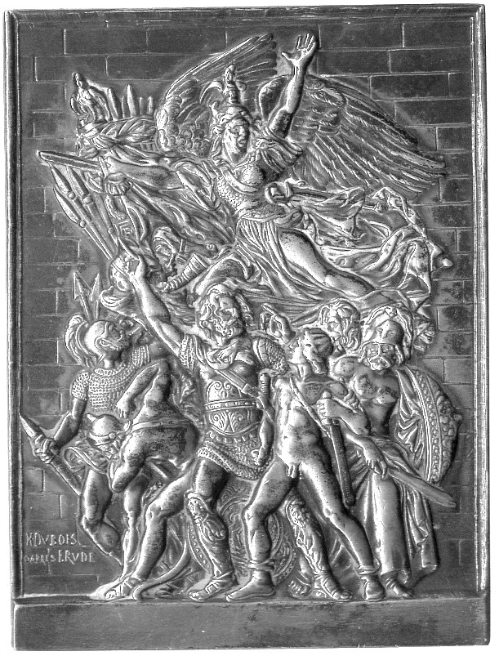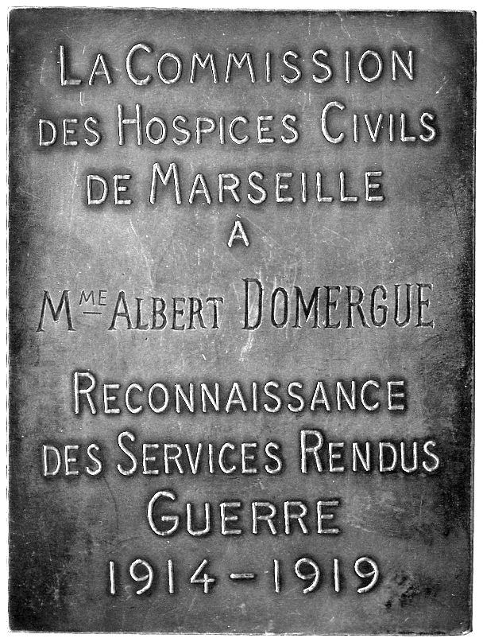  486

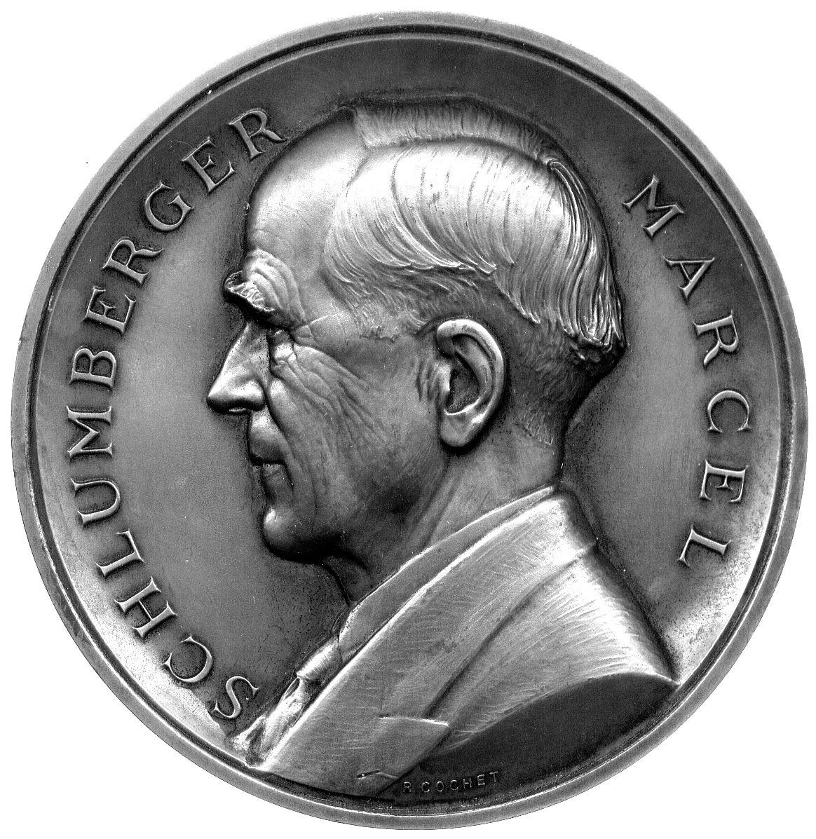487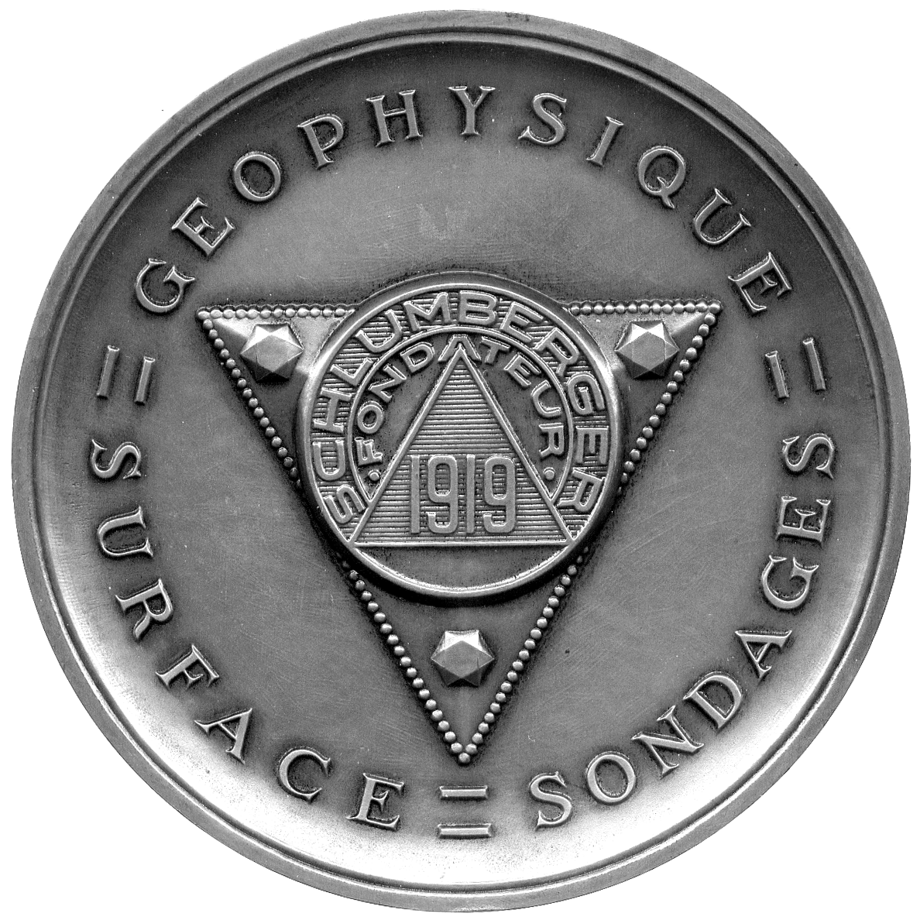

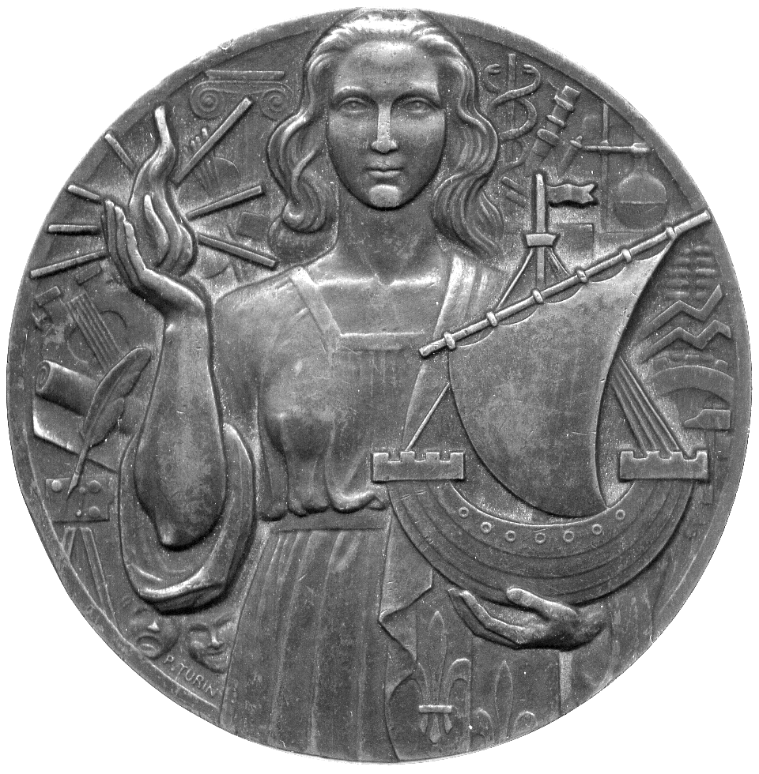499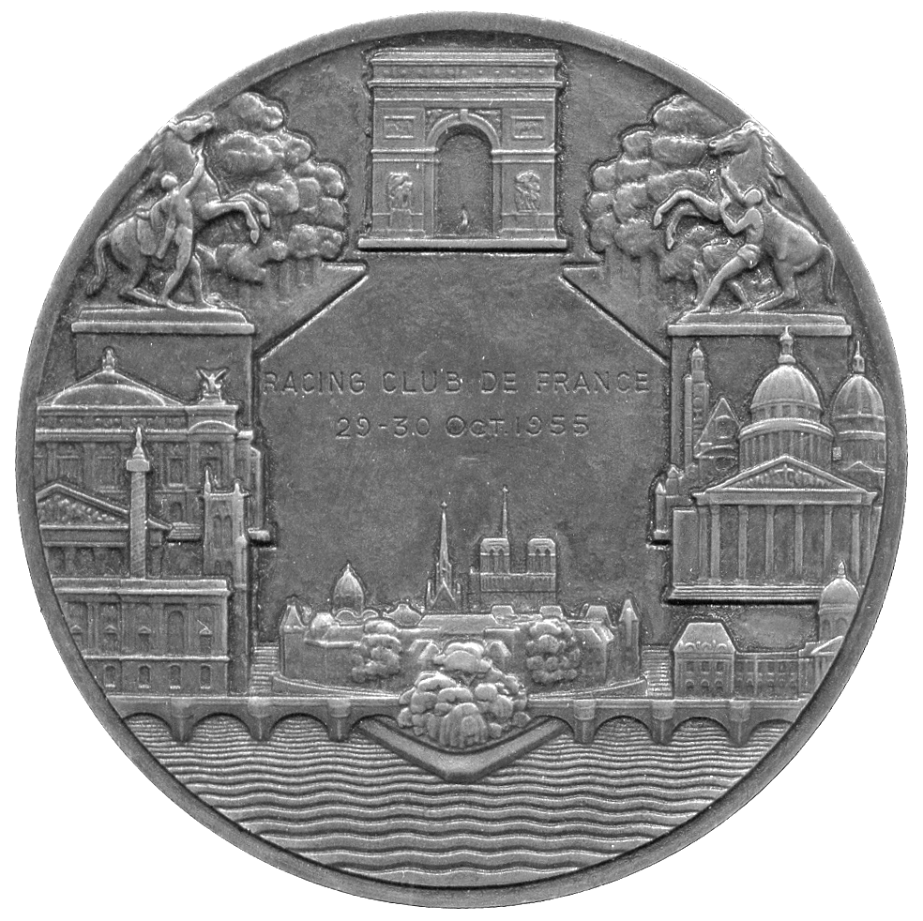

487* Marcel Schlumberger, Copper Medal, by R Cochet, bust left, rev foundation date 1919 within abstract design, 100mm. Good very fine. £30-50
Co-founder in 1919 of the Schlumberger oil-prospecting empire

488 Louis Pasteur, centenary of birth 1922, Silvered Lead Plaque, by V S Canale, bust left, name and dates above, rev legend and laurel sprig, 80mm x 111mm. Good very fine, but surface dings and scratches. £30-50

489* Amsterdam, French Exposition 1922, Bronze Gilt, by A P Schwab, conjoined busts of young Dutch and French women wearing traditional bonnets, award tablet below rev view of city above shields and laurels, 47mm x 63mm, in fitted case of issue. Softly worked, good extremely fine. £30-50

490 Ville de Metz, Bronze Medal c.1925, by F P Niclausse, woman’s profile bust left, rev public buildings, 80mm. Very fine. £20-30
the medallist was a native of Metz

491 Denys Puesch 1926, cast Gilt-Bronze Portrait Medal, by L Bazor, bust right, 116mm (cf CGMP 3/31). About very fine, remnants of glue on the back. £20-30
Director of the French Academy in Rome

492 Professors Maurice and Auguste Pollosson, Bronze Plaquette c.1926, by J Chorel, conjoined busts of the brothers left and almost facing, rev a bridge, legend below VNO AVVULS, NON DEFICIT ALTER (with one torn away the other does not fail [Virgil]), 67mm x 44mm. Very fine. £20-30

493 Death of Georges Clemenceau, 1929, Large Bronze Medal, by F-L Sicard, bust left in high relief, rev owl of Athens, 90mm, in original box of issue (CGMP p.362). Extremely fine and rare. £50-70
G Clemenceau (1841-1929), twice prime minister (1907-10, 1917-20)

494 Professor René Le Fort 1936, Uniface Bronze Plaque, by Blaise, bust left wearing neck badge of Order, 80mm x 60mm, in leather case of issue. Extremely fine. £20-30
Le Fort published research into facial fractures

495 Lyon, Ch. Montcharmont, Thirty Years Management of Théatre des Celestins 1937, Bronze Plaquette, by Bertola, bust left, rev legend below actor’s mask, 50mm x 77mm. Good very fine. £20-30

496* Professor Paul Jeandelize, Laudatory Portrait Medal c.1940, Copper Medal, bust three-quarters facing in very high relief, rev biographical details, 43mm x 60mm. Almost extremely fine, a portrait of some charm. £30-50
Professor of medicine at Nancy university
497* Abolition of Slavery, Universal Suffrage, Social Legislation, French Celebratory Medal, a hundred years of social progress 1948, Bronze, by Bazor, cypress between RF, rev Marianne and Liberty, 1848-1948, 68mm. Almost extremely fine. £100-120

498 Firmin Gillot, Bronze Plaque awarded 1948, by J Vernon, for the Clichés Union Gillot-Rousset-Ruckert, bust of Gillot right, rev legend, named to M.Kaan, 90mm x 64mm. Very fine, rare. £20-30

499* Paris, 1950, Bronze Award Medal, by P Turin, female figure of Paris holding the symbols of the city, accoutrements of the arts and sciences behind, rev the Arc de Triomphe, Île de la Cité and other landmarks around, centre engraved Racing Club de France 29-30 Oct.1955, 81mm (CGMP p.1837). Good very fine. £30-50

500 Pierre Teilhard de Chardin, Bronze Laudatory Medal 1951, by R Delamarre, profile bust right, rev spiral around column reaching to heaven, legend around, 68mm. Very fine. £20-30
De Chardin (1881-1955), Jesuit, palæontologist, philosopher and author

501* National Museum of Modern Art, Mexican Art Exhibition 1952, Bronze Medal, by L Muller, Aztec woman kneeling, symbols of Mexican art behind, rev circle of Aztec art around legend, ship above, 68mm (CGMP 4/1377). Good very fine, darkly patinated. £20-30

502* Edouard Herriot, 80th birthday 1952, Copper Medal, by R Corbin, bust left in high relief, rev view of the Assemblée Nationale from across the Seine, engraved on edge A.BARDON DÉPUTÉ, 80mm. Extremely fine, small stain on reverse. £30-50
Herriot (1872-1957) was a career politician and president of the National Assembly 1947-54.

503* Quatercentenary of the Birth of Antoine de Pluvinel 1955, a Bronze Medal by J Vernon, bust left in ruff, rev Pluvinel teaching Louis XIII to ride a horse, open book below, 68mm (CGMP 4/1865). Minor rim nicks, good very fine £20-30
Antoine de Pluvinel (1555-1620), horse trainer; studied horsemanship under Pignatelli, 1565-71; appointed premier ecuyer to the Duc d’Anjou, the future Henri III, 1572; travelled with him from Cracow to Paris when Henri acceded to the French throne, 1574; founded the Académie d’Equitation, 1594. Other biographical detail is sold with the lot.

504 Armand Salacrou, Bronze Medal 1956, by J Hébert-Coëffin, bust right, rev constellation of Leo, 68mm (CGMP 4/424); Chambre de Commerce de Rouen, c.1960, Bronze Medal, by J Hébert-Coëffin, ship of Rouen, rev citadel with cranes at side, 41mm; together with other base metal medals (6), by Simon, Pillet, H Dubois, etc. First two extremely fine and patinated, others generally very fine. (8) £30-40
Armand Salacrou (1899-1989), dramatist from Rouen

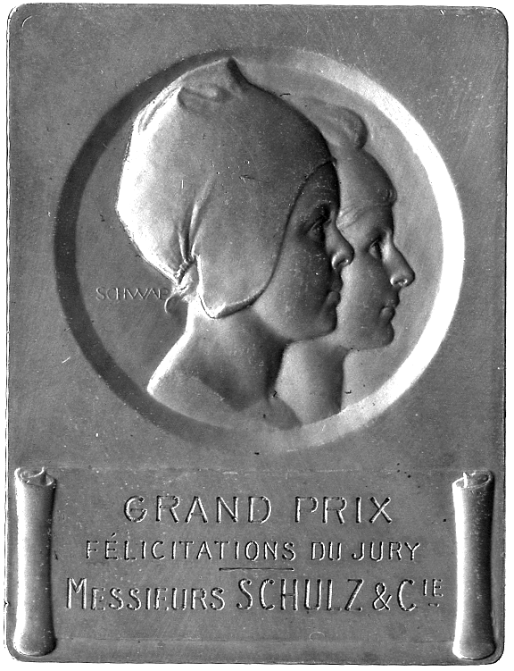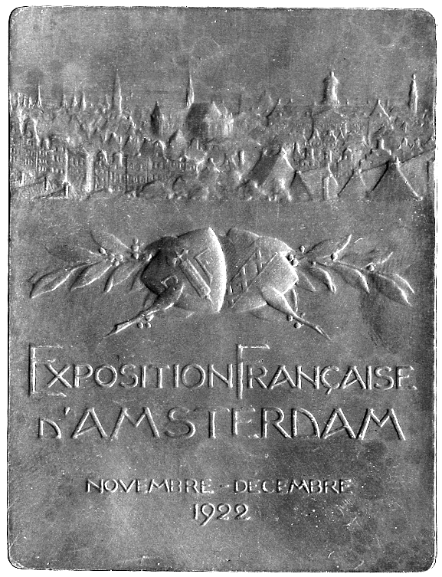  489 | 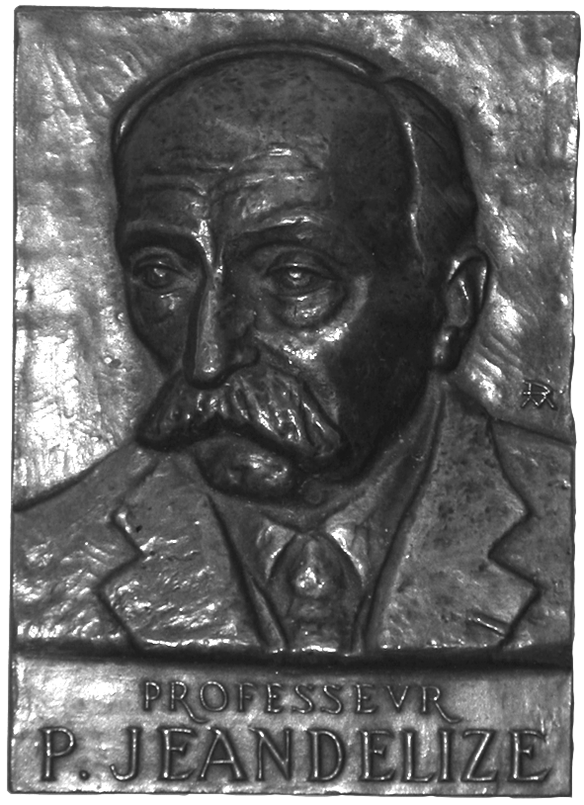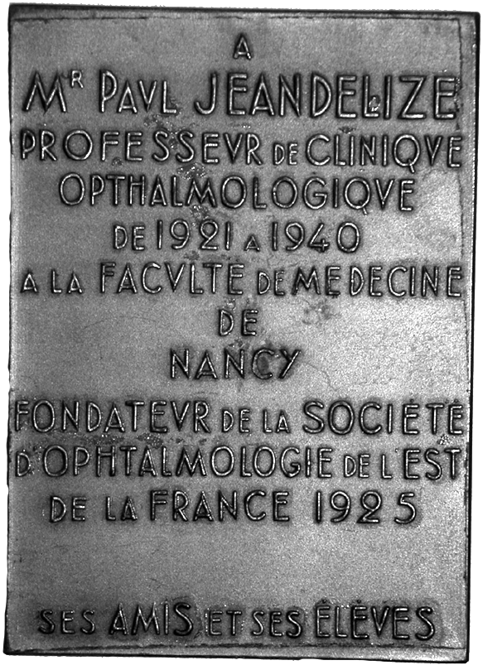  496

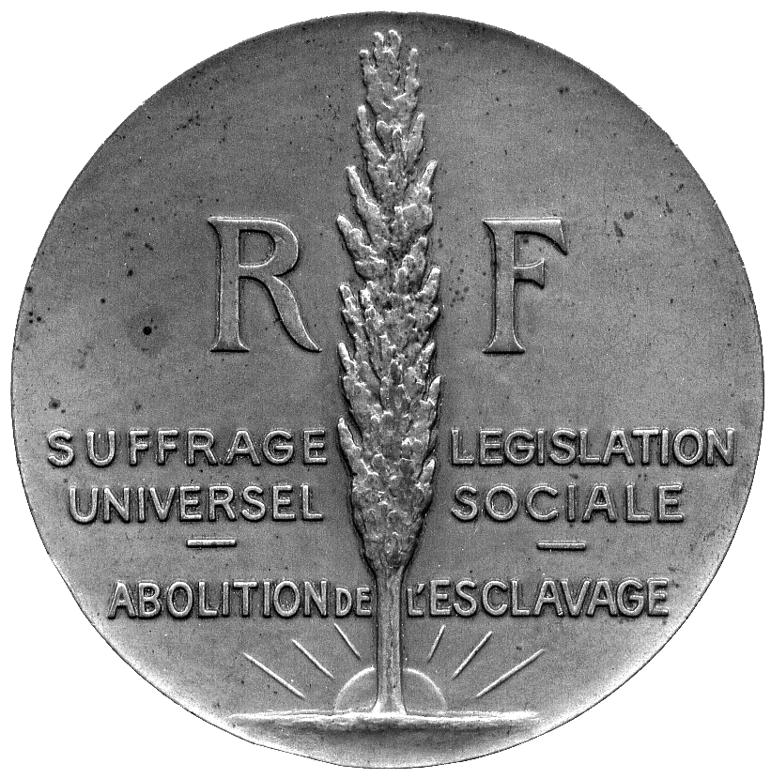497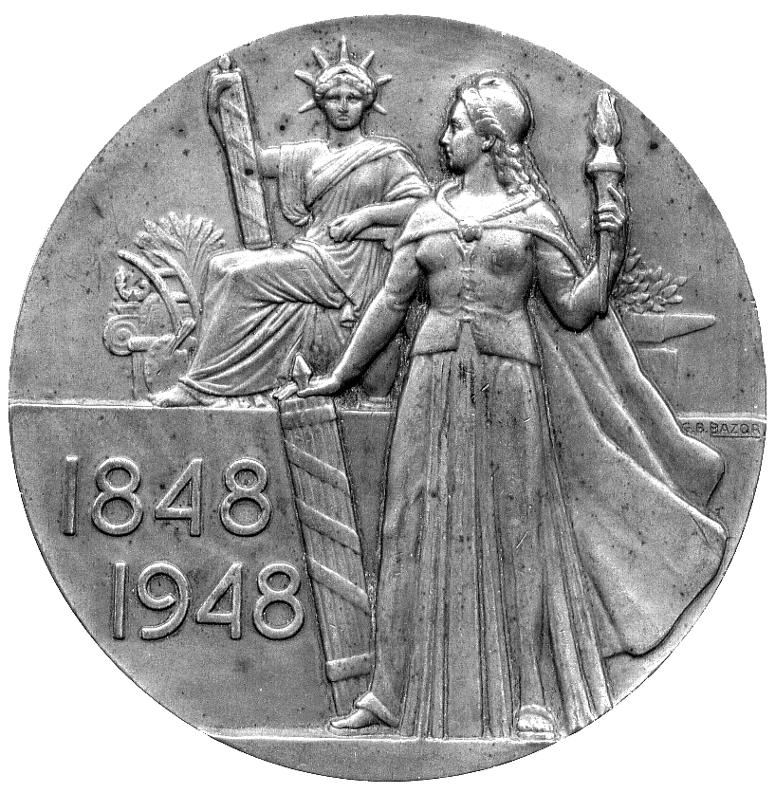

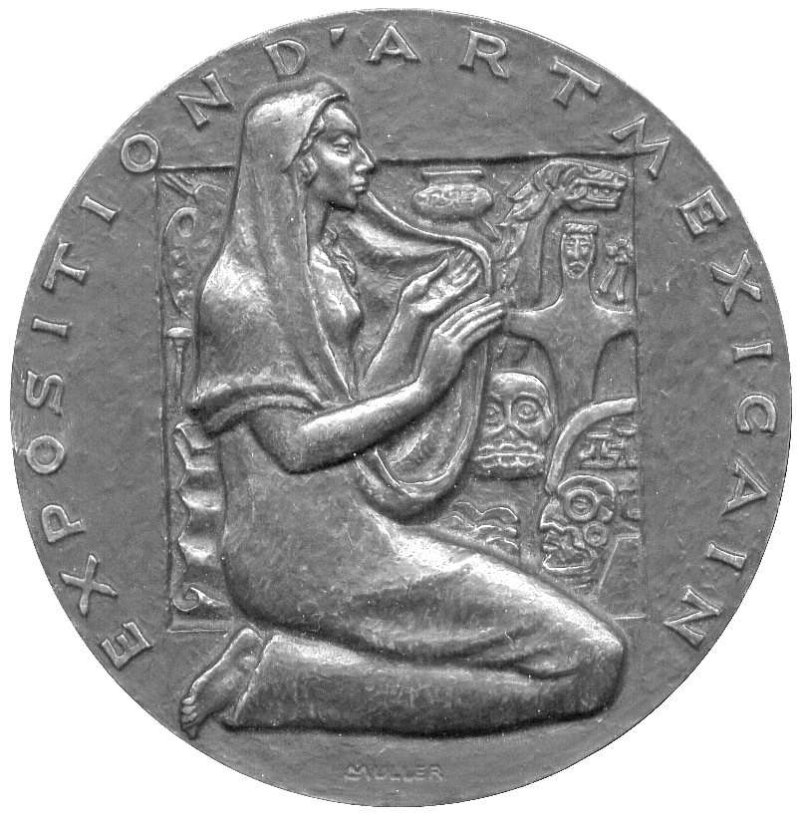501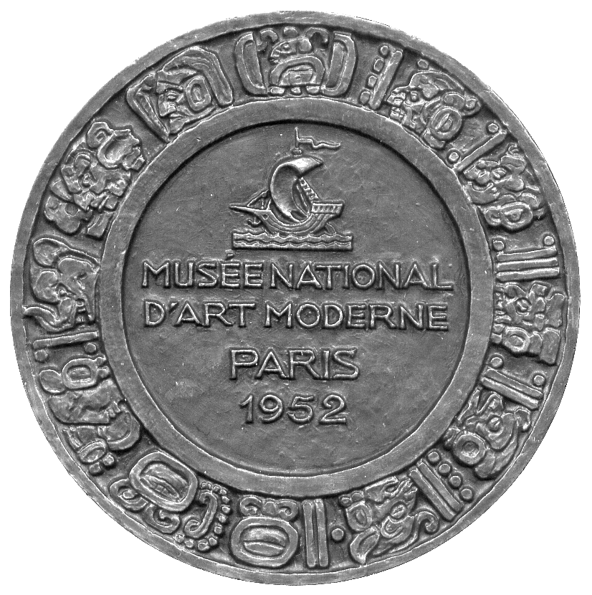

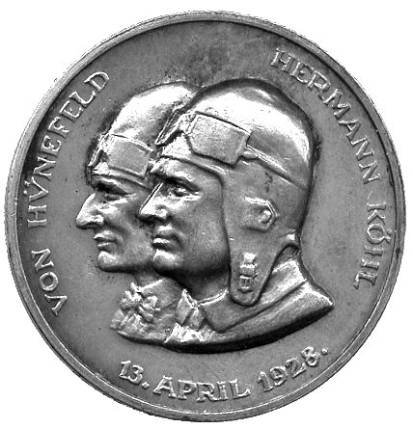510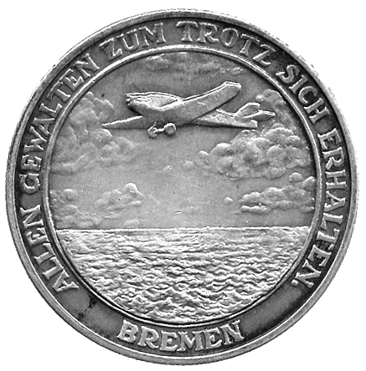 | 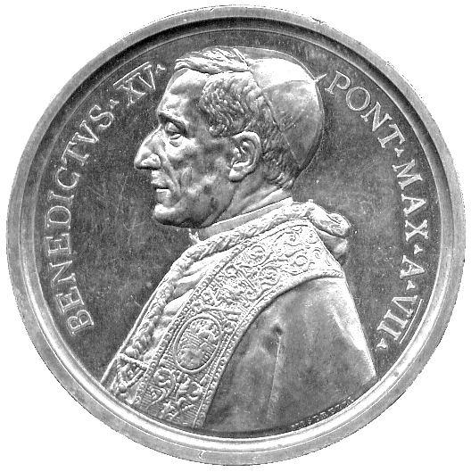511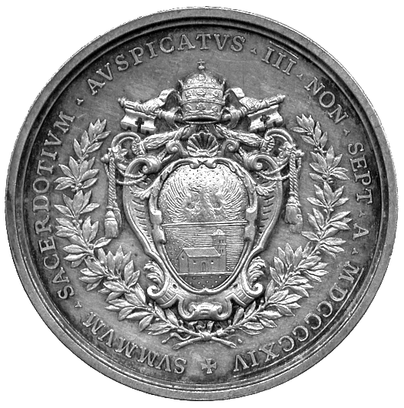

505 Centenary Medal, Pont-à-Mousson, Copper Medal, 1956, by H Dropsy, factory, rev naked youth holds pipe aloft, 68mm; Juliano Mulsant, bronze tribute medal, 1928, by Alfred Rochetta, bust left, in high relief, 80mm; other bronze portrait medals (3), President Armand Fallieres, 1906, by Leon Deschamps, 71mm; President Felix Faure, by J C Chaplain, 1897, 72mm; Alfred Cornu, 1905, by J C Chaplain, 68mm, last three 1920’s strikings. Extremely fine or nearly so. (5) £50-70

506 “La vie est le voyage, l’idée est l’itineraire“, large Bronze Art Medal 1976, by R Pagès, symbolic sunrise in high relief, rev legend (CGMP 4/1430-31). Good very fine. £20-30

507 George Migot, bronze laudatory medal 1976, bust right, rev legend, 50mm (Niggl 1334). Good very fine. £15-25

508 Bureau Veritas, 150th Anniversary 1978, Bronze Art Medal, by A Bizette-Lindet, ship within incuse square, VERITAS around, rev a stylised head within incuse square, upon which various designs representing commerce and travel, 72mm (CGMP -). Extremely fine. £20-30

509 Monnaie de Paris, modern issue medals (6), all base, different subjects, all in boxes of issue. As issued. (6) £30-50

GERMANY

510* Aviation, Silver Medal conjoined busts in flying helmets of von Hunefeld and Hermann Kohl, rev plane over sea, legend around, 37mm. Good very fine. £30-50

ITALY

511* Benedict XV, election 1914, Silver Medal, by C V Binachi, bust right, rev arms of Benedict XV, 44mm (Rinaldi 109). Light marks, very fine. £30-40

512* Benedict XV, year 7, 1920, Silver Medal, by Mistruzzi, bust left, rev Saints Gerolamo and Efrem seated in front of an altar, dove representing the holy spirit and lion in field, 44mm (Rinaldi 115). Light brush marks in field, about extremely fine. £40-50

513* Pius XI, Silver Medal struck, by Karl Goetz, the signing of the Lateran treaty with Italy, bust left, rev St Peter seated on globe, holding two keys along with tablet inscribed PAX, on the globe a map of Italy and Sicily with Vatican City prominent, 36mm (Kienast 120). Good very fine. £50-70
514* Pius XI, Vatican Radio, Silver Medal, by Mistuzzi 1931, bust left, rev herald hovers over globe blowing fanfare on trumpet and distributing radio waves to the world, 36mm (Rinaldi 125), matt surface, small mark on jaw-line otherwise extremely fine; together with Copper Catholic School Committee prize medal, fine. (2) £40-60
Radio Vaticana is the world’s most popular radio station.

JAPAN

515 Olympics, 18th Olympiad, Tokyo 1964, Bronze Commemorative Medal, 30mm, by Yusaku Kamekura, athletes competing, rev sun over Olympic rings. Extremely fine, in case of issue. £8-12

NETHERLANDS

516* Willem (IV) Carel Hendrik Friso, Prince of Orange and Nassau, Funeral Procession 4 February 1752, silver medal, by N van Swinderen, the sarcophagus lying in state, rev view of the funeral procession, 36mm (Forrer V/719; vL suppl 310). Good very fine, dark tone. £30-40

POLAND

517 Historical Commemorative Medals (5), Copper, mostly 1990s, commemorating figures and events from Polish history, all 70mm. About as struck. (5) £15-25

PORTUGAL

518 Brass tokens, value stated 200- (2), 500- (2), 800-, 1- (2), different shaped flans, with common obverse ‘PB’, other coins and medals of the world (7), including Panama Seoul Olympics Balboa 1988, rev horseman, varied state. (14) £40-50

SINGAPORE

519 Sir Thomas Stamford Raffles, Pewter Medal, undated, commemorating the founding of Singapore, 69mm. About extremely fine. £10-15

SPAIN

520* Ferdinand VI (1746-1759), bust of Ferdinand right, rev a cannon projects a cannonball in open country, 48mm. Extremely fine. £50-60

521 Marriage of the future Charles IV and Maria Louisa of Parma, Copper Medal, 1765, by T Pieto, bust of Charles III right, rev conjoined busts right, 50mm. Good very fine, some rim knocks. £30-50

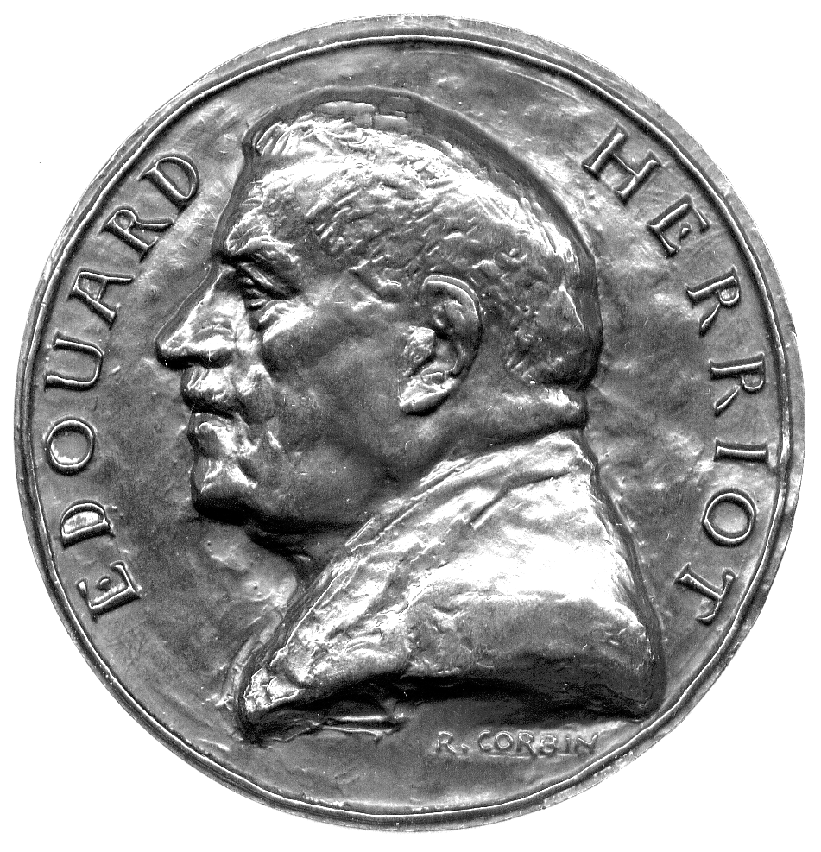502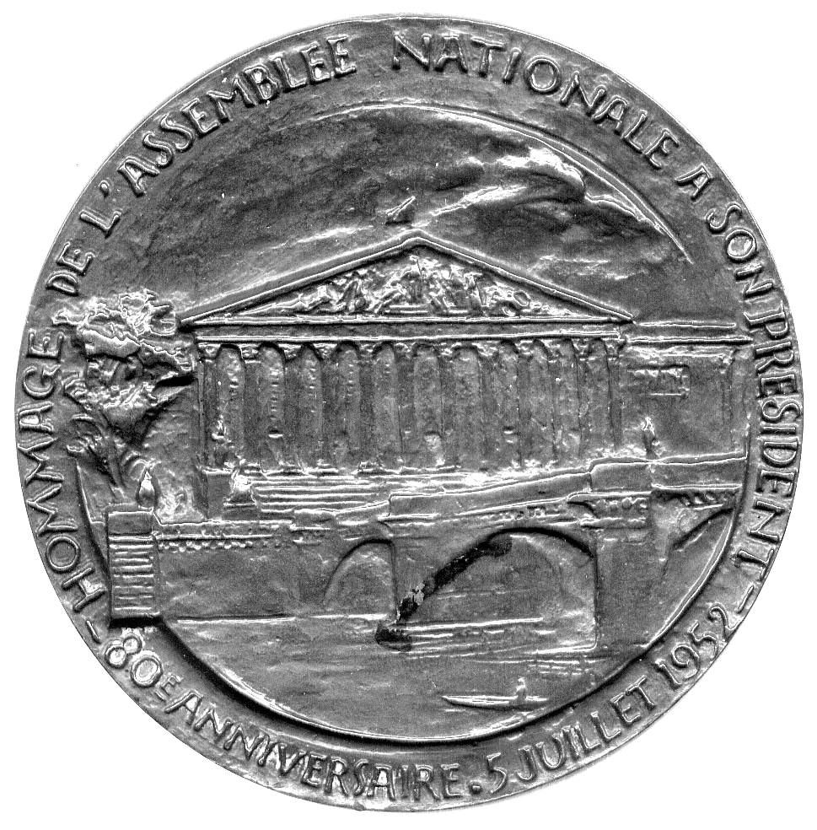

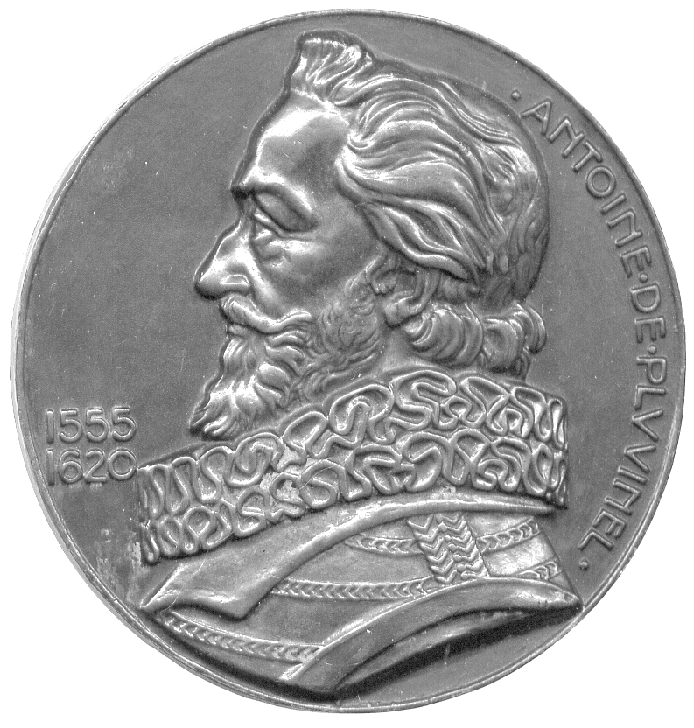503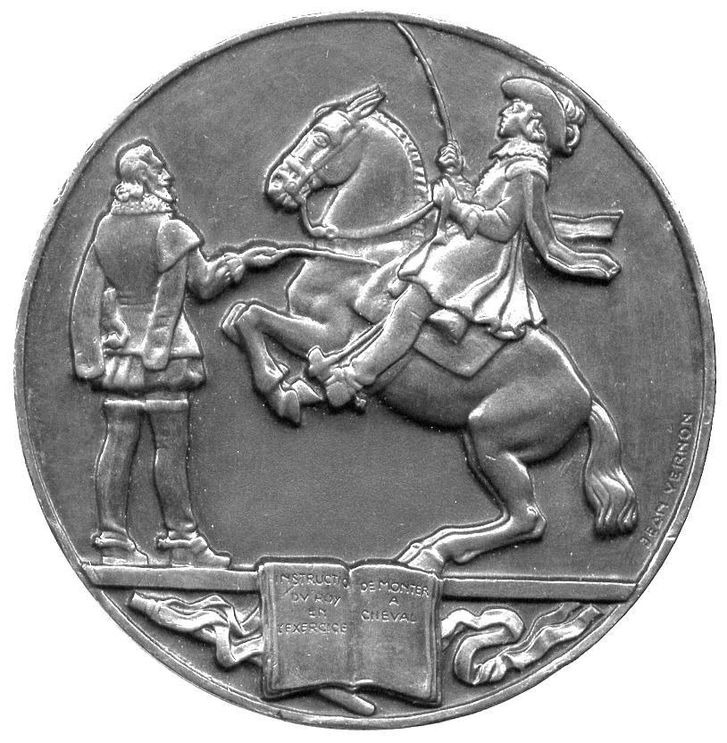 | 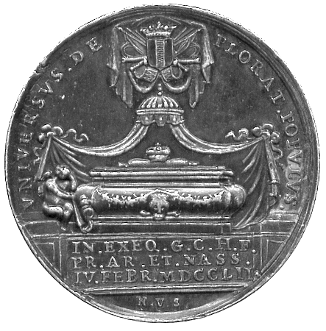  516

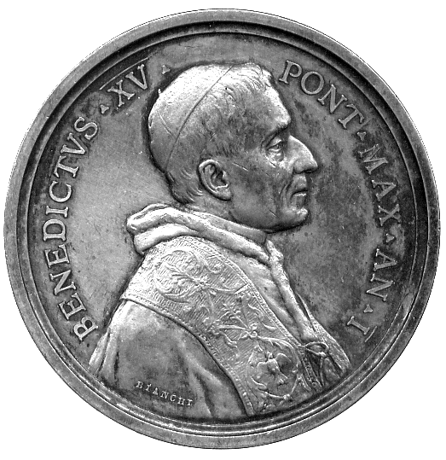512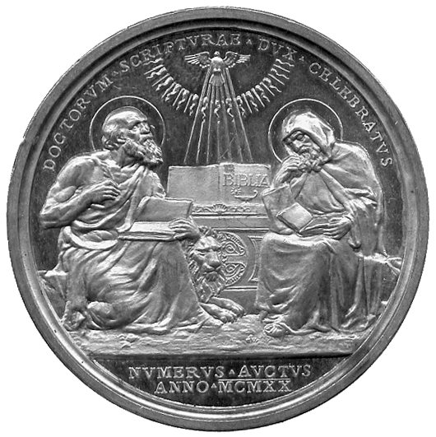 | 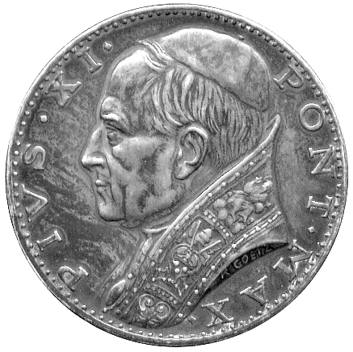513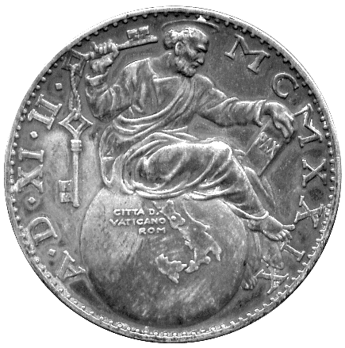

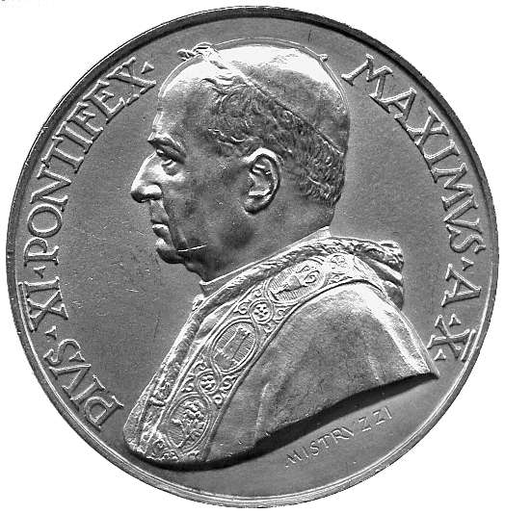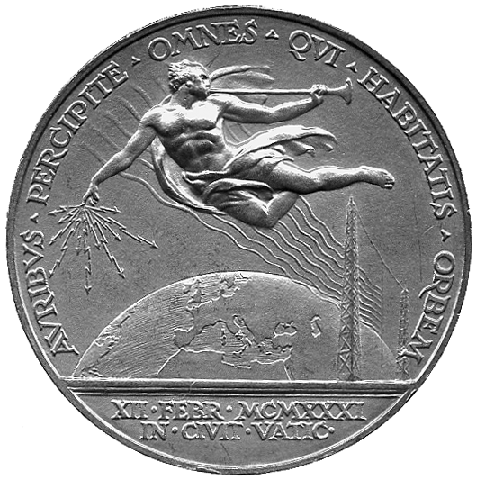  514 | 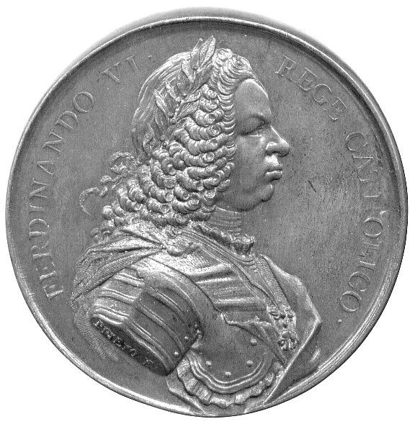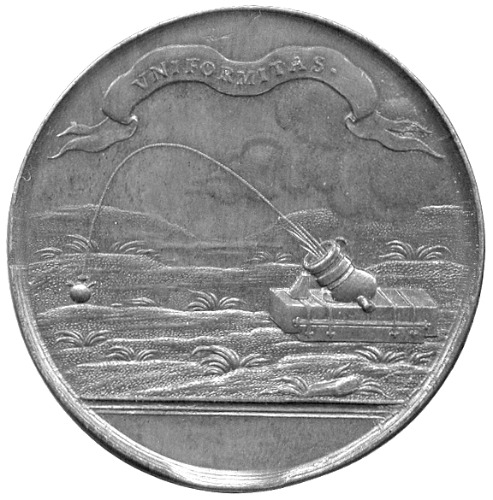  520

522 Spanish Crown Restored to Ferdinand VII by France, Copper Medal, 1823, by Gayrard, bust of Louis XVIII right, rev Gallia repels rebel while protecting the royal family, 50mm. Good extremely fine. £30-50

523 Spanish Crown Restored to Ferdinand VII by France, Copper Medal, 1823, by Andrieu and de Puymaurin, bust of Louis VIII right, rev nine line legend within wreath, 51mm. Good extremely fine, possibly a restrike. £20-30

SWITZERLAND

524 Vevey, Fête des Vignerons 1865, Copper Medal, by Siber, Putti sits on barrel holding glass and sceptre, plants each side, rev legend within grape wreath, 42mm. Almost as struck. £20-30

MILITARY RELATED MEDALS

525 Second World War Burma Stars (20). Some tarnishing but practically mint state. (20) £100-150

526 Second World War Burma Stars (20). Some tarnishing but practically mint state. (20) £100-150

527 Austria, Franz Joseph, Silver Bravery Medal, first class, with red and white ribbon; bronze Bravery Medal (2), one without ribbon, and a cruciform medal. First extremely fine, others nearly so, last fine. (4) £20-30

528 Allied victory 1918, Bronze Plaques (2), by J-P Legastelois, Victory angel above scenes of cannon and troops marching and in trenches, À LA GLOIRE DES ARMÉES DV DROITE ET DE LA LIBERTÉ in exergue, rev French cock below allied flags, award tablet below (one awarded, le palais de la nouveauté à son personnel mobilisé), 48mm x 62mm (CGMP 3/233), good very fine; Great War, memorial plaque, by R Lamourdedieu, statue of France, soldiers by feet, rev engraved for the fallen of Ecole Jean-Baptiste Say, 53mm x 72mm, about very fine. (3) £40-50

529 France, Great War Armistice, 50th Anniversary 1968, bronze, by R Delemarre, emaciated France brandishes flag on devastated battlefield, tree rejuvenates in foreground, rev French soldier trumpets ceasefire, 68mm (CGMP 4/577). Extremely fine. £10-15

530 France, World War I, “La Dette” – the Debt, bronze medal, undated, by P M Dammann, conjoined busts right, the further Mercury, his arm around a blindfolded figure, rev legend, 50mm; Paris, Association Philomathique, 1933, by Dammann, figure on prow of ship, her robes flying, rev fasces, 50mm, in case. First very fine and evocative, second extremely fine. (2) £30-50
MISCELLANEOUS

531 Medals of musicians (3), Belgium, André Grétry 1842, Æ, by C Jéhotte, bust left, rev names of his works radiate from central lyre, good very fine, France, Etienne Mehul, Æ, by Veyrat, bust left, rev lyre and names of works, 41mm, extremely fine, L van Beethoven, uniface square art plaquette c.1927, Æ, by H Dropsy, profile view from behind shoulder, 50mm x 50mm, very fine; Germany, International Singing Competition 1833-1933, silver medal, by A Grath, Richard Wagner left, rev lyre and legend, 60mm, suspension loop, very fine, small scratch by nose. (4) £40-60

532 Miscellaneous Medals (6), including Montague of Winchester School, the erection of a monument to Rubens at Anvers 1840 and a bronze medal commemorating ten years’ archaeology at Kabile 1982, and coinage (33). Mixed grade. (39) £40-60

533 An assortment of British and World Medals (c.25), 19th and 20th centuries, including modern issues, and a quantity of base early 20th century British coinage. Varied state. (lot) £70-90

534 A quantity of modern commemorative medals, many boxed Royal Mint issues, mostly base metal. As issued. (lot) £20-40

535 Commemorative Medals and Medalets (approx 300), 20th Century, mainly base. Varied state. (lot) £50-80

536 Nineteenth and twentieth century copper and bronze medals, medalets etc (approx 70). Generally fine to very fine, some better. (lot) £20-30

